SysArc Infomatix Pvt Ltd
LENDperfect - SRS

Agri Module – KCC

Prepared by: SysArc Infomatix Pvt Ltd
Submission Date: 26 May 2026
Version: V1.2
Request from: Punjab National Bank

Preamble
This document is prepared by SysArc Infomatix Pvt Ltd. SysArc Infomatix Pvt Ltd. reserves the right to amend any portion of this document at any time. This document is marked as confidential and provided for internal use in connection with SysArc’s services only. All information contained in the document is proprietary and confidential and all rights therein are reserved with SysArc Infomatix Pvt Ltd. Client shall not disclose this document to any third party other than the intended receiver. Use of this document is subject to the terms and conditions in force with SysArc. By receiving/downloading this document, the client expressly acknowledges and accepts this disclaimer.
Document Revision History
Ver. No. | Ver. Date | Prepared By | Reviewed By | Approved By | Affected Section & Summary of Change
1.0 | 04 May 2026 | Surya J |  |  | Initial Draft
1.1 | 18 May 2026 | Surya J |  |  | Changed content based on new Artifacts
1.2 | 26 May 2026 | Surya J |  |  | Changed Buttons and artifacts
Table of Contents
1 Introduction 1
2 Lead Management 1
2.1 New Lead Creation 1
2.1.1 Dedupe 3
2.1.2 Party Details 4
2.1.3 Exposure Details 6
2.1.4 Sourcing Details 8
2.1.5 Field Level Validation 11
1. 21
2. 21
3. 21
4. 21
5. 21
3 Parties Involved 23
3.1 Party Details 23
3.1.1 Co-applicant & Guarantor Onboarding 25
3.1.2 360 ° Verification 26
3.1.3 Field Level Validation 28
4 Proposal Data Entry 31
4.1.1 Facility Details 31
4.1.2 Net worth 40
4.1.3 Proposal Info 42
4.1.4 Document Details 42
4.1.5 Due Diligence 44
5 Agri Details 49
5.1.1 Land holding Details 49
5.1.2 Other Income Details and PACS Details 52
5.1.3 Activities Proposed 53
6 Field investigation 56
6.1.1 Pre-Sanction Inspection Report 56
7 Security 59
7.1 Assets & Security Details 59
7.1.1 Field Level Validation 61
8 Rating 77
8.1.1 Score Card 77
9 Assessment 78
9.1 Assessment Eligibility 78
9.1.1 Field Level Validation 79
1. 80
2. 80
3. 80
4. 80
5. 80
10 Decision Making 80
10.1 Pricing and Concession 80
10.2 Terms and Conditions 81
10.2.1 Field Level Validation 82
10.3 Proposal Recommendation 85
10.3.1 Process Note Generation 87
10.3.2 Sanction letter Generation 87
10.3.3 Application Form Generation 87
10.3.4 Field Level Validation 87
10.4 Workflow & Approval 90
10.4.1 Field Level Validation 92
10.5 Workflow History 93
10.5.1 Field Level Validation 94
10.6 Post Sanction Documents 95
10.6.1 Manual Document Execution 95
10.6.2 Field Level Validation 95
10.7 Handoff Details 96
10.7.1 Field Level Validation 99
10.8 Pre Disbursement Compliance 102
10.8.1 Field Level Validation 105
11 Dependencies 106

About SysArc
Founded in 1997, with industry strength and experience in the financial and banking sector. We develop world-class banking solutions - primarily focused on effective implementation of the business process, cutting down on operating expenses, reducing processing time and increasing customer satisfaction multi-fold. We have expanded into the financial services software arena, with the same dedication to excellence to be a touchstone of the corporate culture. We do not simply produce software. we create innovative solutions that allow the customers to outperform their competitors.
Acknowledgments
The documentation team along with Subject Matter Experts (SMEs) have contributed towards the creation of this document. This document has been a team effort with each member providing their inputs and suggestions for improvement so that the document meets End-User requirements. The team consists of Senior Technical Writer, Subject Matter Expert and unnamed countless other members who have made this approach document possible.
Document Conventions
- The normal font used in the document is Cambria.
- The main pages are divided into chapters. Each chapter starts with Heading 1.
- The sub-pages are further divided into sections and subsections are represented as Heading 1.1, through Heading 1.1.1.1.1
- The steps involved to navigate through the application are provided in Bullet points. Sometimes the bullet points may have sub-levels of steps. Each level will display different Bullet points.
- The information that needs emphasis is in Bold Fonts. It may represent the page name, field name, drop-down, checkbox, radio buttons, links, or action buttons.
- The content “Bolded and inserted within Quotes” represents the pre-set options or list values that you may select from one of the various control fields. E.g.: “Yes,” “No.”
- A note inserted in the document at relevant places is represented with (bulb icon) at relevant locations.
- Any References will be represented with  (book icon) at relevant locations.
- Any Warning message is represented with  (alert icon) at relevant locations.
- Any Alert messages are represented with  (alert icon) at relevant locations.
- Any Hyperlink is represented in with normal font in blue color, bolded, underlined and italicized and displays as “Hyperlink”

Introduction
This document serves as the addendum for the Agri base SRS signed off. The changes received during the UAT phase has been documented in the further sections.

Lead Management
The Lead Management tab allows the user to create a lead for a new loan request.
The lead is mostly sourced by the branch user for the walk-in customer. The lead created will be pushed to the Lead Group Inbox, from where the user can pick the lead and create a loan application.
Under the Lead Management main menu on the left navigation bar, the following sub menu will be given.
- New Lead Creation – allows the user to create a new lead for a loan request.
The functionality of New Lead Creation is explained in the following section.

New Lead Creation
The initial step to process a loan application is to create a lead for a loan request. The basic details of the borrower are captured in the lead. These basic details are used for further detailed application processing.
With the New Lead Creation sub menu, the user can create a lead for Agri Schemes. On the left navigation bar, the user must click Lead Management, and then click New Lead Creation Agri to land on the New Lead Creation screen displays as shown below.
Screen Functionality
The system shall allow the user to navigate to the New Lead Creation screen from:
- Left Navigation Menu → Lead Management → New Lead Creation
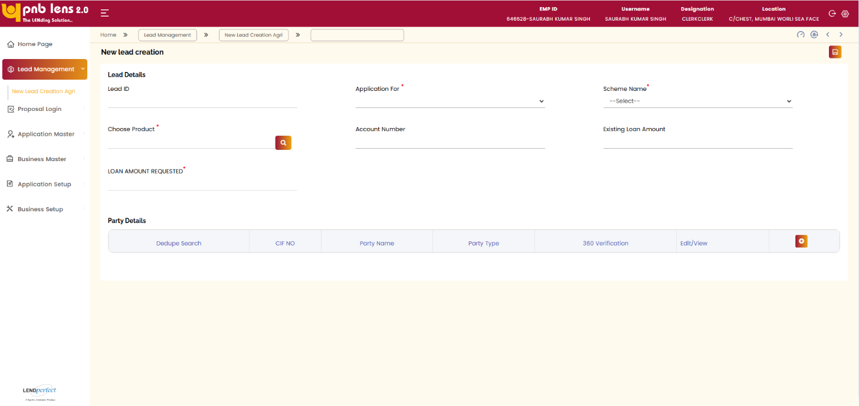
Application Type Selection
The system shall allow the user to select Application For.
The system shall restrict selection to:
- Fresh
Scheme Selection
- The system shall allow the user to select Scheme Name.
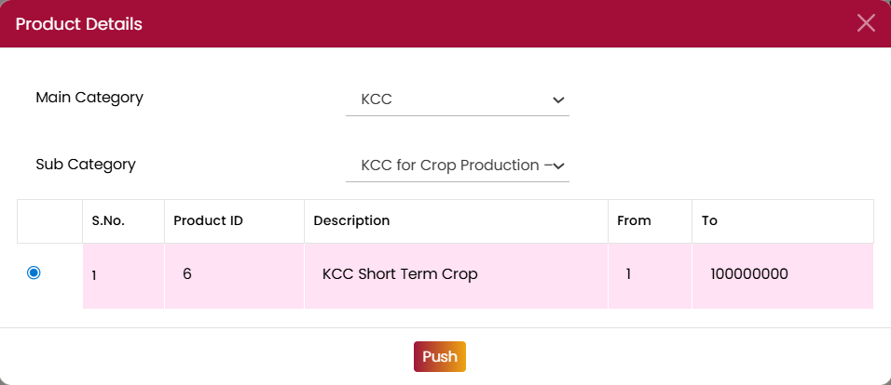
Product Selection
- The system shall allow the user to open the Choose Product search popup.
- The system shall:
  - Auto-display Main Category based on the Type of Loan
  - Allow selection of Sub Category from a dropdown
Applicant Addition
- The system shall enforce that:
  - At least one applicant must be added
- The system shall allow users to:
  - Click Add New Row to add applicant records in the Party Details grid
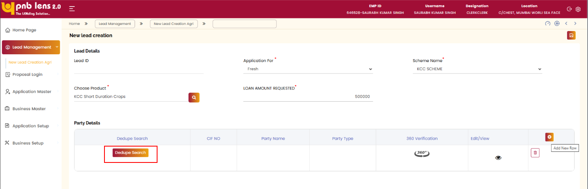
Click Dedupe Search and the dedupe pop up appears
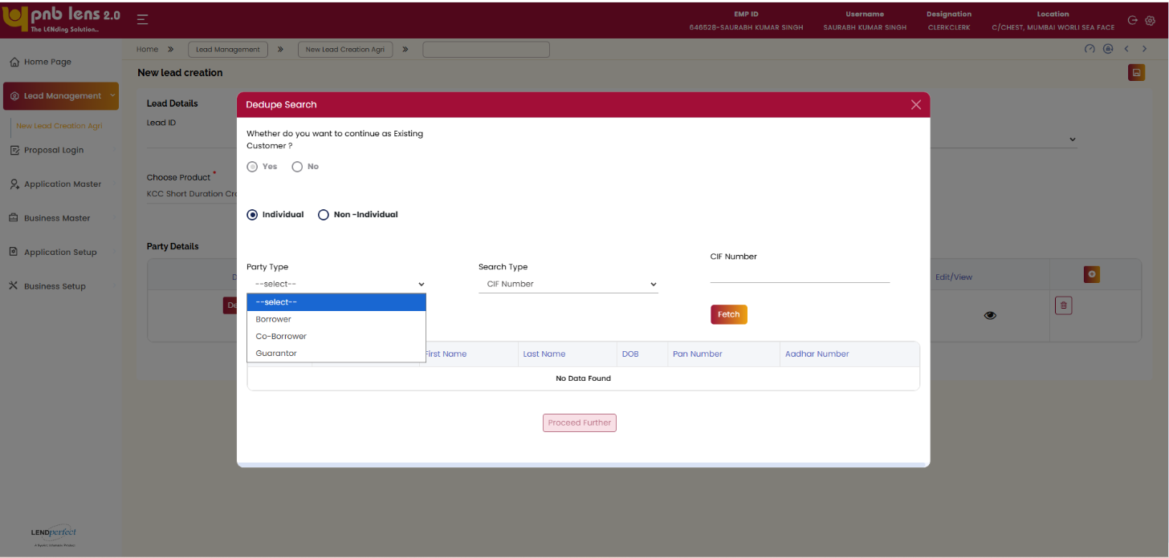
User has to select the party type and search type, then enter the CIF number. Click Fetch.

Dedupe
The user needs to manually select the key value for dedupe from the Dedupe Option dropdown. This dropdown will have the following list of values for the user selection.
- CIF Number
- Account Number
- PAN
- Aadhaar
Note:
- For ETB Customer - Key value to be selected is CIF ID, Account Number, PAN, or Aadhaar.
- For ETB Customer, in case of multiple CIF IDs, the CIF pulling can be performed basis PAN or Aadhaar to identify the Exact CIF ID.
Upon selecting a key value, a text box gets enabled beside the dropdown with nomenclature same as the selected key value. For instance, if the user selects CIF number as key value, the nomenclature of the text box will be displayed as CIF number. The user needs to type the corresponding value on the text box, and the click the Search icon beside the text box.
Based on the key value entered; the system performs CIF pulling to check for any matching record in CBS and the dedupe result will be shown in a popup window as per the scenarios addressed below.

Dedupe Result ETB customer
In case of ETB customer, based on the key value entered, the system pulls data (all the matching records) from CBS and displays on the popup window.
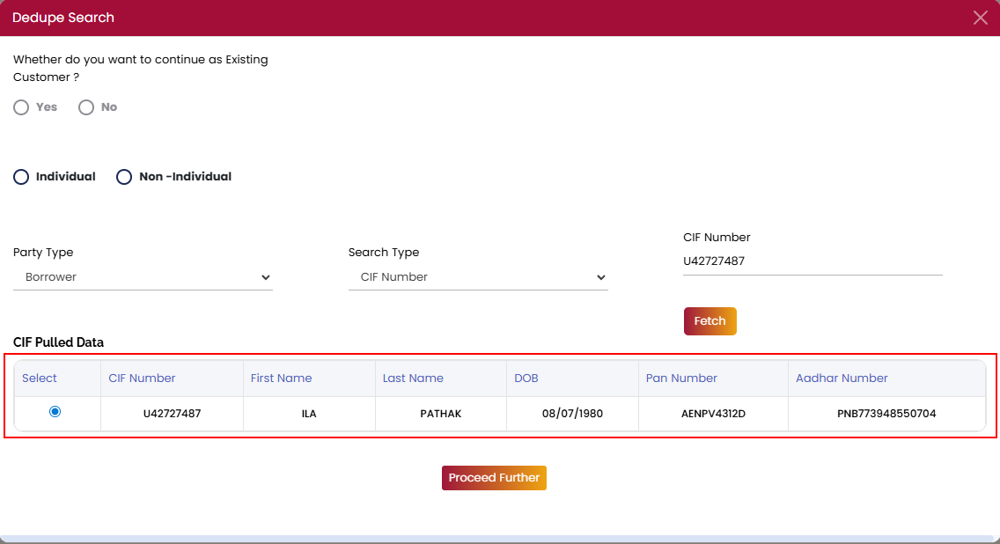
From the records, the user needs to select the exact record and click Proceed Further. Once the user clicks proceed further system will trigger the Deposit API, Liability API, Exposure fund and Non fund API. If any API encounters technical failure, system will restrict the additional of the customer. System will proceed to add the customer once all the above-mentioned API are successful.
Validations:
- On the API mentioned in the previous point are successful, system will validate the Go-No Go Parameters based on the CIF and Liability response applicable for the selected scheme. If any of the Go-Nogo check is failed, system will display a relevant alert and restrict the addition of the customer to Lead.

Party Details
Click in the Edit/View column on the Party Details grid, the party details pop up appears.
Party Details (Ind & Non-Ind) screen allows the user to create a customer profile (individual or non-individual profile) for all the participants such as (applicant, co-applicant, and guarantor) of the proposal.
Customer data from the CIF response will be auto populated in this screen as per the field listing table. Other fields to be manually entered by the user.
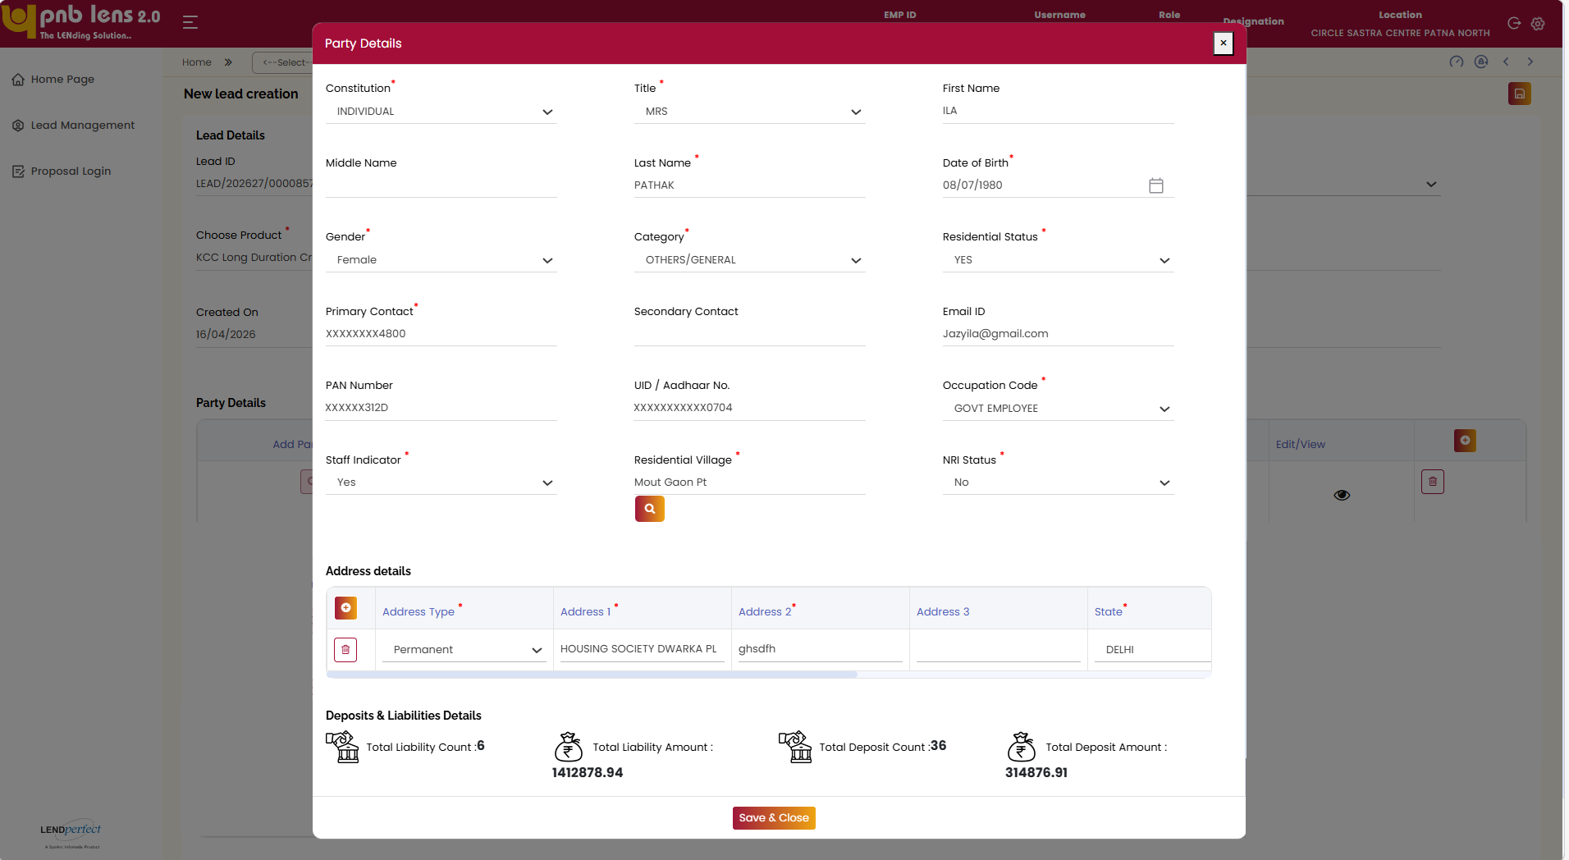
Similarly, Co-applicant and Guarantor Onboarding will also happen on this screen.
Enter all the mandatory details and click save& close. The lead ID will be generated.
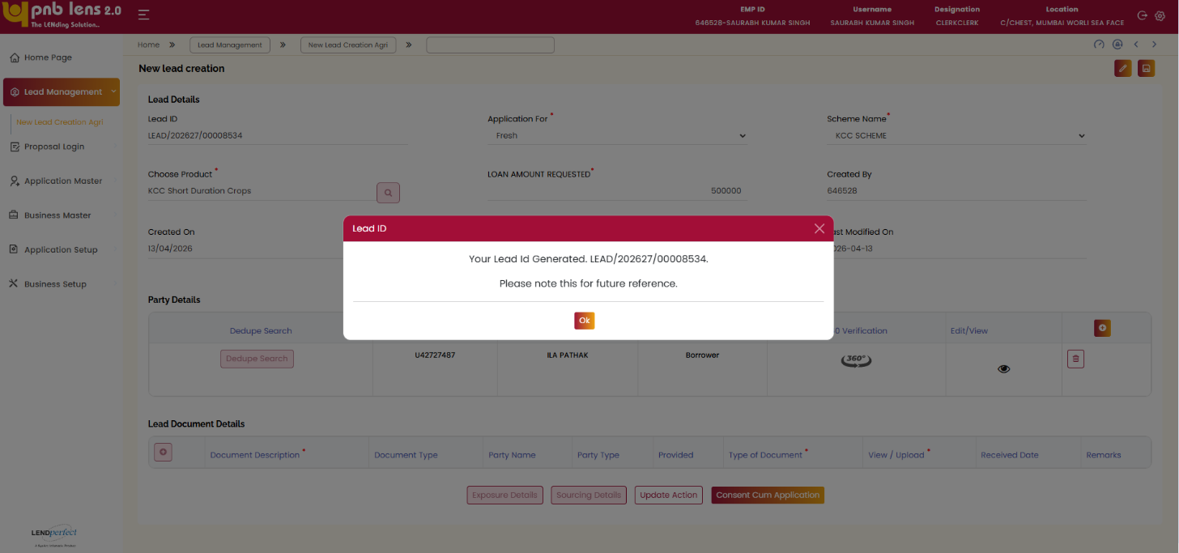
Once the lead ID is generated the Exposure details, Sourcing detail, update action and Create cum application button will be enabled.

You can view the response on the 360° popup window. In case of API failure scenarios, you must manually trigger the corresponding service on the 360° popup window.
PAN Verification:
If the customer is having PAN linked in the CBS, same will be auto populated in the party details pop up screen. If the PAN is auto populated, then PAN verification is Mandatory. Verify button will be enabled if the PAN is available entered or auto populated in the field. On clicking Verify button, system will trigger the PAN verification API. If the Verification is successful, Verify button will be disabled and verification status can be viewed in the 360 verifications. If in case of any API failure, system will display error message.
Aadhaar Verification:
Aadhar verification is mandatory. Verify button will be enabled beside UID/Aadhar No field. On clicking Verify button, system will trigger Aadhar Vault API to fetch the Aadhar number of the customer. Once the Aadhar Number is fetched, system will automatically trigger the Aadhar verification API. If the Verification is successful, verify button will be disabled and verification status can be viewed in the 360 verifications. If in case of any API failure, system will display error message.
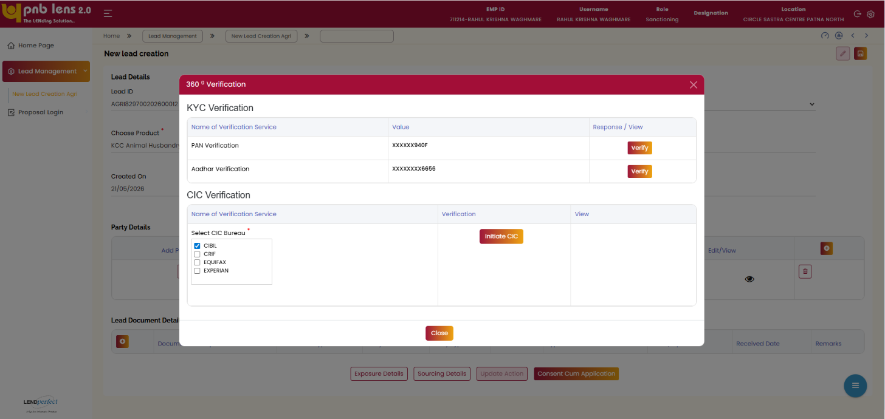
CIC Generation:
Under CIC Verification section, Multiple CIC will be provided with checkbox. User can select any of the Bureaus by selecting the checkboxes. Initiate CIC button will be enabled once the To generate CIC, Click Initiate CIC to verif the 360° Verification and click Close. Without saving the Initiate CIC will be restricted with error message.

Once you click Ok, the lead documents details and Exposure details, Sourcing details, update action and Consent cum application will be enabled.

Exposure Details
Screen Functionality
The Exposure Details screen allows the user to capture and update exposure-related information for the customer. The user must enter all mandatory details pertaining to exposure before proceeding further.
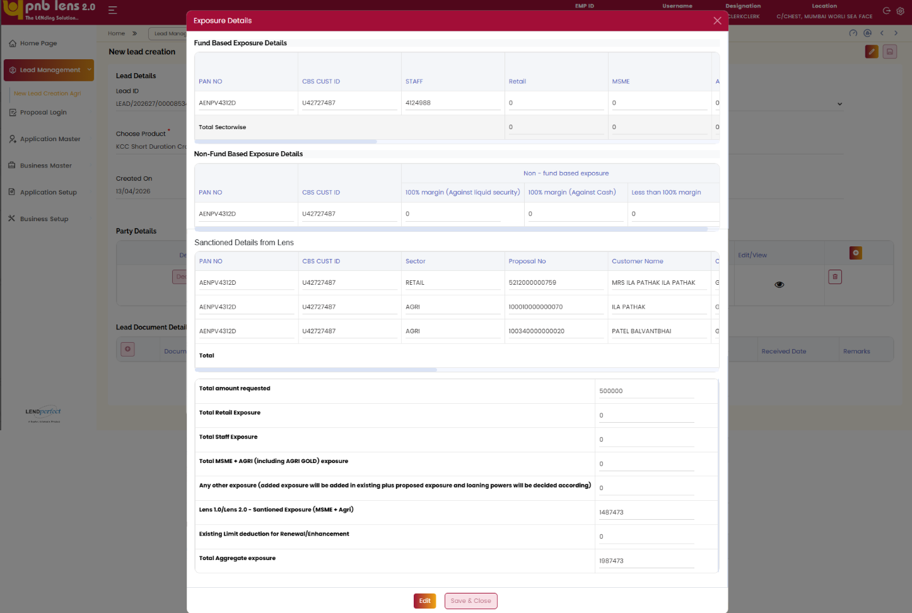The system allows the user to modify the entered details using the Edit option, if required. Once the details are completed, the user can confirm the information by clicking Save & Close
Based on the customer’s exposure details, the system conditionally enables the Send option along with the respective Sol or organization. If the exposure criteria are not met, the user can continue the process from the Sourcing Details section.
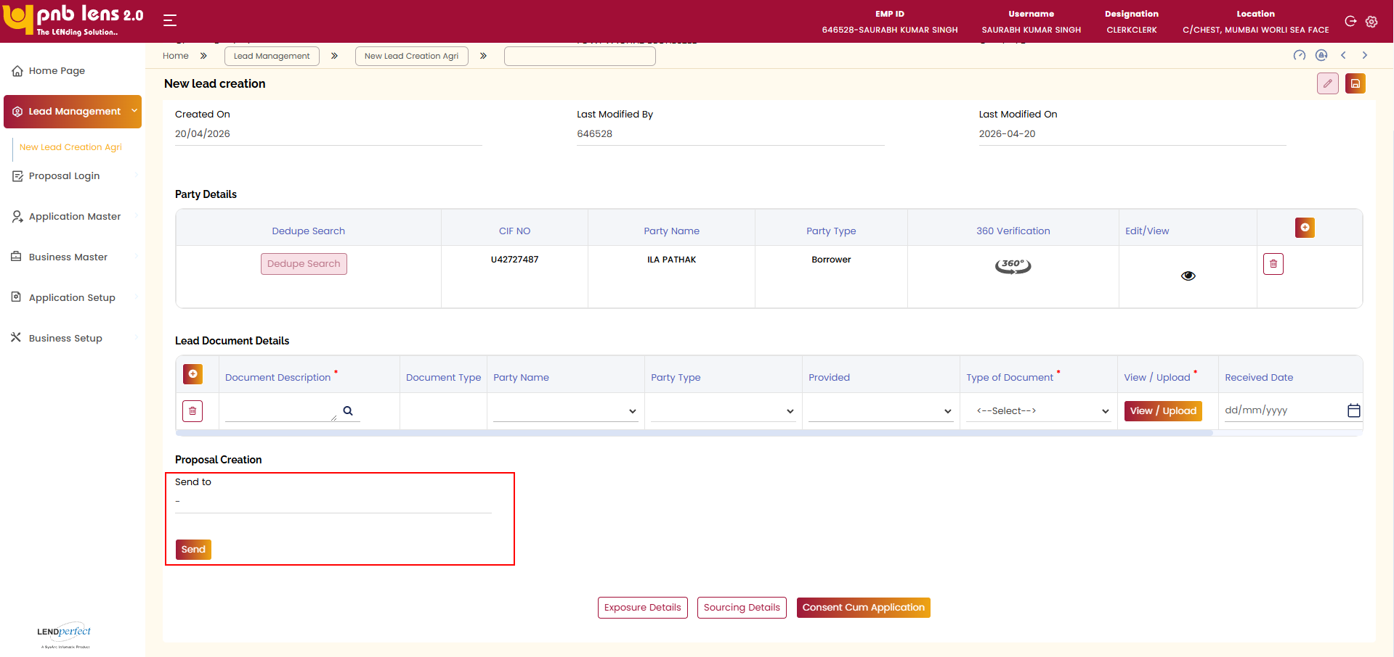
The system allows the user to send the application to the respective Sol or organization by clicking the Send button. The details captured in this screen are carried forward for further processing.

Sourcing Details
The Sourcing Details section in the New Lead Creation process allows the user to capture and verify sourcing-related information for the lead. The system displays the sourcing details upon accessing this section.
The system auto populates key sourcing fields based on the logged-in user. By default, the Sourcing ID and Sourcing Name reflect the details of the logged-in user. Similarly, the preferred branch and corresponding Sol ID are auto populated based on the user’s branch
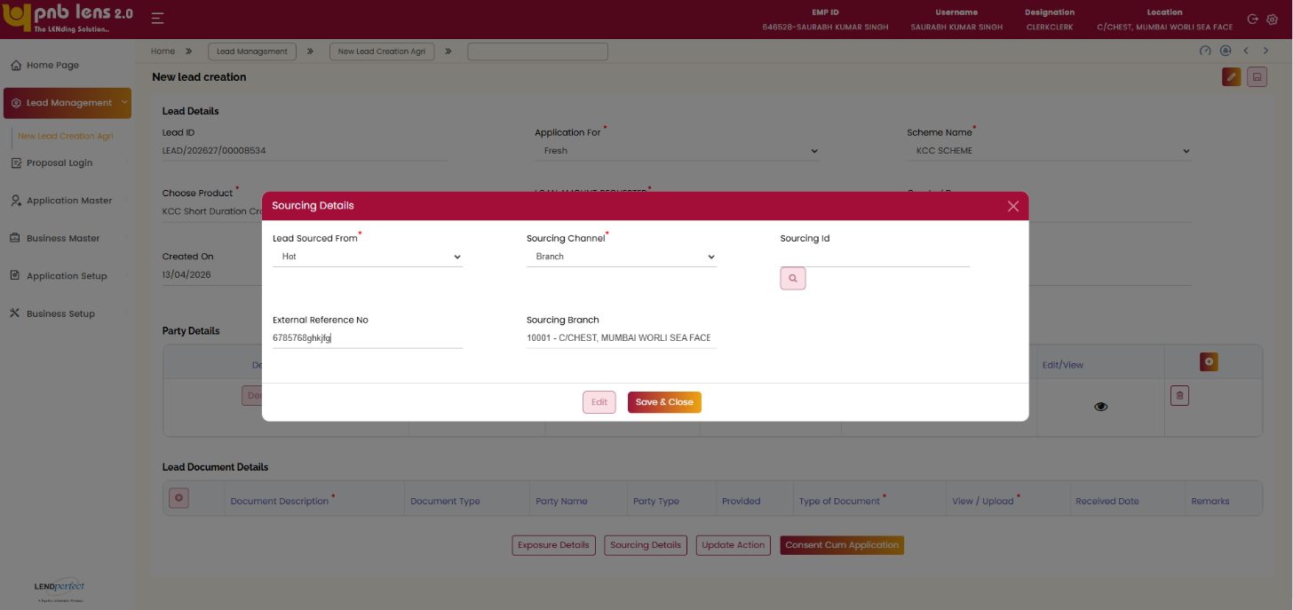
The system allows the user to verify and update sourcing information, including the Lead Sourced From and Sourcing Channel fields. The user can search and select the appropriate Sourcing ID using the search functionality, upon which the system updates the corresponding sourcing details.
The system displays the sourcing branch information, which the user can verify before proceeding. Once all required details are confirmed, the user can complete the sourcing details by clicking the Save & Close option.
The details captured in this section are used for lead tracking and further processing within the system.
Note:
- Once the lead is submitted, the lead will be forwarded to the Lead Group inbox of the branch selected in this search box once the lead is submitted. From where application creation can be initiated.
- Once transferred, the lead action will be updated on the Dashboard of the transferred branch.
Once the user completes entering all the mandatory details, the user needs to click the Save button to submit the lead. Now, the Update Action popup window appears as shown in the figure below.
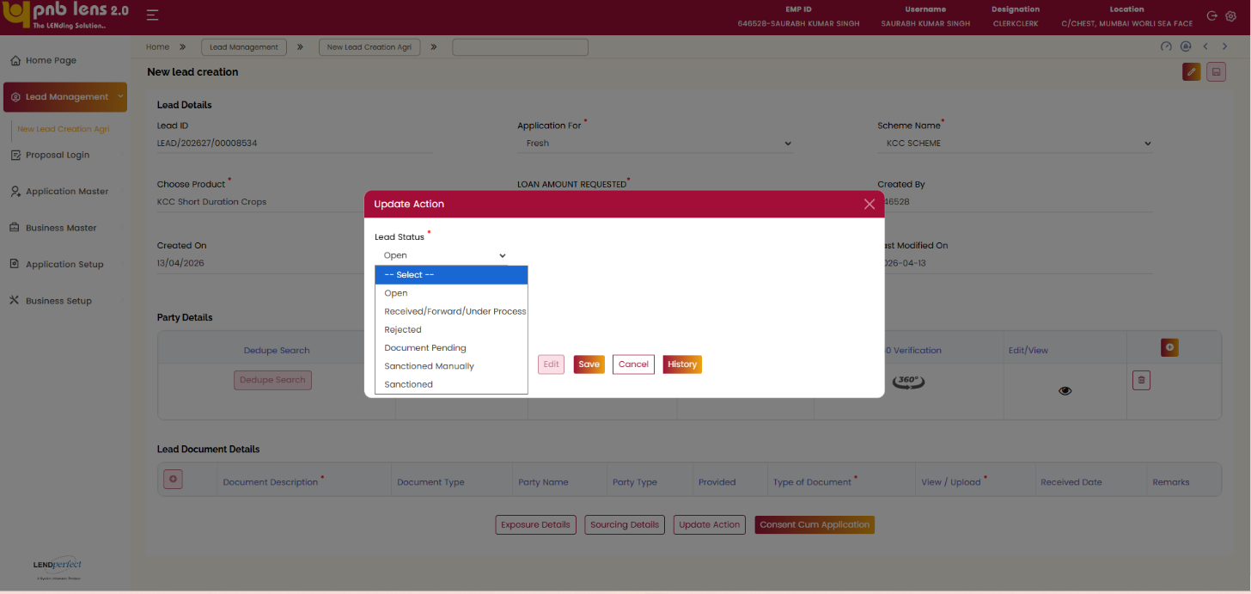
On the above popup window, the user needs to update the actions to be taken on the lead further. Here, the user needs to fill the date when customer visited the branch, the preferred mode of contacting the customer in the respective fields and update the status of the lead.
If you select Sanctioned Manually, the list of existing sanctioned details will appear. Select the required sanctioned details and click save. The create application button will be disabled and marked as sanctioned manually.
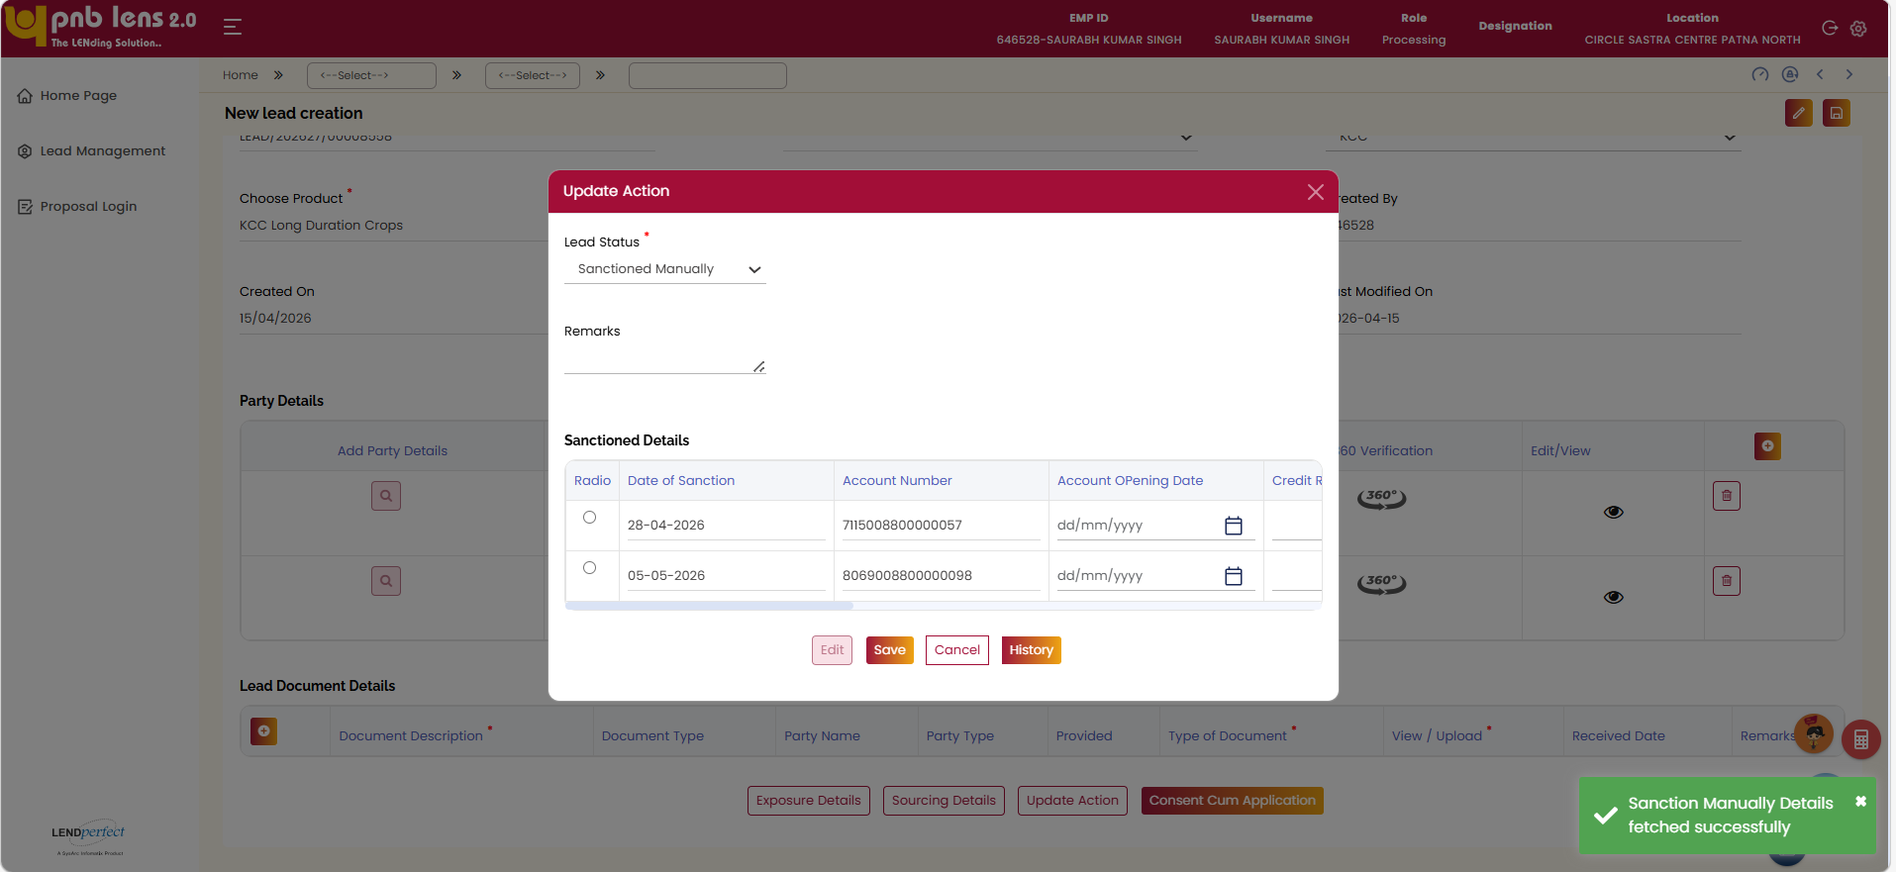
The following actions will be performed in the system based on the lead status marked in the Update Action popup window.
Lead Status | Action
Open | The cases for which lead status is marked as Open will remain in the lead stage itself. In future, these cases can be reinitiated.
Document Pending | Email will be triggered to customer for Document Pending cases by referring TAT from setup.
Converted or Received/Forward/Under Process | The Create Application button is enabled on the New Lead Creation screen. The user needs to click this button to initiate loan application creation for the lead.
Rejected | Remarks needs to be captured.
Sanctioned Manually | The create application button will be disabled and marked as Sanctioned Manually.
Remarks / Rejection Reason – This is a text area to capture the remarks for the action taken on the lead or the reason for rejecting the lead.
 | If you select the lead status as Rejected, the nomenclature of the field will change to Rejection Reason.
To view the history of update action, click History on the Update Action popup window.
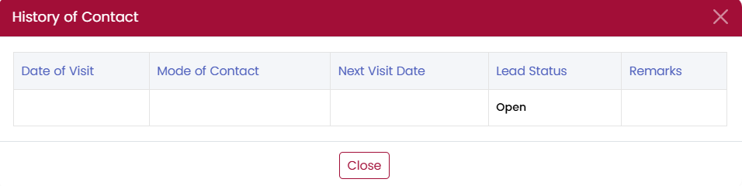
In the lead Document Details grid fill the mandatory details.
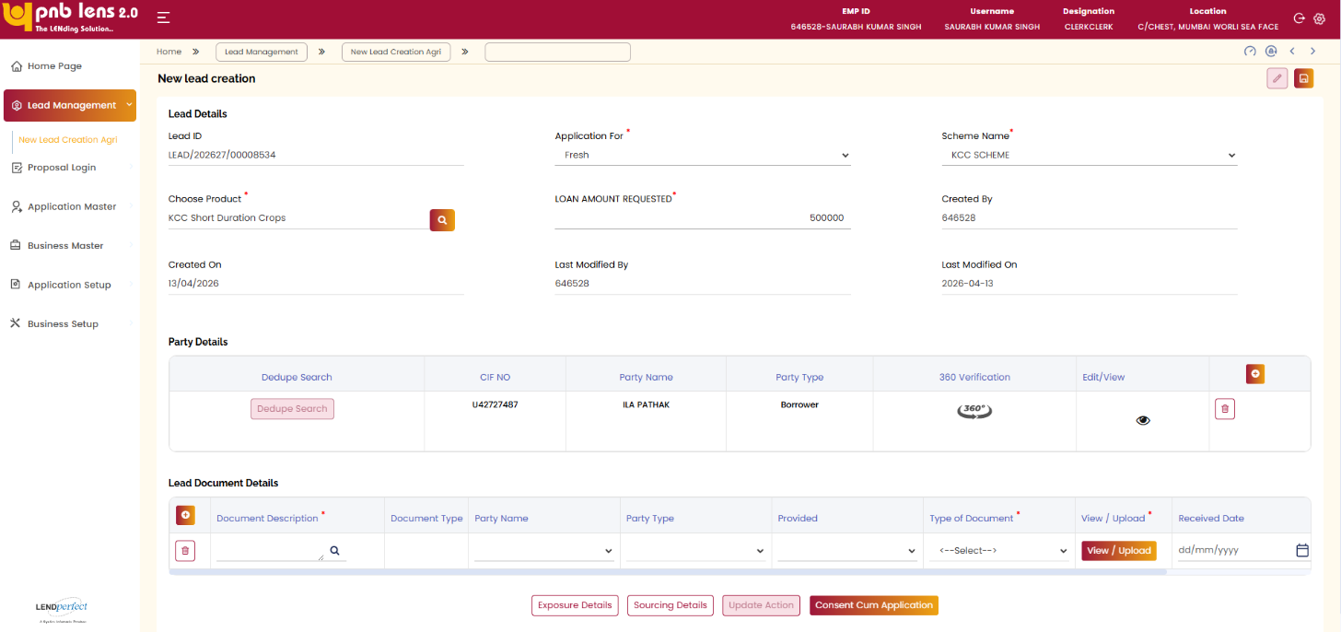
Click View / Upload against the required document in the Lead Document Details section.
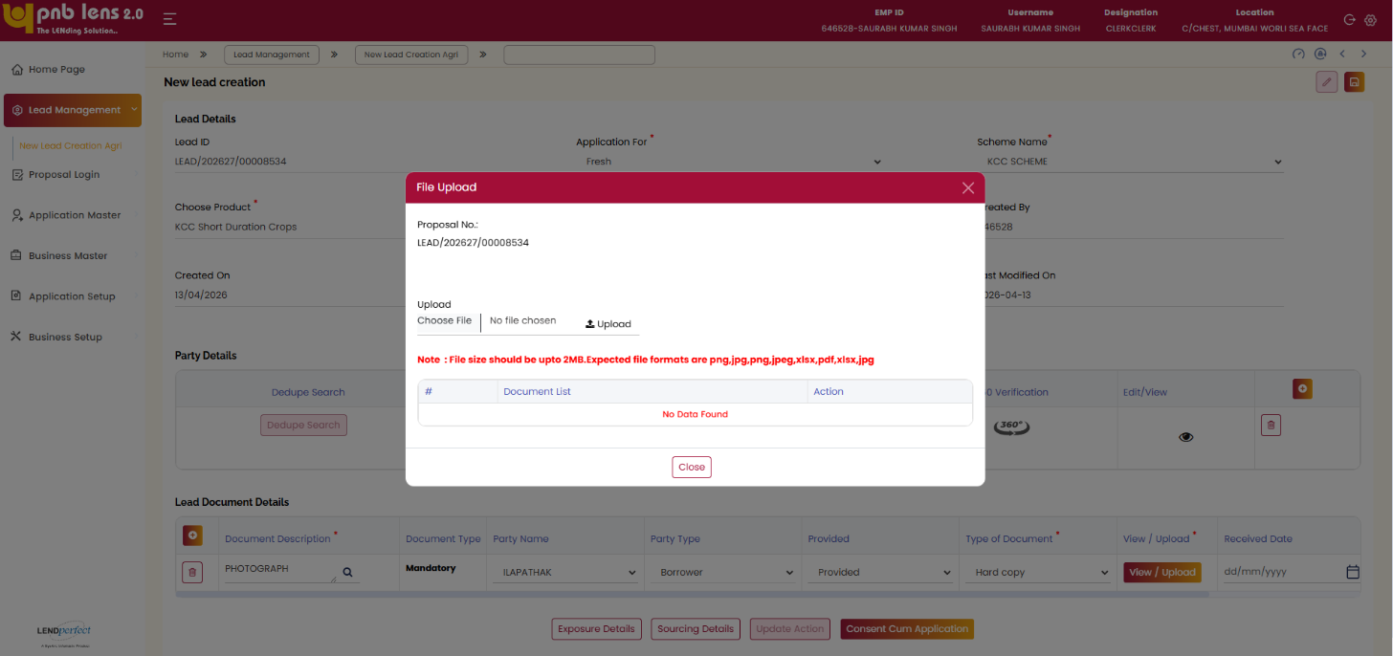
Click Close to return to the lead screen and continue processing. Once the action is updated, the Create Application button is enabled on the lead creation screen. Click the Create Application to proceed with Application Creation.
 | If you close the lead without initiating application creation, the lead will be moved to the group inbox of the preferred branch selected. Then, you have to self-assign the lead to proceed with application creation.  Before creating application, you can click Consent Cum Application to view and print the application.
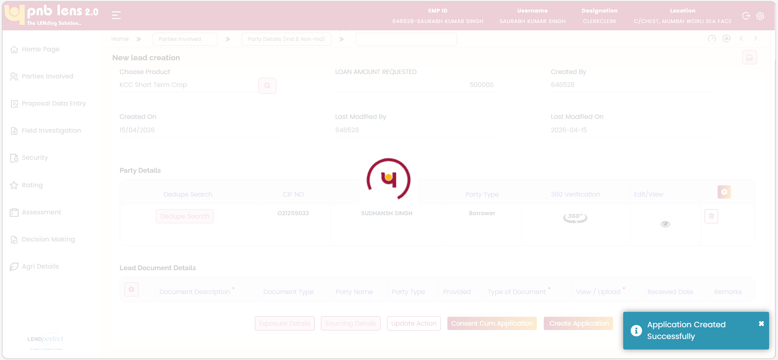
Partially filled Leads
The user can also partially fill the mandatory details and save the lead to generate Lead ID. The partially filled leads will be available in the Lead Inbox.
In case of partially filled leads, the user can revisit the lead from the Lead Inbox by clicking on the Lead ID. While revisiting, the screen will be in non-editable mode by default. Clicking the Edit button on the screen allows the user to edit/modify or continue filling the remaining details.
Clicking the Cancel button allows the user to exit the current action. The Cancel button is enabled only when the Save button is enabled and disabled when the Edit button is enabled.
Interface Touch Points
CBS

Field Level Validation

Lead Details (Individual)
S. No | Field Name | Field Type | Source | Validations/ Formulas | Mandatory Flag | DB Type
 | Lead ID | Text Box | Auto populate | System generated unique ID for the lead. Lead ID is generated only when the lead is saved. | Non-mandatory | VARCHAR
 | Application For | Dropdown | Manual Entry | - Fresh  - Renewal | Mandatory | VARCHAR
 | Scheme Name | Dropdown | Manual Entry | - KCC  - KSY | Mandatory | VARCHAR
 | Choose Product | Search Box | Product Details popup | Upon clicking the Search box, the Product Details popup window appears. Wherein the user needs to select the sub-category. The Loan Product gets auto populated on this field. | Mandatory | VARCHAR
 | Account Number | Text Box | Manual Entry | Numeric | Non-Mandatory | Number
 | Existing Loan Amount | Text Box | Manual Entry | Numeric | Mandatory | Number
 | Loan Amount Requested | Text Box | Manual Entry | The value entered will be validated against the min and max range of the product attached on the lead | Mandatory | Number
Product Details - Popup page starts
 | Main Category | Drop down | Auto Populate | LOV:  - KCC  - KSY | Mandatory | VARCHAR
 | Subcategory | Drop down | Manual | KCC LOV:  - KCC — Working Capital for Animal Husbandry  - KCC tor Crop Production — Long Duration  - KCC for Crop Production — Short Duration  - KCC — Working Capital for Fishery  KSY LOV:  - Kisan Samriddhi Yojana | Mandatory | VARCHAR
 | S. No | Column | Auto populated | Displays the serial number | NA | VARCHAR
 | Product ID | Column | Auto populated | Displays the unique ID of the product | NA | VARCHAR
 | Description | Column | Auto populated | Displays the selected product subcategory | NA | VARCHAR
 | From | Column | Auto populated | Displays the minimum loan amount for the selected product | NA | VARCHAR
 | To | Column | Auto populated | Displays the maximum loan amount for the selected product | NA | VARCHAR
Product Details - Popup page ends
 | Dedupe | Button | Manual | Allows the user to perform dedupe in the popup page | NA | NA
Dedupe - Popup page starts
 | Individual | Radio Button | Manual | Either Individual or Non individual radio button to be mandatorily selected | Mandatory | VARCHAR
 | Non - Individual | Radio Button | Manual | Either Individual or Non individual radio button to be mandatorily selected - | Mandatory | VARCHAR
If Individual is selected in Dedupe
Fields for Individual Starts
 | Party Type | Dropdown | Manual | Borrower  Co-Borrower  Guarantor | Mandatory | VARCHAR
 | Search Type | Dropdown | Manual | LOV  Account Number  CIF Number  Aadhar Number  Pan Number | Mandatory | VARCHAR
 | CIF Number | Text box | Manual Entry | Numeric | Mandatory | NUMBER
 | Fetch | Button | Manual | On Click it will communicate with CBS based on the Customer ID entered and give the result in the Grid below it is only for ETB | Conditional Mandatory | NA
 | CIF Number | Column Label | Auto Populate | Fetch from CBS | Mandatory | NUMBER
 | First Name | Column Label | Auto Populate | Fetch from CBS | Non- mandatory | VARCHAR
 | Last name | Text Box | Auto Populate | Fetch from CBS | Non-Mandatory | VARCHAR
 | DOB | Column Label | Auto Populate | DD/MM/YYYY | Mandatory | Date
 | PAN number | Text Box | Auto Populate | Non- mandatory field to dedupe search, If entered the value will be taken for dedupe search | Non- mandatory | VARCHAR
 | Aadhaar Number | Text Box | Auto Populate | Non- mandatory field to dedupe search, If entered the value will be taken for dedupe search | Non- mandatory | NUMBER
Fields for Individual ends
If Individual is selected in Dedupe
Fields for Non-Individual Starts
 | Party Type | Dropdown | Manual | Borrower  Co-Borrower  Guarantor | Mandatory | VARCHAR
 | Search Type | Dropdown | Manual | LOV  Account Number  CIF Number  Aadhar Number  Pan Number | Mandatory | VARCHAR
 | CIF Number | Text box | Manual Entry |  | Mandatory | NUMBER
 | Fetch | Button | Manual | On Click it will communicate with CBS based on the Customer ID entered and give the result in the Grid below it is only for ETB | Conditional Mandatory | NA
 | CIF Number | Column Label | Auto Populate | Fetch from CBS | Mandatory | NUMBER
 | First Name | Column Label | Auto Populate | Fetch from CBS | Non- mandatory | VARCHAR
 | Last name | Text Box | Auto Populate | Fetch from CBS | Non-Mandatory | VARCHAR
 | DOB | Column Label | Auto Populate | Fetch from CBS
 | PAN number | Text Box | Auto Populate | Non- mandatory field to dedupe search, If entered the value will be taken for dedupe search | Non- mandatory | VARCHAR
 | Aadhaar Number | Text Box | Auto Populate | Non- mandatory field to dedupe search, If entered the value will be taken for dedupe search | Non- mandatory | NUMBER
Fields for Non-individual ends
Fields for Party details Starts
 | Constitution | Dropdown | Auto populate | Auto populate based on individual and non-individual | Mandatory | VARCHAR
 | Title | Drop Down | Auto populate | LOVs | Mandatory | VARCHAR
 | First Name | Text Box | Auto Populate for ETB and manual for NTB | Auto populate from CBS for ETB and from lead for NTB Individual customer | Mandatory | Alphabetic
 | Middle Name | Text Box | Auto Populate for ETB and manual for NTB | Auto populate from CBS for ETB and from lead for NTB | Non-mandatory | Alphabetic
 | Last Name | Text Box | Auto Populate for ETB and manual for NTB | Auto populate from CBS for ETB and from lead for NTB | Mandatory | Alphabetic
 | Date of birth | Date picker | Auto Populate for ETB and manual for NTB | Auto populate from CBS for ETB and manual for NTB  dd-mm-yyyy format  Validation: DOB should be above 21 years and minors are not allowed. | Mandatory | Date
 | Gender | Dropdown | CBS/Manual | - Other  - Female  - Male  - Transgender | Non-Mandatory | VARCHAR
 | Category * | Dropdown | Manual | - General  - OBC  - SC  - ST  - Others  - Not Applicable | Mandatory | VARCHAR
 | Residential status | Drop down | Manual | 1) Resident Indian  2) NRI  3) PIO | Mandatory
 | Primary Contact * | Text Box | Manual | Numeric | Mandatory | NUMBER
 | Secondary Contact | Text Box | Manual | Numeric | Non-Mandatory | Numeric
 | Email ID | Text Box | Auto populate / Manual | Auto populate from CBS for ETB and manual for NTB (If not available from CBS should be manually enterable | Non – Mandatory | String
 | PAN no. | Text Box | Auto populate | Alphanumeric | Non – Mandatory | VARCHAR
 | UID / Aadhaar Ref No. | Text Box | Auto populate/ Manual | Numeric  Enabled only for ETB | Non-mandatory | NUMBER
 | Occupation Code | Dropdown | Manual | Central Govt  State Govt  Quasi Govt  State PSU  Central PSU  PSBs  Railways  Defence  Paramilitary  Captive Branch Location  Pvt Firms  MNC | Conditional Mandatory | Varchar
 | Staff indicator | Dropdown | Manual | - Yes  - No | Mandatory | VARCHAR
 | Residential Village | Search Box | Manual | LOV from Setup | Mandatory | VARCHAR
 | NRI Status | Dropdown | Manual | - Yes  - No | Mandatory | VARCHAR
- Residential Village popup
 | Residential State | Dropdown | Manual | List of state names need to be available | Mandatory | VARCHAR
 | Residential District | Dropdown | Manual | Based on the selected state list of the corresponding district needs to be available | Mandatory | VARCHAR
 | Residential Sub- District | Dropdown | Manual | Based on the district, relevant sub district names need to be available | Mandatory | VARCHAR
 | Residential Village | Dropdown | Manual | Based on the Sub- district, relevant village name needs to be available | Mandatory | VARCHAR
Address Fields
1 | Address Line 1 | Text Box | CBS / Manual | For ETB lead the same will be populated from CBS and for NTB the same to be manually entered | Mandatory | VARCHAR
2 | Address Line 2 | Text Box | CBS / Manual | For ETB lead the same will be populated from CBS and for NTB the same to be manually entered | Non-mandatory | VARCHAR
3 | Address Line 3 | Text Box | CBS / Manual | For ETB lead the same will be populated from CBS and for NTB the same to be manually entered | Non-mandatory | VARCHAR
4 | State | Dropdown | CBS / Manual | For ETB lead the same will be populated from CBS and for NTB the same to be manually Selected | Mandatory | VARCHAR
5 | City/ District | Dropdown | CBS / Manual | For ETB lead the same will be populated from CBS and for NTB the same to be manually Selected | Mandatory | VARCHAR
 | Town/ Village | Text Box | CBS / Manual |  | Non- mandatory | VARCHAR
6 | Pin code | Text Box | CBS / Manual | For ETB lead the same will be populated from CBS and for NTB the same to be manually entered | Mandatory | VARCHAR
Fields for Party Details Ends
Field for Exposure Details Starts
Fund-based Exposure Details
1. | PAN NO | Table header | Auto Populate |  | Non - Mandatory | Number
2. | CBS CUST ID | Table header | Auto Populate |  | Non - Mandatory | Number
3. | Staff | Table header | Auto Populate |  | Non - Mandatory | Number
4. | Retail | Table header | Auto Populate |  | Non - Mandatory | Number
5. | MSME | Table header | Auto Populate |  | Non - Mandatory | Number
6. | Agri (including Agri Gold) | Table header | Auto Populate |  | Non - Mandatory | Number
7. | Advance deposit (FB / NFB) (Over and above) | Table header | Auto Populate |  | Non - Mandatory | Number
7.1 | Retail | Table header | Auto Populate |  | Non - Mandatory | Number
7.2 | (MSME + Agri) | Table header | Auto Populate |  | Non - Mandatory | Number
8. | Advance against LIC policies / PLS | Table header | Auto Populate |  | Non - Mandatory | Number
9. | Advance to Individuals against shares/debentures of approved companies,  bonds of public sector undertakings & units of approved mutual funds, including specified units of IJTI | Table header | Auto Populate |  | Non - Mandatory | Number
10.1 | Retail | Table header | Auto Populate |  | Non - Mandatory | Number
10.2 | Gold | Table header | Auto Populate |  | Non - Mandatory | Number
11. | Total exposure of customer ID of all sectors | Table header | Auto Populate |  | Non - Mandatory | Number
12. | Total Sector wise | Table header | Auto Populate |  | Non - Mandatory | Number
Non Fund-based Exposure Details
1. | PAN no | Table header | Auto Populate |  | Non - Mandatory | Number
2. | CBS Cust ID | Table header | Auto Populate |  | Non - Mandatory | Number
3. | Non - fund based exposure | Table header | Auto Populate |  | Non - Mandatory | Number
3.1 | 100% margin (Against liquid security) | Table header | Auto Populate |  | Non - Mandatory | Number
3.2 | 100% margin (Against Cash) | Table header | Auto Populate |  | Non - Mandatory | Number
3.3 | Less than 100% margin | Table header | Auto Populate |  | Non - Mandatory | Number
Sanctioned Details from LENS grid starts
 | Pan no | Table header | Auto Populate |  | Non - Mandatory | Number
 | CBS Cust ID | Table header | Auto Populate |  | Non - Mandatory | Number
 | Sector | Table header | Auto Populate |  | Non - Mandatory | Number
 | Proposal no | Table header | Auto Populate |  | Non - Mandatory | Number
 | Customer name | Table header | Auto Populate |  | Non - Mandatory | Number
 | Customer Type | Table header | Auto Populate |  | Non - Mandatory | Number
 | Product | Table header | Auto Populate |  | Non - Mandatory | Number
 | Sanction Date | Table header | Auto Populate |  | Non - Mandatory | Number
 | Sanction Amount | Table header | Auto Populate |  | Non - Mandatory | Number
 | Status | Table header | Auto Populate |  | Non - Mandatory | Number
 | Application | Table header | Auto Populate |  | Non - Mandatory | Number
 | Total | Table header | Auto Populate |  | Non - Mandatory | Number
Sanctioned Details from LENS grids ends
 | Total amount requested | Text Box | Auto Populate |  | Non - Mandatory | Number
 | Total Retail Exposure | Text Box | Auto Populate |  | Non - Mandatory | Number
 | Total Staff Exposure | Text Box | Auto Populate |  | Non - Mandatory | Number
 | Total MSME + AGRI (including AGRI GOLD) exposure | Text Box | Auto Populate |  | Non - Mandatory | Number
 | Any other exposure (added exposure will be added in existing plus proposed exposure and loaning powers will be decided according) | Text Box | Auto Populate |  | Non - Mandatory | Number
 | Lens 1.0/Lens 2.0 - Santioned Exposure (MSME + Agri) | Text Box | Auto Populate |  | Non - Mandatory | Number
 | Existing Limit deduction for Renewal/Enhancement | Text Box | Auto Populate |  | Non - Mandatory | Number
 | Total Aggregate exposure | Text Box | Auto Populate |  | Non - Mandatory | Number
Fields for Exposure Details ends
Fields for Sourcing Details starts
 | Lead Sourced from | Dropdown | Manual | Lov  - Manual creation  - CRM | Mandatory | VARCHAR
 | Sourcing Channel | Dropdown | Manual | Lov  - Staff  - CRM | Mandatory | VARCHAR
 | Sourcing ID | Search box | Manual | Numeric | Non- mandatory | Number
 | External Reference No | Text box | Manual | Alphanumeric | Non- mandatory | Alphanumeric
 | Sourcing branch | Text box | Auto populated from lead | Alphanumeric | Non- mandatory | Alphanumeric

Buttons and Update Action Popup
Front End fields (UI Interface)
S.No | Field Name | Field Type | Source | Validations / Formulas | Mandatory Flag | DB Type
Buttons
1 | Save | Button | NA | Allows the user to Save the lead. By default, this button will be displayed on the screen. | NA | NA
2 | Update Action | Button | NA | Opens the Update Action popup window. Wherein the user can update the lead status. The button is displayed on the screen once the lead is saved | NA | NA
3 | Consent Form | Button | NA | Allows the user to generate the consent form. This button is displayed on the screen once the lead is saved. | NA | NA
4 | Application Form | Button | NA | Allows the user to generate the application form. This button is displayed on the screen once the lead is saved. | NA | NA
5 | Create Application | Button | NA | Navigates the user to application creation screen. | NA | NA
Update Action – Popup
1 | Date of Visit | Date Picker | Manual | dd-mm-yyyy format  Should not allow future dates for selection | Non-mandatory | DATE
2 | Mode of Contact | Dropdown | Manual | LOVs:  - By Call  - By Mail  - Personal Visit | Non-mandatory | VARCHAR
3 | Next Visit Date | Date Picker | Manual | dd-mm-yyyy format  Should not allow previous dates for selection | Non-mandatory | DATE
4 | Lead Status | Dropdown | Manual | LOVs:  - Open  - Document Pending  - Converted  - Rejected | Mandatory | VARCHAR
5 | Meeting Remarks/ Rejection Reason | Text Area | Manual | String.  If lead status is rejected, this field name displays as Rejection Reason.  For remaining lead statuses, this field name displays as Meeting Remarks. | Mandatory | VARCHAR
6 | Edit | Button | NA | Allows modifying the details on the active screen. | NA | NA
7 | Save | Button | NA | Allows saving the details on the active screen. | NA | NA
8 | Cancel | Button | NA | Allows cancelling the current operation. | NA | NA
9 | History | Button | NA | Allows viewing the audit log on a popup window. | NA | NA
E. Update Action History – Popup
1 | Date of Visit | Column Heading | Auto populate | Displays the date of visit updated by the user | NA | NA
2 | Mode of Contact | Column Heading | Auto populate | Displays the mode of contact updated by the user | NA | NA
3 | Next Visit Date | Column Heading | Auto populate | Displays the next visit date updated by the user | NA | NA
4 | Lead Status | Column Heading | Auto populate | Displays the lead status updated by the user | NA | NA
5 | Close | Button | NA | Allows closing the popup window. | NA | NA
Back End fields
NA
Field Level notes, alerts, and static content for validation
NA

Parties Involved

Party Details
Screen Functionality
The Parties Involved screen allows the user to view and manage details of all applicants associated with the application. Upon accessing the Parties Details / Ind & Non-Ind section, the system displays the customer and application details, including information captured during the New Lead Creation process.
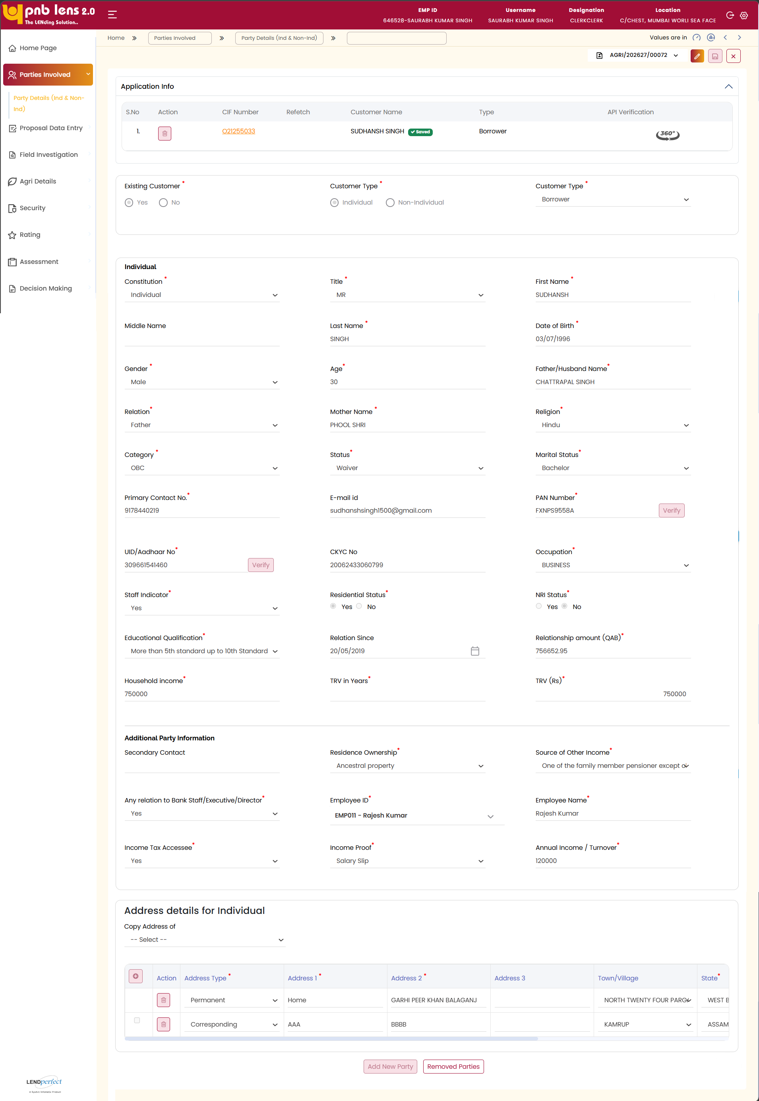
The system auto populates the previously captured applicant details. The system indicates the completion status by displaying a Saved message when all mandatory fields are completed, or a Pending message when mandatory information is missing. The user must update any missing mandatory details to proceed.
The system allows the user to verify key information, including customer details, application details, customer type, and assigned role. The user can update any required information that is not auto populated.
The system enables the user to perform verification actions such as PAN and Aadhaar validation. The user can also review and update residential and address details as required.
Address Details
Address Details auto populate from lead. However, provision will be given to manually enter the address details.
Once the system auto populates the address details in each row on the address table, the user needs to manually select the address type as Present/Permanent/Communication from the Address Type dropdown.
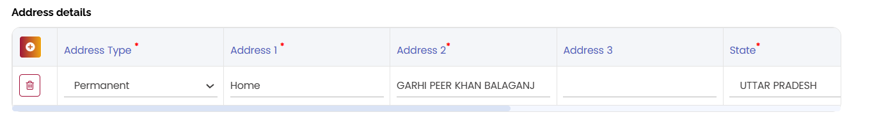

Co-applicant & Guarantor Onboarding
The user needs to click the Add New Party button to onboard the co-applicant and guarantor. Upon clicking this button, the dedupe popup window appears as shown in the figure below.
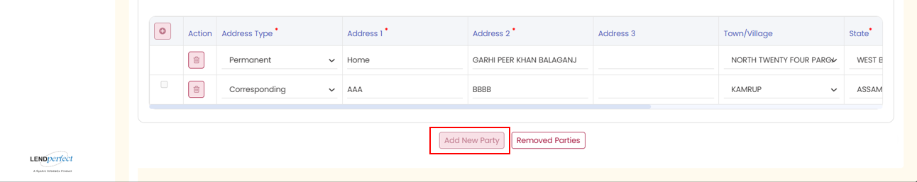
On the above window, the user needs to select the dedupe parameter from the Dedupe Option dropdown, and then click the Search button. Based on the dedupe result, the type of the applicant is decided as either ETB customer or NTB customer. And, according to the customer profile creation process continues as explained for the main borrower.
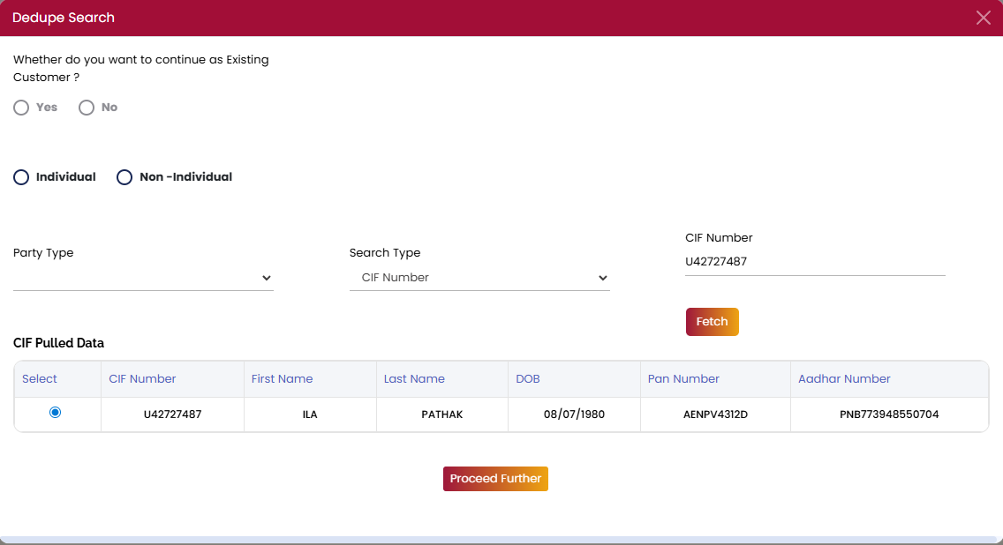
On the above popup window, enter the CIF number if the user is an ETB customer or Aadhaar Number if the user is a NTB customer, whichever is applicable.
Click the Dedupe Search button. Accordingly, the customer profile creation process continues as explained for the main applicant.

360 ° Verification
The 360° Verification popup window displays the list of APIs triggered for the current proposal for all the parties involved in the proposal, such as applicant, co-applicant, and guarantor. This screen is the repository for all the API responses.
Besides, in case of any API failure, the Verify button will be enabled against the respective service. You can visit the 360° Verification popup window to manually retrigger the service.
To view the API responses on the 360° verification popup window,
On the customer profile table, click  against the party for whom you need to view the API response/re-trigger API. The 360° Verification popup window appears listing all the API services. The input values for applicable services will be populated from the Party Details screen.
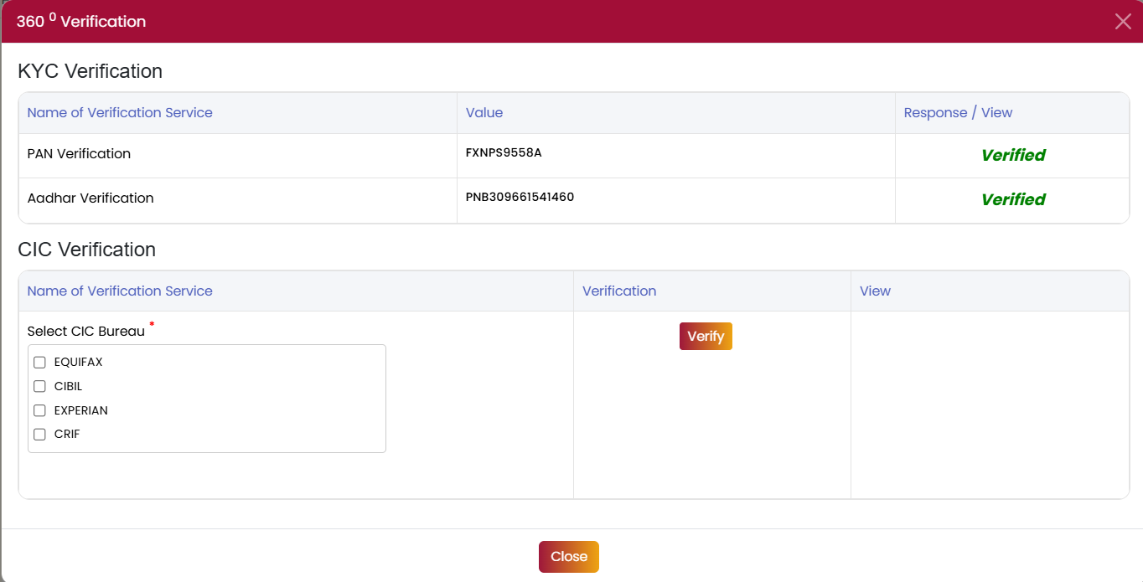
Once users verify the PAN and Aadhar verification, User needs to click verify Button, if data available within the 90-day period, users will see the message “Bureau verified successfully” and View report, Override button will be enabled. Click View report to view the Corresponding Report and use Override option to fetch new credit report from Bureau. Else, the system call the CIC API.
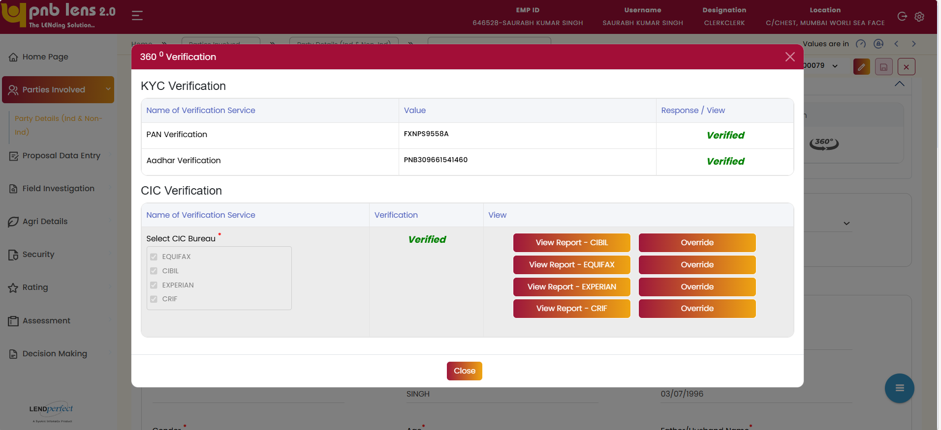
Upon success verification,
Click Close in the popup window and then Click Save in the parties involved screen to save the changes.

Field Level Validation
S. No | Field Name | Field Type | Source | Validations/ Formulas | Mandatory Flag | DB Type
1 | Existing Customer | Radio Button | Manual | Yes  No | Mandatory | VARCHAR
2 | Customer Type (Selection) | Radio Button | Manual | Individual  Non-Individual  Based on the constitution, the field structure dynamically changes. | Mandatory | VARCHAR
3 | Customer Type | Dropdown | Manual | Borrower  Co-Borrower  Guarantor | Mandatory | VARCHAR
4 | Constitution | Dropdown | Manual | Individual  Non-Individual  Based on the constitution, the field structure dynamically changes. | Mandatory | VARCHAR
5 | Title | Dropdown | Manual | MISS  MRS  MR  M/S  MX  MESSERS  DR  COLONEL  LT. COL  MAJOR  MASTER (MINOR)  MOHAMMAD  MIGRATION DEFAULT  SIR  SHEIKH | Mandatory | VARCHAR
6 | First Name | Text Box | Manual | Alphabetic | Mandatory | VARCHAR
7 | Middle Name | Text Box | Manual | Alphabetic | Non- mandatory | VARCHAR
8 | Last Name | Text Box | Manual | Alphabetic | Mandatory | VARCHAR
9 | Date of Birth | Date Picker | Manual | dd-mm-yyyy format | Mandatory | DATE
10 | Gender | Dropdown | Manual | - Other  - Female  - Male  - Transgender | Mandatory | VARCHAR
11 | Age | Text Box | Auto calculated | Numeric | NA | Number
12 | Father/Husband Name | Text Box | Manual | Alphabetic | Mandatory | VARCHAR
13 | Relation | Dropdown | Manual | Alphabetic | Mandatory | VARCHAR
14 | Mother Name | Text Box | Manual | Alphabetic | Mandatory | VARCHAR
15 | Religion | Dropdown | Manual | Alphabetic | Mandatory | VARCHAR
16 | Category | Dropdown | Manual | - General  - OBC  - SC  - ST  - Others  - Not Applicable | Mandatory | VARCHAR
17 | Status | Dropdown | Manual | Alphabetic | Mandatory | VARCHAR
18 | Marital Status | Dropdown | Manual | - Bachelor  - Married  - Divorced  - Widow  - Single | Mandatory | VARCHAR
19 | Primary Contact No | Text Box | Manual | Numeric | Mandatory | NUMBER
20 | Email ID | Text Box | Manual | String | Non- mandatory | VARCHAR
21 | PAN Number | Text Box | Manual | Alphanumeric | Mandatory | VARCHAR
22 | UID/Aadhaar No | Text Box | Manual | Numeric | Mandatory | NUMBER
23 | CKYC No | Text Box | Auto | Alphanumeric | Non- mandatory | NUMBER
24 | Occupation | Dropdown | Manual | 1. If self-employed - no validation  2. If Salaried - Organisation Type dropdown gets dynanically enabled. | Mandatory | VARCHAR
25 | Staff Indicator | Dropdown | Manual | - Yes  - No | Mandatory | VARCHAR
26 | Residential Status | Radio Button | Manual | - Yes  - No | Mandatory | VARCHAR
27 | NRI Status | Radio Button | Manual | - Yes  - No | Mandatory | VARCHAR
28 | Educational Qualification | Dropdown | Manual | - Upto 5th standard  - More than 5th standard up to 10th Standard  - More than 10th standard but below graduate level  - Graduate and above | Mandatory | VARCHAR
29 | Relation Since | Date Picker | Manual | DD/MM/YYYY | Non- mandatory | DATE
30 | Relationship Amount (QAB) | Text Box | Auto | Numeric | Non- mandatory | NUMBER
31 | Household Income | Text Box | Manual | Numeric | Mandatory | NUMBER
32 | TRV in Years | Text Box | Auto | Numeric | Non- mandatory | NUMBER
33 | TRV (Rs) | Text Box | Auto | Numeric | Non- mandatory | NUMBER
34 | Secondary Contact | Text Box | Manual | Numeric | Non- mandatory | NUMBER
35 | Residence Ownership | Dropdown | Manual | - House in self-name (owned)  - House in Spouse name  - House in Parents name  - Ancestral property  - Rented | Mandatory | VARCHAR
36 | Source of Other Income | Dropdown | Manual | - Applicant has no other Source of Income  - Income from other activity or (for which documentary proof is available)  - Pensioner applicant except drawing pension under old age pension scheme  - One of the family member salaried  - Salaried applicant with Govt/PSU/Local Govt/Reputed organizations etc.  - One of the family member pensioner except old age pension | Mandatory | VARCHAR
37 | Relation to Bank Staff/Executive/Director | Dropdown | Manual | - Yes  - No | Mandatory | VARCHAR
40 | Income Tax Assessee | Dropdown | Manual | - Yes  - No | Mandatory | VARCHAR
41 | Income Proof | Dropdown | Manual | - Salary Slip  - Bank Statement  - Income Tax Return (ITR)  - Form 16  - Audited Financial Statements  - Other | Mandatory | VARCHAR
42 | Annual Income / Turnover | Text Box | Manual | Numeric | Mandatory | NUMBER
43 | Copy Address Of | Dropdown | Manual | Alphabetic | Non- mandatory | VARCHAR
44 | Address Type | Dropdown | Manual | - Permanent  - Corresponding  - Other | Mandatory | VARCHAR
45 | Address 1 | Text Box | Manual | String | Mandatory | VARCHAR
46 | Address 2 | Text Box | Manual | String | Non- mandatory | VARCHAR
47 | Address 3 | Text Box | Manual | String | Non- mandatory | VARCHAR
48 | Town/Village | Dropdown | Manual | LOV from setup | Mandatory | VARCHAR
49 | State | Dropdown | Manual | LOV from setup | Mandatory | VARCHAR

Proposal Data Entry
The Proposal Data Entry captures the new proposal, existing loans with the bank, and borrowings from other bank details. Capture the owned land details, cropping details, income details, etc., The following are the screens below Proposal Data Entry tab
- Facility Details
- Net worth
- Personal info
- Document Details
- Due Diligence

Facility Details
Screen Functionality
The Facility Details screen allows the user to capture the details of the facility details. Multiple facility provision is not applicable for KCC.
The facility details captured in the lead stage auto populates from the lead. The user needs to manually fill the remaining details. The facility details captured here will be carried to other levels
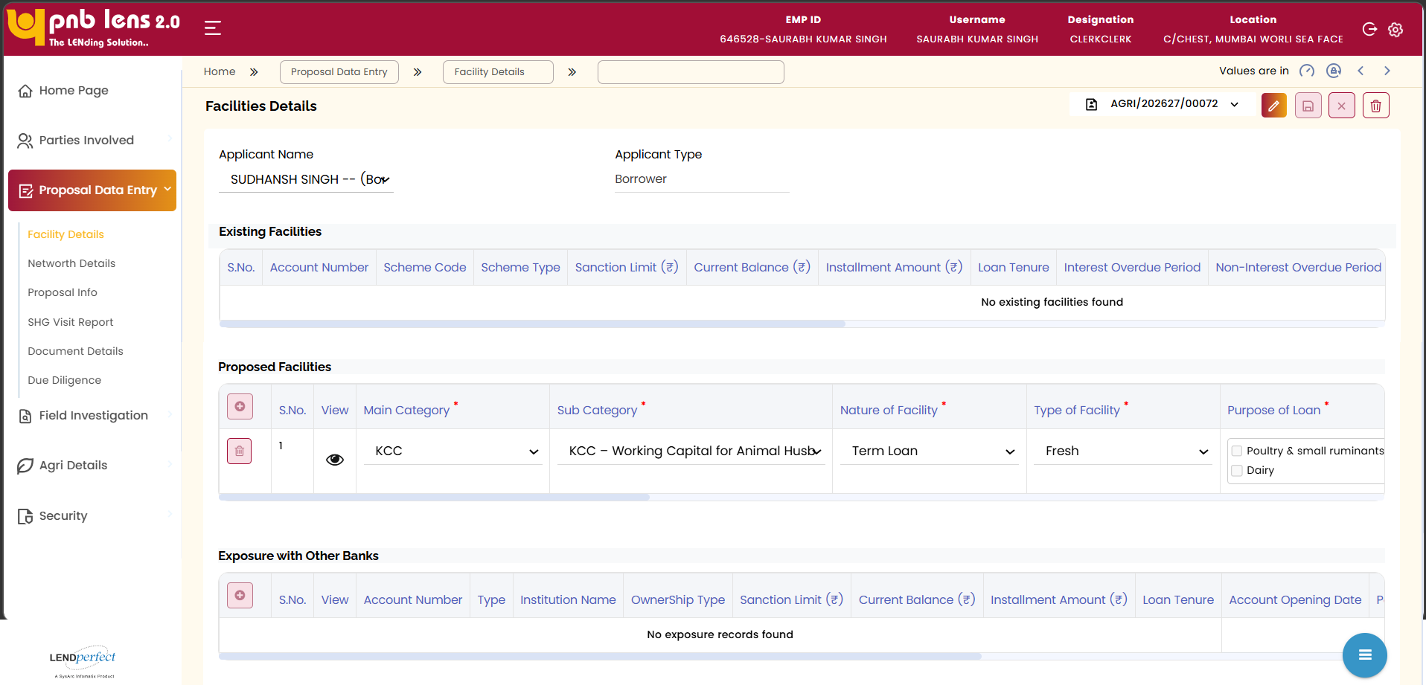
Note:
            - Multiple facility provision is not applicable for KCC.
In the Proposed Facilities section, review the auto populated or selected facility information.
Click icon to view the proposed facility information in detail.
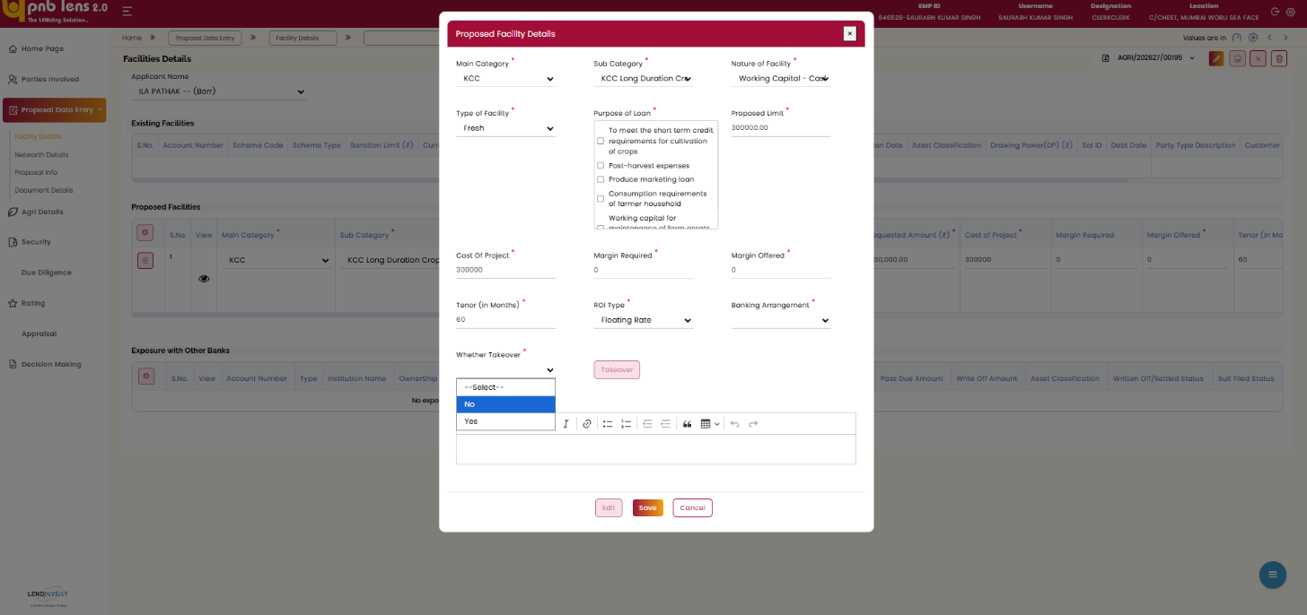
If user select whether Takeover as Yes, the Takeover window popups.
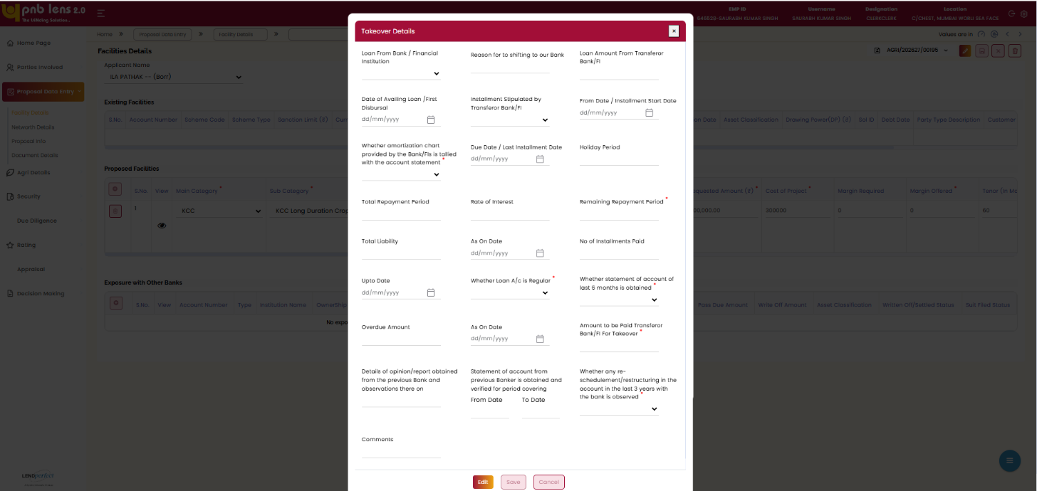
Ensure all mandatory facility details are completed and validated. Click Save button to save the details. Once saved, the details will be displayed on the table.
Interface Touch Points
No interface touch point for the screen.

Field Level Validation
S. No | Field Name | Field Type | Source | Validations/ Formulas | Mandatory Flag | DB Type
 | Applicant Name | Display Field | Auto | Numeric | Non- mandatory | VARCHAR
 | Applicant Type | Display Field | Auto | Numeric | Non- mandatory | VARCHAR
Existing Facilities
 | Account Number | Column Heading | NA | NA | NA | NA
 | Scheme Code | Column Heading | NA | NA | NA | NA
 | Scheme Type | Column Heading | NA | NA | NA | NA
 | Sanction Limit (₹) | Column Heading | NA | NA | NA | NA
 | Current Balance (₹) | Column Heading | NA | NA | NA | NA
 | Installment Amount (₹) | Column Heading | NA | NA | NA | NA
 | Loan Tenure | Column Heading | NA | NA | NA | NA
 | Interest Overdue Period | Column Heading | NA | NA | NA | NA
 | Non-Interest Overdue Period | Column Heading | NA | NA | NA | NA
 | Sanction Date | Column Heading | NA | NA | NA | NA
 | Asset Classification | Column Heading | NA | NA | NA | NA
 | Drawing power (DP) | Column Heading | NA | NA | NA | NA
 | Sol ID | Column Heading | NA | NA | NA | NA
 | Debt Date | Column Heading | NA | NA | NA | NA
 | Party Type Description | Column Heading | NA | NA | NA | NA
 | Customer ID | Column Heading | NA | NA | NA | NA
 | Party Name | Column Heading | NA | NA | NA | NA
 | Relationship Code Description | Column Heading | NA | NA | NA | NA
Proposed Facilities
 | S.No | Auto Number | Auto | Displays the serial number | Non- mandatory | NUMBER
 | View | Icon/Button | Auto | NA | Non- mandatory | VARCHAR
 | Main Category | Dropdown | Manual | KCC | Mandatory | VARCHAR
 | Sub Category | Dropdown | Manual | - KCC for Crop Production — Long Duration  - KCC for Crop Production — Short Duration  - KCC — Working Capital for Animal Husbandry  - KCC — Working Capital for Fishery | Mandatory | VARCHAR
 | Nature of Facility | Dropdown | Manual | - Term Loan  - Additional Term Loan  - Demand Draft  - Working Capital -  - Over Draft  - Working Capital - Cash Credit  - Working Capital -  - Bank Guarantee  - Working Capital - Letter of Credit  - Working Capital -  - Term Loan  - Working Capital  - Letter of Guarantee  - Working Capital - Packing Credit  - Working Capital  - Letter of Comfort  - Forward Contract  - Bill Finance  - Pre-Shipment  - Foreign Currency Loan | Mandatory | VARCHAR
 | Type of Facility | Dropdown | Manual | Fresh | Mandatory | VARCHAR
 | Purpose of Loan | Checkbox Group | Manual | LOV - List of Agri products  Based on the product selected, the field structure and validation changes whereever applicable. | Mandatory | VARCHAR
 | Requested Amount | Textbox | Manual | Numeric | Mandatory | NUMBER
 | Cost of the Project | Textbox | Manual | Numeric | Mandatory | NUMBER
 | Margin Required | Textbox | Manual | Numeric | Mandatory | NUMBER
 | Margin Offered | Textbox | Manual | Numeric | Mandatory | NUMBER
 | Tenor (In Months) | Textbox | Manual | Numeric | Mandatory | NUMBER
 | No of Instalments (TL) | Textbox | Manual | Numeric | Mandatory | NUMBER
 | Tenor Frequency (TL) | Textbox | Manual | Numeric | Mandatory | NUMBER
 | Moratorium (In Months) | Textbox | Manual | Numeric | Mandatory | NUMBER
 | ROI Type | Dropdown | Manual | - Fixed Rate  - Floating Rate | Mandatory | VARCHAR
 | Banking Arrangements | Dropdown | Manual | - sole  - Consortium  - Multiple Banking | Mandatory | VARCHAR
 | Whether Takeover | Textbox | Manual | Yes  No | Mandatory | NUMBER
 | Takeover | Button / Action | Manual | NA | Mandatory | VARCHAR
Exposure with Other Banks
 | S.No | Auto Number | Auto | Displays the serial number | Non- mandatory | NUMBER
 | View | Icon/Button | Manual | NA | Non- mandatory | VARCHAR
 | Account number | Textbox | Manual | Alphanumeric | Non- mandatory | Alphanumeric
 | Type | Textbox | Manual | Numeric | Non- mandatory | VARCHAR
 | Institution Name | Textbox | Manual | Alphanumeric | Non- mandatory | Alphanumeric
 | Ownership Type | Textbox | Manual | Numeric | Non- mandatory | VARCHAR
 | Sanction Limit (Exposure) | Textbox | Manual | Numeric | Non- mandatory | NUMBER
 | Current Balance (Exposure) | Textbox | Manual | Numeric | Non- mandatory | NUMBER
 | Installment Amount (Exposure) | Textbox | Manual | Numeric | Non- mandatory | NUMBER
 | Loan Tenure (Exposure) | Textbox | Manual | Numeric | Non- mandatory | NUMBER
 | Account Opening Date | Date Picker | Manual | Numeric | Non- mandatory | DATE
 | Pass Due Amount | Textbox | Manual | Numeric | Non- mandatory | NUMBER
 | Write off Amount | Textbox | Manual | Numeric | Non- mandatory | NUMBER
 | Asset Classifications | Textbox | Manual | Numeric | Non- mandatory | VARCHAR
 | Written off/ Settled Status | Textbox | Manual | Numeric | Non- mandatory | VARCHAR
 | Suit Filed Status | Textbox | Manual | Numeric | Non- mandatory | VARCHAR
Fields for Proposed Asset Details starts
1 | Main Category * | Dropdown | Manual | - KCC-UGC  - DIRECT AGRICULTURE  - KCC for Crop Production — Long Duration  - KCC for Crop Production — Short Duration  - KCC — Working Capital for Animal Husbandry  - KCC — Working Capital for Fishery  - Kisan Samriddhi Yojana  - KCC  - KSY  - TL NRLM | Mandatory | VARCHAR
2 | Sub Category * | Dropdown | Manual | - KCC-UGC  - DIRECT AGRICULTURE  - KCC for Crop Production — Long Duration  - KCC for Crop Production — Short Duration  - KCC — Working Capital for Animal Husbandry  - KCC — Working Capital for Fishery  - Kisan Samriddhi Yojana  - KCC  - KSY | Mandatory | VARCHAR
3 | Nature of Facility * | Dropdown | Manual | - Term Loan  - Additional Term Loan  - Demand Draft  - Working Capital - Over Draft  - Working Capital -  - Cash Credit  - Working Capital - Bank Guarantee  - Working Capital - Letter of Credit  - Working Capital  - Term Loan  - Working Capital -  - Letter of Guarantee  - Working Capital - Packing Credit  - Working Capital -  - Letter of Comfort  - Forward Contract  - Bill Finance  - Pre-Shipment  - Foreign Currency Loan | Mandatory | VARCHAR
4 | Type of Facility * | Dropdown | Manual | - Fresh  - Renew | Mandatory | VARCHAR
5 | Purpose of Loan * | Multi-select Dropdown / Checkbox | Manual | Checkbox As per selected product | Mandatory | VARCHAR
6 | Proposed Limit * | Text Box | Manual | Number | Mandatory | Decimal
7 | Cost of Project * | Text Box | Manual | Number | Mandatory | NUMBER
8 | Margin Required * | Text Box | Manual | Number | Mandatory | NUMBER
9 | Margin Offered * | Text Box | Manual | Number | Mandatory | NUMBER
10 | Tenor (in Months) * | Text Box | Manual | Number | Mandatory | NUMBER
11 | ROI Type * | Dropdown | Manual | - Fixed Rate  - Floating Rate | Mandatory | VARCHAR
12 | Banking Arrangement * | Dropdown | Manual | - Sole  - Consortium  - Multiple Banking | Mandatory | VARCHAR
13 | Whether Takeover * | Dropdown | Manual | - Yes  - No | Mandatory | VARCHAR
14 | Takeover | Button / Action | Manual | NA | Mandatory | VARCHAR
15 | Remarks | Rich Text Editor | Manual | Alphanumeric | Mandatory | VARCHAR
Fields for Takeover details starts
1 | Loan From Bank / Financial Institution | Dropdown | Manual | Alphabetic | Non- mandatory | VARCHAR
2 | Reason for shifting to our Bank | Text Box | Manual | Alphabetic | Non- mandatory | VARCHAR
3 | Loan Amount from Transferor Bank/NBFC | Text Box | Manual | Numeric | Non- mandatory | NUMBER
4 | Date of Availing Loan / First Disbursal | Date Picker | Manual | DD/MM/YYYY | Non- mandatory | DATE
5 | Installment Stipulated by Bank/NBFC | Dropdown | Manual | Monthly  Quarterly | Non- mandatory | NUMBER
6 | From Date / Installment Start Date | Date Picker | Manual | DD/MM/YYYY | Non- mandatory | DATE
7 | Whether amortization chart provided by the Bank/NBFC is tallied with account statement | Dropdown | Manual | - Yes  - No | Mandatory | VARCHAR
8 | Due Date / Last Installment Date | Date Picker | Manual | DD/MM/YYYY | Non- mandatory | DATE
9 | Holiday Period | Text Box | Manual | Number | Non- mandatory | NUMBER
10 | Total Repayment Period | Text Box | Manual | Number | Non- mandatory | NUMBER
11 | Rate of Interest | Text Box | Manual | Number | Non- mandatory | NUMBER
12 | Remaining Repayment Period | Text Box | Auto | Number | Non- mandatory | NUMBER
13 | Total Liability | Text Box | Manual | Alphabetic | Non- mandatory | NUMBER
14 | As on Date (Liability) | Date Picker | Manual | DD/MM/YYYY | Non- mandatory | DATE
15 | No of Installments Paid | Text Box | Manual | Number | Non- mandatory | NUMBER
16 | Upto Date | Date Picker | Manual | DD/MM/YYYY | Non- mandatory | DATE
17 | Whether Loan A/c is Regular | Dropdown | Manual | - Yes  - No | Mandatory | VARCHAR
18 | Whether statement of account of last 6 months is obtained | Dropdown | Manual | - Yes  - No | Mandatory | VARCHAR
19 | Overdue Amount | Text Box | Manual | Numeric | Non- mandatory | NUMBER
20 | As on Date (Overdue) | Date Picker | Manual | DD/MM/YYYY | Non- mandatory | DATE
21 | Amount to be Paid to Transferor Bank/FI for Takeover | Text Box | Manual | Number | Mandatory | NUMBER
22 | Details of opinion/report obtained from the previous Bank observations | Text Area | Manual | Alphabetic | Non- mandatory | VARCHAR
23 | Statement of account from previous Bank verified for period covering (From–To) | Date Range | Manual | From Date - DD/MM/YYYY | Non- mandatory | DATE
23 | Statement of account from previous Bank verified for period covering (From–To) | Date Range | Manual | To Date –  DD/MM/YYYY | Non- mandatory | DATE
24 | Whether any restructuring in the account in last 2 years with Bank is observed | Dropdown | Manual | - Yes  - No | Mandatory | VARCHAR
25 | Comments | Text Area | Manual | Alphanumeric | Non- mandatory | VARCHAR
26 | Edit | Button | Manual | NA | Non- mandatory | VARCHAR
27 | Save | Button | Manual | NA | Non- mandatory | VARCHAR
28 | Cancel | Button | Manual | NA | Non- mandatory | VARCHAR

Net worth
Screen Functionality
The Net worth screen allows the user to view the net worth of the applicant(s).
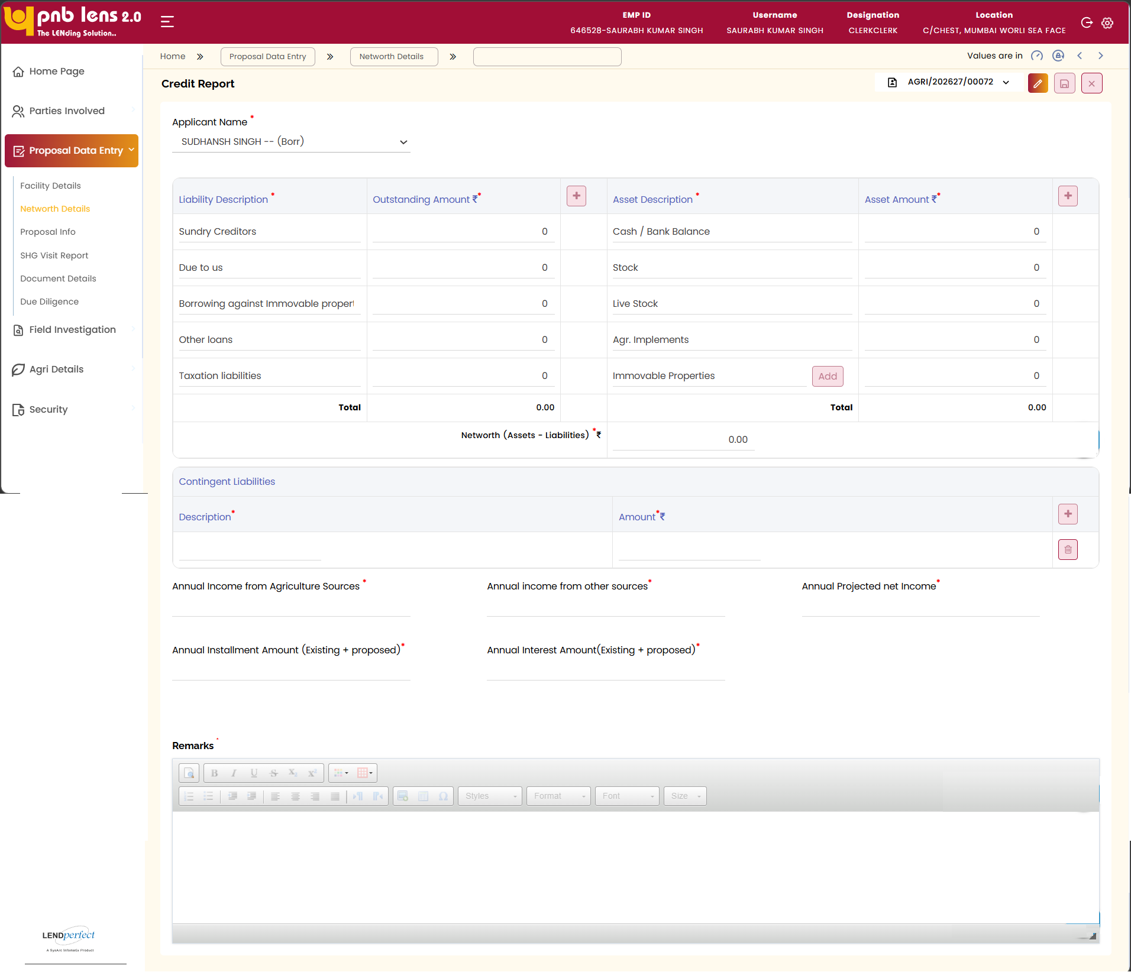
The net worth is calculated as follows
Total Assets – Total Liabilities = Net Worth
Based on the existing liabilities, the asset details, and the deposit details, the system auto-calculates the net worth and displays on this screen. The net worth is calculated separately for the applicant, co-applicant, and guarantor. The user shall select the intended applicant from the Applicant Type drop-down to view the associated net worth.
Interface Touch Points
Interfaces with CBS to pull deposit and liability.

Field Level Validation
S. No | Field Name | Field Type | Source | Validations/ Formulas | Mandatory Flag | DB Type
1 | Applicant Name | Dropdown/Display | Auto | Alphabetic | Mandatory | VARCHAR
2 | Sundry Creditors | Display Field | Auto | Numeric | Non- mandatory | NUMBER
3 | Due to us | Display Field | Auto | Numeric | Non- mandatory | NUMBER
4 | Borrowing against Immovable Property | Display Field | Auto | Numeric | Non- mandatory | NUMBER
5 | Other Loans | Display Field | Auto | Numeric | Non- mandatory | NUMBER
6 | Taxation Liabilities | Display Field | Auto | Numeric | Non- mandatory | NUMBER
7 | Outstanding Amount | Text Box/Grid | Manual | Numeric | Mandatory | NUMBER
8 | Total Liabilities | Calculated Field | Auto | Sum of  Outstanding amount | Non- mandatory | NUMBER
9 | Cash/Bank Balance | Display Field | Auto | Numeric | Non- mandatory | NUMBER
10 | Stock | Display Field | Auto | Numeric | Non- mandatory | NUMBER
11 | Live Stock | Display Field | Auto | Numeric | Non- mandatory | NUMBER
12 | Agricultural Implements | Display Field | Auto | Numeric | Non- mandatory | NUMBER
13 | Immovable Properties | Grid/Add | Manual | Numeric | Mandatory | NUMBER
14 | Asset Amount | Text Box/Grid | Manual | Numeric | Mandatory | NUMBER
15 | Total Assets | Calculated Field | Auto | Networth (Assets - Liabilities) | Non- mandatory | NUMBER
17 | Contingent Liabilities Description | Text Box/Grid | Manual | Alphabetic | Mandatory | VARCHAR
18 | Contingent Liabilities Amount | Text Box/Grid | Manual | Numeric | Mandatory | NUMBER
19 | Annual Income from Agriculture | Text Box | Manual | Numeric | Mandatory | NUMBER
20 | Annual Income from Other Sources | Text Box | Manual | Numeric | Mandatory | NUMBER
21 | Annual Projected Net Income | Text Box | Manual | Numeric | Mandatory | NUMBER
22 | Annual Installment Amount | Text Box | Manual | Numeric | Mandatory | NUMBER
23 | Annual Interest Amount | Text Box | Manual | Numeric | Mandatory | NUMBER
24 | Remarks | Rich Text Editor | Manual | Alphanumeric | Mandatory | VARCHAR

Proposal Info
Indicate whether the proposal is linked to a Government-sponsored scheme or not. Confirm the Debit Card requirement for the applicant. In the proposal summary area, enter a concise description covering the nature of the proposal. Once all the details are entered, click Save to confirm.
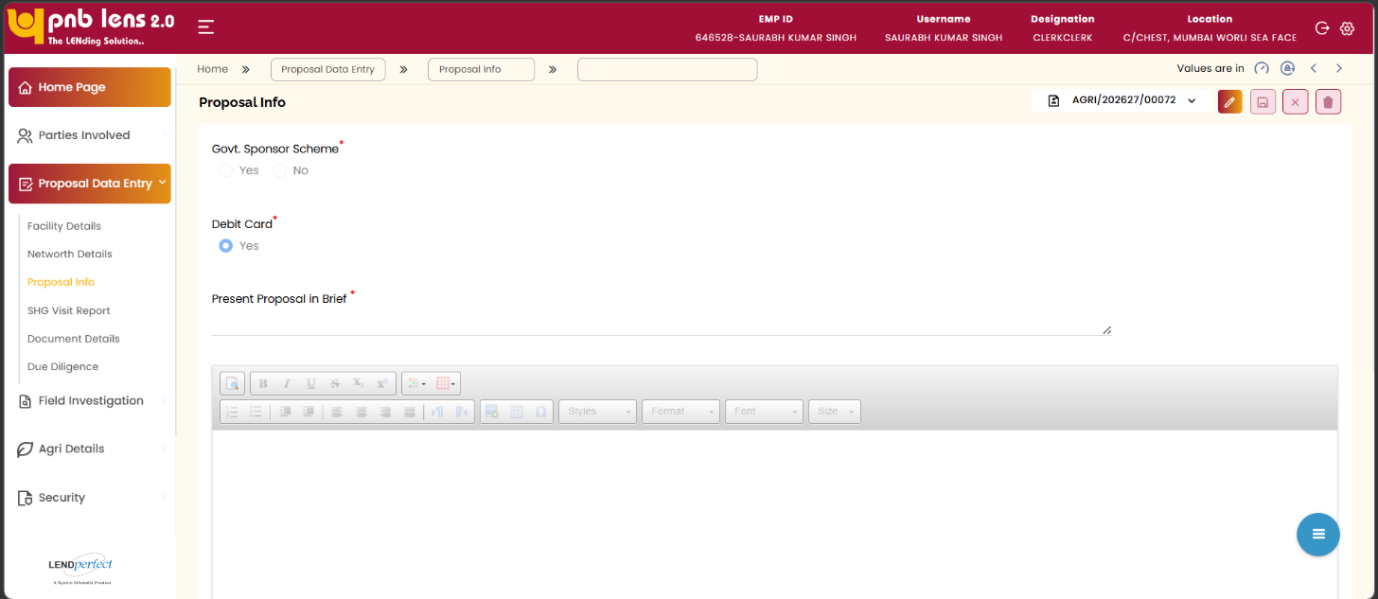

Field level Validation
S. No | Field Name | Field Type | Source | Validations/ Formulas | Mandatory Flag | DB Type
1 | Govt. Sponsor Scheme | Radio Button | Manual | Yes  No | Mandatory | VARCHAR
2 | Debit Card | Radio Button | Manual | Yes | Mandatory | VARCHAR
3 | Present Proposal in Brief | Rich Text Editor | Manual | Alphanumeric | Mandatory | VARCHAR

Document Details
Screen Functionality
Document Details tab allows you to capture the pre-sanction documents for the proposed proposal.
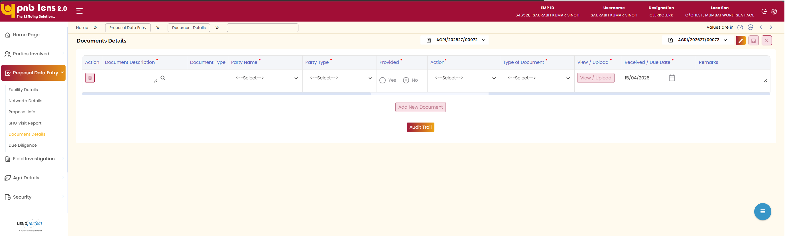
The pre-sanction documents specific to KCC loan are predefined in setup. The user shall view the list of mandatory documents to be collected from the applicant for the selected KCC loan product.
Attaching a document
By default, the fields are non-editable. Clicking Edit makes the fields editable. In the Document Description column, the user needs to click and select the document to be uploaded. Select the party name, party type, document type, enter remarks corresponding to each document for future references, and other details. The system auto-updates the document type and the document upload status. Click View/ Upload to browse for the document from the file location.
Click Choose File and select the document from the file location. Click Upload. The document gets attached to the loan application.
Once the document is uploaded, the user can view the uploaded documents by clicking the View/Upload button.
Click the Add New Document button to attach additional documents to the loan application. This adds a new column for attaching additional documents.
Interface Touch Points
No interface touch points for the screen.

Field Level Validation
S. No | Field Name | Field Type | Source | Validations/ Formulas | Mandatory Flag | DB Type
1 | Action | Icon/Button | Manual | Allows deleting the associated record. | Non- mandatory | VARCHAR
2 | Document Description | Lookup / Search | Manual | Auto populated based on the document selected in the Document Search popup window. | Mandatory | VARCHAR
3 | Document Type | Dropdown | Manual | Auto populates based on the document selected. | Non- mandatory | VARCHAR
4 | Party Name | Dropdown | Manual | Displays Applicant Name | Mandatory | VARCHAR
5 | Party Type | Dropdown | Manual | Applicant, co-applicant, or guarantor as applicable | Mandatory | VARCHAR
6 | Provided | Radio Button | Manual | - Yes  - No | Mandatory | VARCHAR
7 | Action (Select) | Dropdown | Manual | To be provided later  Provided  Not Applicable  Waiver/ Not Available | Non- mandatory | VARCHAR
8 | Type of Document | Dropdown | Manual | Hard Copy  Soft Copy | Mandatory | VARCHAR
9 | View / Upload | Button | Manual | Allows the user to upload new documents / view already uploaded document. | Non- mandatory | VARCHAR
10 | Received / Due Date | Date Picker | Manual | DD/MM/YYYY format | Mandatory | DATE
11 | Remarks | Text Box | Manual | Alphanumeric | Non- mandatory | VARCHAR
12 | Add New Document | Button | Manual | NA | Non- mandatory | VARCHAR
13 | Audit Trail | Button | Manual | NA | Non- mandatory | VARCHAR

Due Diligence
Click Proposal Data Entry screen and then click Due Diligence on the left navigation bar. The Due Diligence screen appears

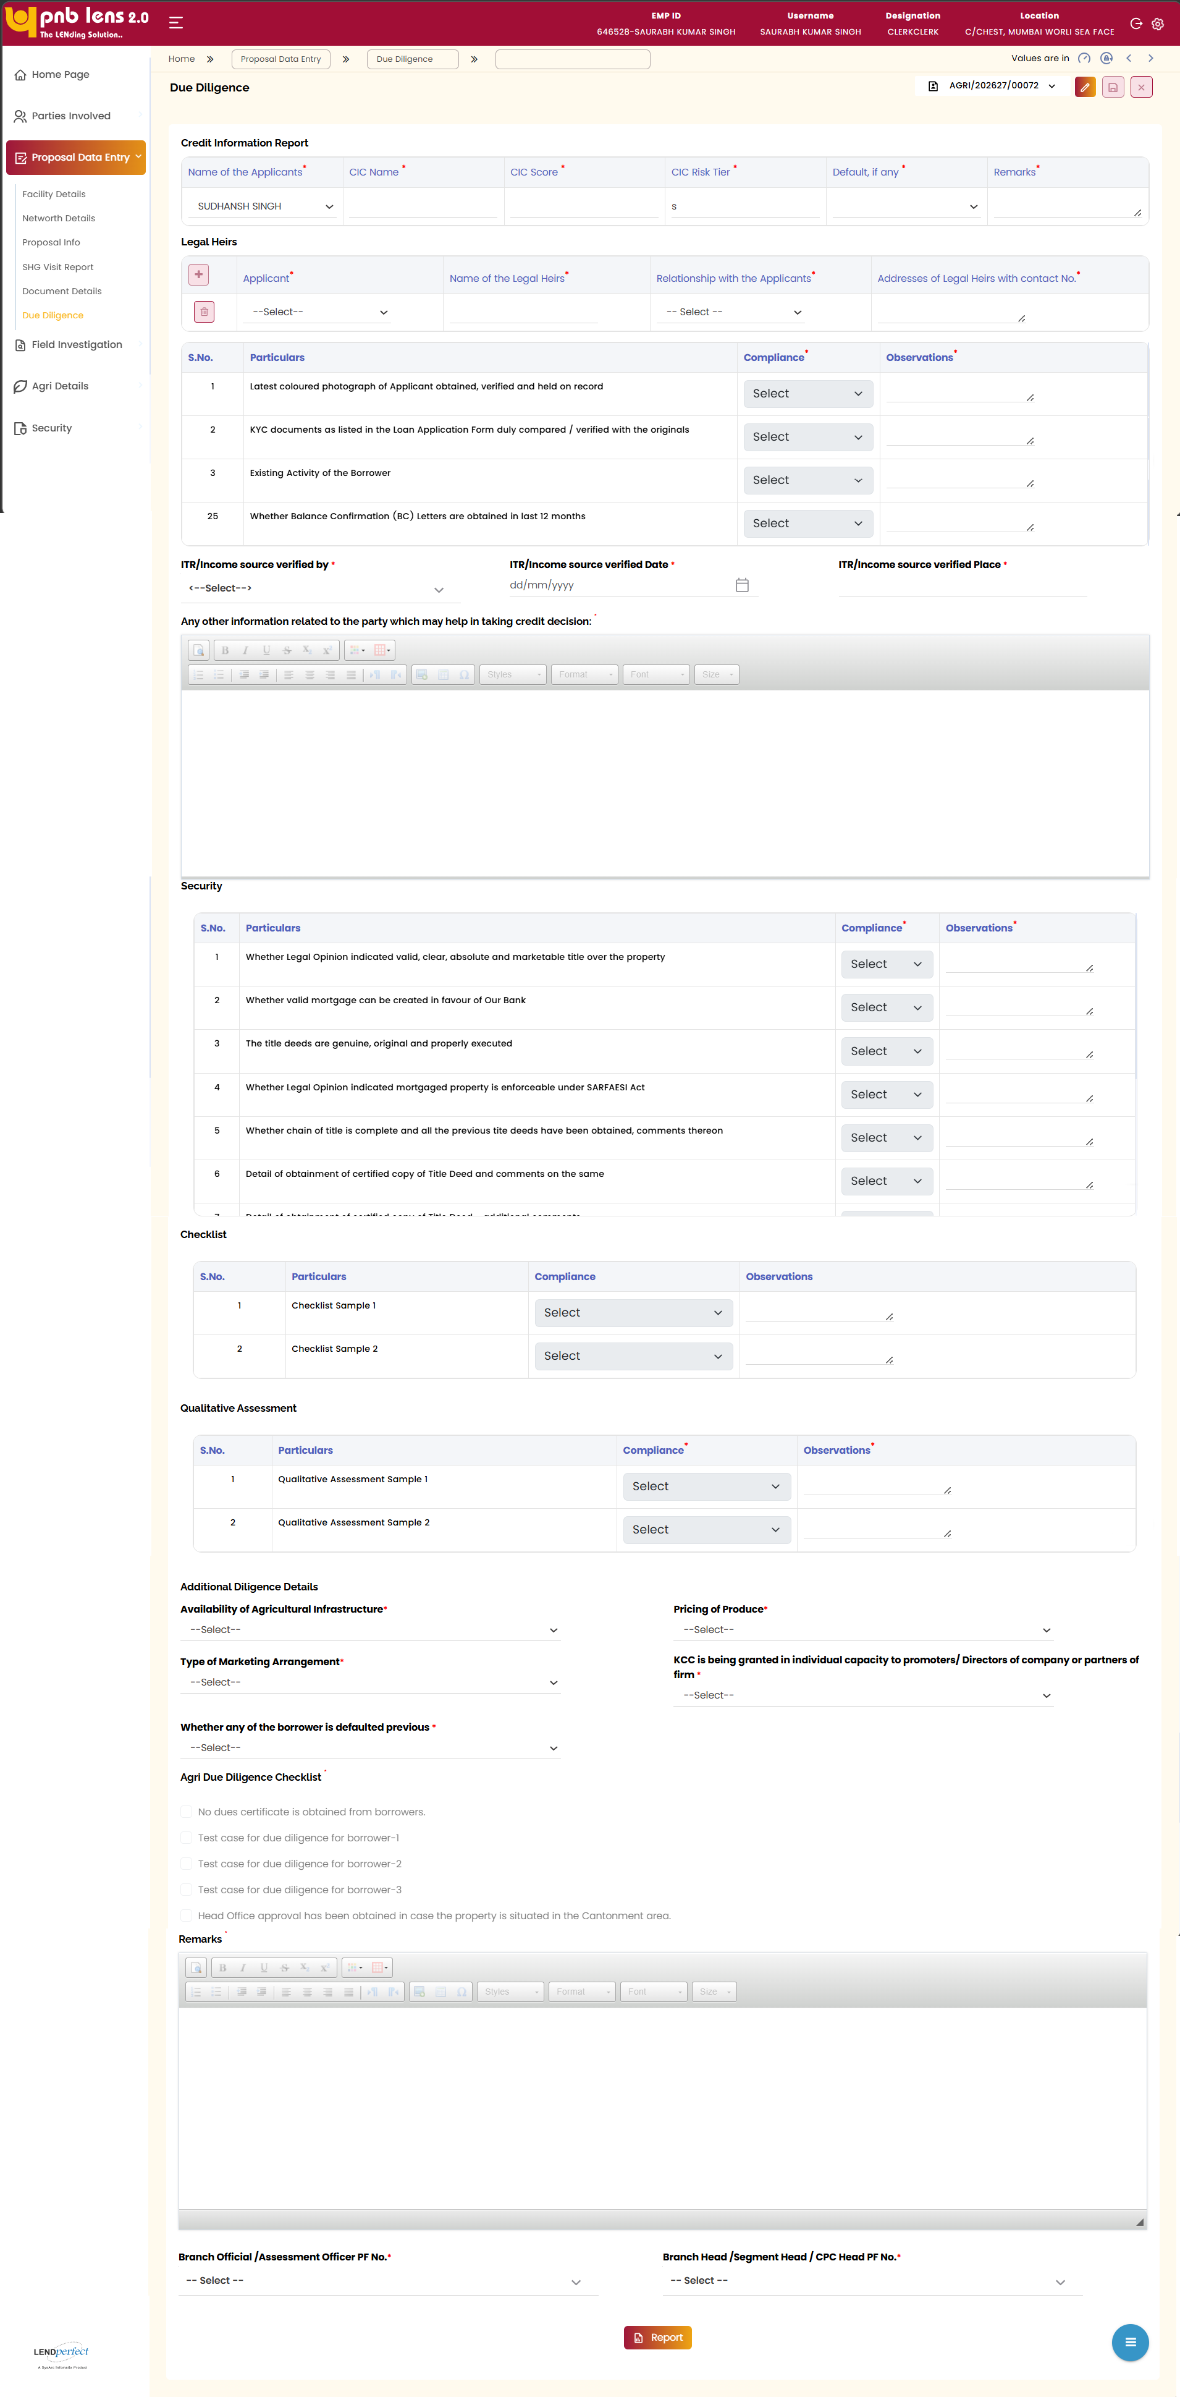
Click Edit to make the screen editable. Enter all the mandatory details in Credit information Report table. Review the customer background and identification details in Legal heirs table. Complete the Compliance and vigilance-related checks based on available records and declarations.
Record observations against each due diligence parameter using the available selection options. Complete security-related checks to assess property or collateral risks. Record checklist confirmations to ensure all procedural requirements are met.
Complete Qualitative Assessment inputs relevant to credit evaluation. Provide additional information or remarks to support due diligence findings. Ensure all the mandatory details are entered. Once all the details are entered, click Save to confirm. Click Report to view the Due Diligence report.

Field Level Validation
S. No | Field Name | Field Type | Source | Validations/ Formulas | Mandatory Flag | DB Type
1 | Name of Applicant | Dropdown | Auto | From Lead | Mandatory | VARCHAR
2 | CIC Name | Dropdown | Manual | Alphanumeric | Mandatory | VARCHAR
3 | CIC Score | Text Box | Manual | Numeric | Mandatory | NUMBER
4 | CIC Risk Tier | Text Box | Manual | Alphabetic | Mandatory | VARCHAR
5 | Default (if any) | Dropdown | Manual | - Yes  - No | Non- mandatory | VARCHAR
6 | Remarks (Credit Info) | Text Box | Manual | Alphanumeric | Non- mandatory | VARCHAR
7 | Applicant (Legal Heir) | Dropdown | Manual | Alphabetic | Mandatory | VARCHAR
8 | Name of Legal Heirs | Dropdown | Manual | Alphabetic | Mandatory | VARCHAR
9 | Relationship with Applicant | Dropdown | Manual | - Self  - Aunty  - Nephew  - Husband  - Nieces  - Brother  - Propreitor  - Sister  - Partner  - son  - Director  - Daughter  - Friend  - Colleague  - Others  - Member  - Father | Mandatory | VARCHAR
10 | Address of Legal Heirs | Text Area | Manual | Alphanumeric | Mandatory | VARCHAR
11 | Due Diligence Particulars | Label | Auto | NA | Mandatory | VARCHAR
12 | Compliance (DD) | Dropdown | Manual | - Yes  - No  - NA | Mandatory | VARCHAR
13 | Observations (DD) | Text Box | Manual | Alphanumeric | Non- mandatory | VARCHAR
14 | ITR/ income source verified by | Dropdown | Manual | Alphabetic | Mandatory | VARCHAR
15 | ITR/ income source verified Date | Date Picker | Manual | DD/MM/YYYY | Mandatory | DATE
16 | ITR/Income source verified Place | Text Box | Manual | Alphabetic | Mandatory | VARCHAR
17 | Additional Credit Info | Rich Text Editor | Manual | Alphanumeric | Non- mandatory | VARCHAR
18 | Security Particulars | Label | Auto | NA | Mandatory | VARCHAR
19 | Compliance (Security) | Dropdown | Manual | - Yes  - No  - NA | Mandatory | VARCHAR
20 | Observations (Security) | Text Box | Manual | Alphanumeric | Non- mandatory | VARCHAR
21 | Checklist Particulars | Label | Auto | NA | Mandatory | VARCHAR
22 | Compliance (Checklist) | Dropdown | Manual | - Yes  - No  - NA | Mandatory | VARCHAR
23 | Observations (Checklist) | Text Box | Manual | Alphanumeric | Non- mandatory | VARCHAR
24 | Qualitative Particulars | Label | Auto | NA | Mandatory | VARCHAR
25 | Compliance (Qualitative) | Dropdown | Manual | - Yes  - No  - NA | Mandatory | VARCHAR
26 | Observations (Qualitative) | Text Box | Manual | Alphanumeric | Mandatory | VARCHAR
27 | Availability of Agricultural Infrastructure | Dropdown | Manual | - Available at far off places,Limited Facilities are availbale in nearby area.  - Adequately available  - Krishi Vigyan Kendra (KVK) or similar government sponsored research Centre is available in nearby area | Mandatory | VARCHAR
28 | Pricing of Produce | Dropdown | Manual | - No MSP but less fluctuation in price  - Produce with minimum support price (MSP) available  - Produce with no MSP and high fluctuation in price | Mandatory | VARCHAR
29 | Type of Marketing Arrangement | Dropdown | Manual | - No Tie up arrangement  - Informal tie up arrangement (based on historical evidence for last 2 years)  - Formal tie up arrangement | Mandatory | VARCHAR
30 | KCC is being granted in individual capacity to promoters/ Directors of company or partners of firm | Dropdown | Manual | - Yes  - No | Mandatory | VARCHAR
31 | Whether any of the borrower is defaulted previous | Dropdown | Manual | - Yes  - No | Mandatory | VARCHAR
 | Borrower doesn't prepare any book of accounts and doesn't have credible financial statements | Dropdown | Manual | - Yes  - No | Mandatory | VARCHAR
32 | Verified through Kisan Rin portal that the loan applicants have not availed Kisan Credit Card Benefits from other Bank | Display/List | Auto | - No dues certificate is obtained from borrowers.  - Test case for due diligence for borrower-I  - Test case for due diligence for borrower-2  - Test case for due diligence for borrower-3  - Head Office approval has been obtained in case the property is situated in the Cantonment area. | Non- mandatory | VARCHAR
33 | Final Remarks | Rich Text Editor | Manual | Alphanumeric | Non- mandatory | VARCHAR
34 | Branch Officer PF No | Dropdown | Manual | LOVs of Branch officer | Mandatory | VARCHAR
35 | Branch Head PF No | Dropdown | Manual | LOVs of Branch Head | Mandatory | VARCHAR
36 | Report | Button | Manual | NA | Non- mandatory | VARCHAR

Agri Details

Land holding Details
Screen Functionality
The Land Holding Details screen, available under the Agri Details section, allows the user to capture and manage information related to the applicant’s land holdings. Upon accessing this screen, the system displays existing land holding records in a tabular format, if available, for user review.
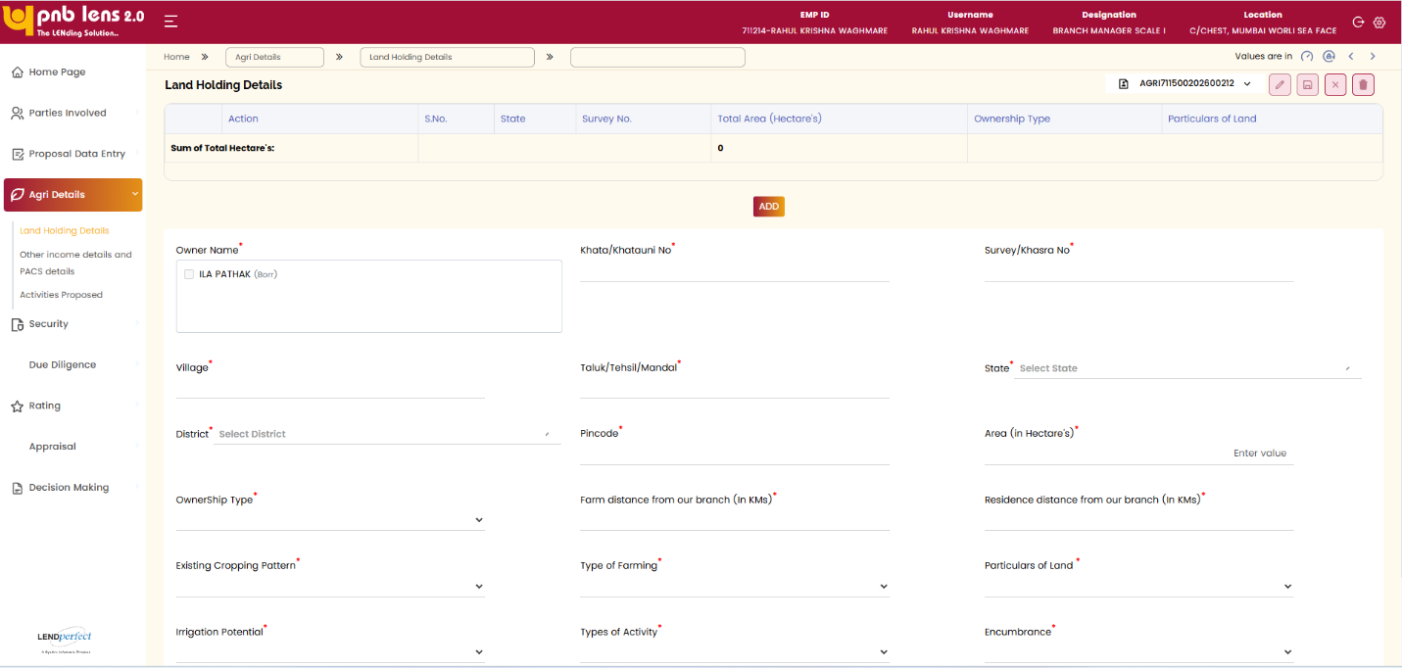
The system allows the user to add new land holding records using the Add option. The user is required to enter details necessary to uniquely identify the land parcel, including location and land identification information. The system also allows the user to capture ownership and cultivation details relevant to the applicant.
The system enables the user to record encumbrance or charge details associated with the land, if applicable. The user must ensure that all mandatory land holding details are completed before proceeding.
Upon completion, the user can save the information by clicking the Save option

Field Level Validation
S. No | Field Name | Field Type | Source | Validations/ Formulas | Mandatory Flag | DB Type
 | Action | Icon/Button | Manual | NA | Non- mandatory | VARCHAR
 | S.No | Auto Number | Auto | Displays the serial number | Non- mandatory | NUMBER
 | State | Table Column | Manual | NA | Non- mandatory | VARCHAR
 | Survey No | Table Column | Manual | NA | Non- mandatory | VARCHAR
 | Total Area (Hectares) | Table Column | Manual | NA | Non- mandatory | NUMBER
 | Ownership Type | Table Column | Manual | NA | Non- mandatory | VARCHAR
 | Particulars of Land | Table Column | Manual | NA | Non- mandatory | VARCHAR
 | Sum of Total Hectares | Calculated Field | Auto | Sum of Total Area (Hectares) | Non- mandatory | NUMBER
 | Add | Button | Manual | NA | Non- mandatory | VARCHAR
 | Owner Name * | Text Box | Manual | Fetch from Lead | Mandatory | VARCHAR
 | Khata/Khatauni No * | Text Box | Manual | Alphanumeric | Mandatory | VARCHAR
 | Survey/Khasra No * | Text Box | Manual | Alphanumeric | Mandatory | VARCHAR
 | Village * | Text Box | Manual | Alphanumeric | Mandatory | VARCHAR
 | Taluk/Tehsil/Mandal | Text Box | Manual | Alphanumeric | Non- mandatory | VARCHAR
 | State * | Dropdown | Manual | LOVs of states | Mandatory | VARCHAR
 | District * | Dropdown | Manual | LOVs of Districts based on selected state | Mandatory | VARCHAR
 | Pincode * | Text Box | Manual | LOVs of Pincode based on district | Mandatory | NUMBER
 | Area (in Hectares) * | Text Box | Manual | Numeric | Mandatory | NUMBER
 | Ownership Type | Dropdown | Manual | - Joint borrowers with separate lands ownership  - Single borrower - land held jointly with others  - Oral Tenant - Single borrower  - Tenant Farmer - Single borrower  - JLG  - Tenant Farmer Group  - Land less Labour - Single borrower  - Single borrower - individual owner and cultivator  - Joint borrowers who jointly held land  - Lessee allottee-farmers with record occupancy rights or farmers with ancestral/perpetual rights of cultivation | Mandatory | VARCHAR
 | Type of Farming * | Dropdown | Manual | - Traditional farming  - Certified Organic Farming (certified by the agriculture and processed Food products Export Development Authority(APEDA)„  - Scientific Farming (including seed germination, vegetative propagation tissue culture etc.) | Mandatory | VARCHAR
 | Irrigation Potential * | Dropdown | Manual | - Group or community minor irrigation/ arrangement by Society or panchayat  - Only rain fed no other source of irrigation  - Land perennially irrigated - Supply using diesel pumps etc.  - Land perennially irrigated directly from canal/river etc  - Land perennially irrigated - supply using electricity  Dry land farming | Mandatory | VARCHAR
 | Types of Activity * | Dropdown | Manual | Direct | Mandatory | VARCHAR
 | Particulars of Land * | Dropdown | Manual | - Irrigated  - Non-irrigated | Mandatory | VARCHAR
 | Encumbrance * | Dropdown | Manual | Yes  No  If Yes is selected additional field will be enabled | Mandatory | VARCHAR
 | Farmer Type | Dropdown | Manual | - Small Farmer  - Marginal Farmer  - Other Farmers | Mandatory | VARCHAR
 | Security | Textbox | Manual | Alphanumeric | Mandatory | VARCHAR
 | Mortgage | Textbox | Manual | Alphanumeric | Mandatory | VARCHAR
 | Date of mortgage | Date Picker | Manual | DD/MM/YYYY | Mandatory | DATE

Other Income Details and PACS Details
Screen Functionality
The Other Income Details and PACS Details screen, available under the Agri Details section, allows the user to capture income-related information for the applicant. Upon accessing this screen, the system enables the user to update and maintain income details as required.
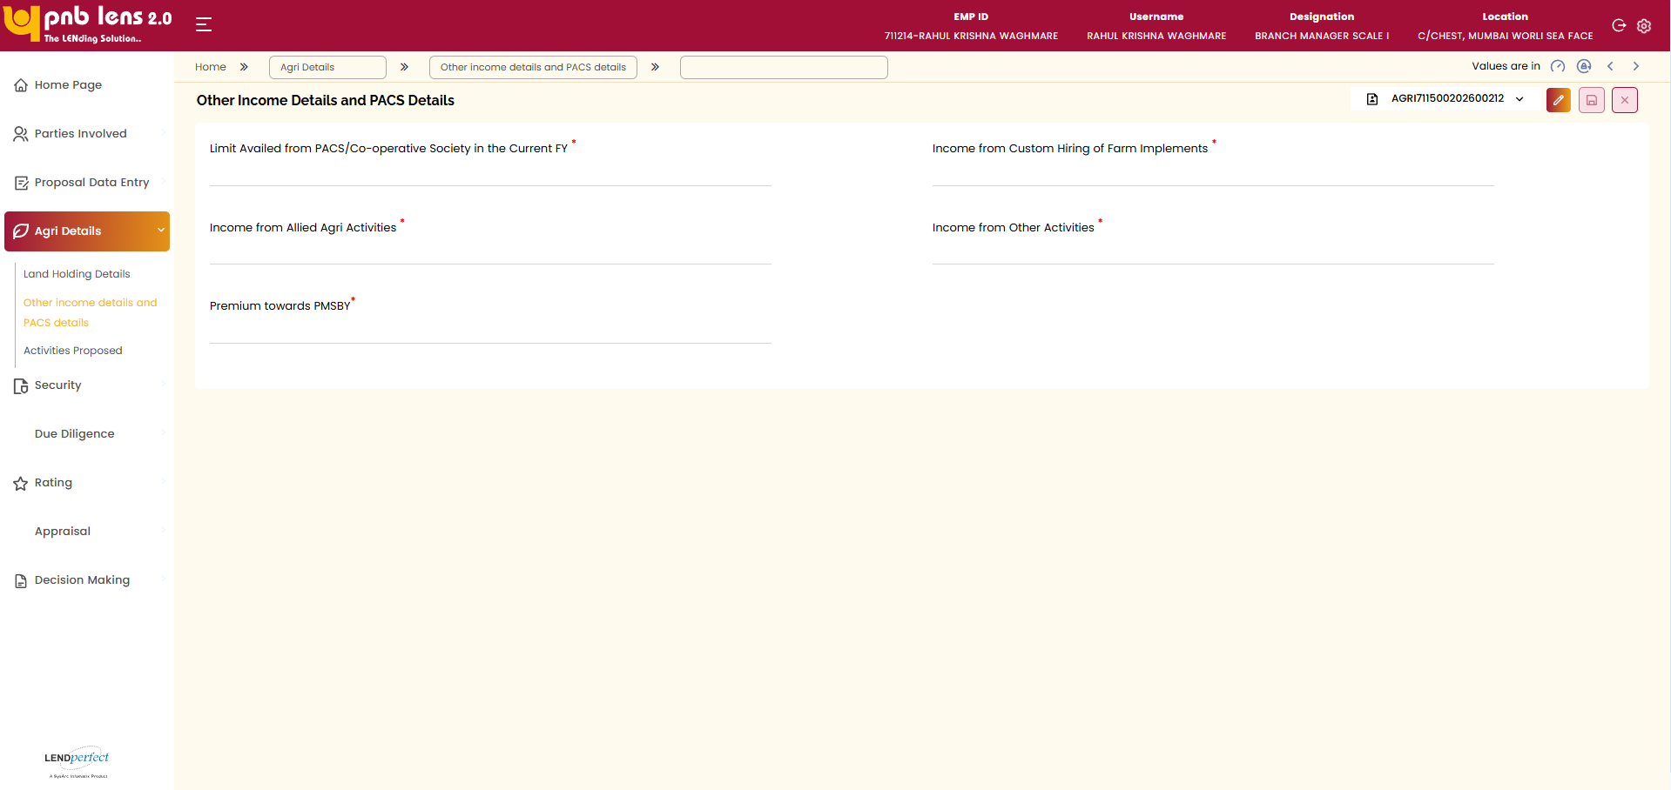
The system allows the user to modify the details using the Edit option and capture all mandatory income-related information. The user can record income availed from PACS or Cooperative Society for the current financial year, along with income from other non-farm or allied activities, where applicable.
The user must ensure that all mandatory fields are accurately completed before proceeding. Upon completion, the user can confirm the details by clicking the Save option

Field Level Validation
S. No | Field Name | Field Type | Source | Validations/ Formulas | Mandatory Flag | DB Type
1 | Limit Availed from PACS / Co-operative Society (Current FY) * | Text Box | Manual | NA | Mandatory | NUMBER
2 | Income from Custom Hiring of Farm Implements * | Text Box | Manual | NA | Mandatory | NUMBER
3 | Income from Allied Agri Activities * | Text Box | Manual | NA | Mandatory | NUMBER
4 | Income from Other Activities * | Text Box | Manual | NA | Mandatory | NUMBER
5 | Premium towards PMFBY * | Text Box | Manual | NA | Mandatory | NUMBER

Activities Proposed
Based on the Facility Name, for Long Term and Short Term the crop details page will appear. For Animal Husbandry the Agri allied details page will appear

For Animal Husbandry and Fishery
Screen Functionality
The Agri Allied Details screen for Animal Husbandry and Fishery allows the user to capture details related to allied agricultural activities. The system enables selection of location details and entry of livestock information using the Add New Row option.
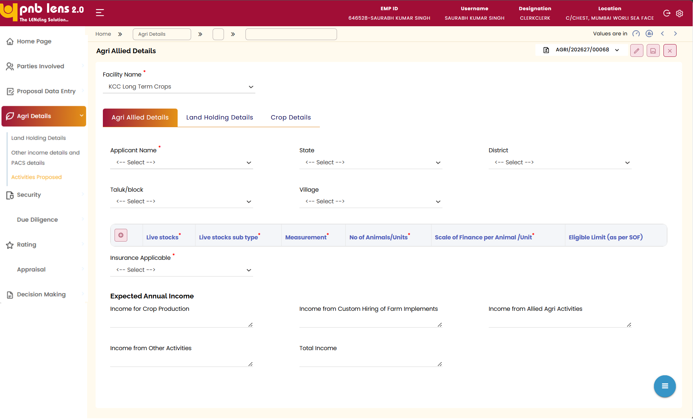
The user can record agricultural details, update insurance applicability, and enter expected annual income from relevant sources. All mandatory fields must be completed before saving.
Upon clicking Save, the system validates and stores the details for further processing.

Field Level Validation
S. No | Field Name | Field Type | Source | Validations/ Formulas | Mandatory Flag | DB Type
1 | Facility Name * | Dropdown | Auto populate | Fetch from Lead | Mandatory | VARCHAR
2 | Applicant Name * | Dropdown | Auto populate | Fetch from Lead | Mandatory | VARCHAR
3 | State | Dropdown | Manual | LOVs of states | Non- mandatory | VARCHAR
4 | District | Dropdown | Manual | LOVs of Districts based on selected state | Non- mandatory | VARCHAR
5 | Taluk/Block | Dropdown | Manual | LOVs of Taluk/Block based on district | Non- mandatory | VARCHAR
6 | Village | Dropdown | Manual | LOVs of Villages | Non- mandatory | VARCHAR
7 | Action | Icon/Button | Manual | NA | Non- mandatory | VARCHAR
8 | Live Stocks * | Dropdown | Manual | NA | Mandatory | VARCHAR
9 | Live Stocks Sub Type * | Dropdown | Manual | NA | Mandatory | VARCHAR
10 | Measurement * | Dropdown | Manual | NA | Mandatory | VARCHAR
11 | No. of Animals/Units * | Text Box | Manual | NA | Mandatory | NUMBER
12 | Scale of Finance per Animal/Unit * | Text Box | Auto | NA | Mandatory | NUMBER
13 | Eligible Limit (as per SOF) | Calculated Field | Auto | NA | Non- mandatory | NUMBER
14 | Insurance Applicable * | Dropdown | Manual | - Yes  - No | Mandatory | VARCHAR
15 | Income for Crop Production | Text Box | Manual | Alphanumeric | Non- mandatory | NUMBER
16 | Income from Custom Hiring of Farm Implements | Text Box | Manual | Alphanumeric | Non- mandatory | NUMBER
17 | Income from Allied Agri Activities | Text Box | Manual | Alphanumeric | Non- mandatory | NUMBER
18 | Income from Other Activities | Text Box | Manual | Alphanumeric | Non- mandatory | NUMBER
19 | Total Income | Calculated Field | Auto | Alphanumeric | Non- mandatory | NUMBER

Crop Details
Screen Functionality
The Crop Details screen allows the user to capture information related to crop activities for the proposed facility. The system displays existing crop records, if available, for review.
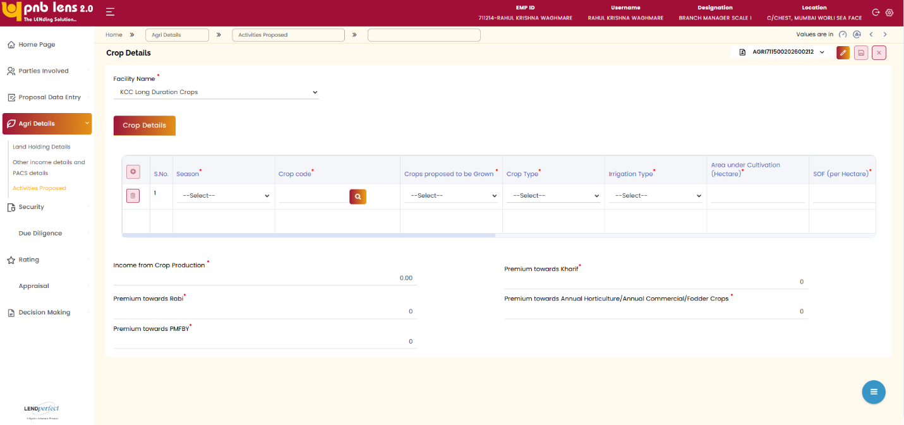
The user can add crop details by specifying season, crop code, crops proposed, irrigation type, and cropping type. The system also allows entry of estimated income from crop production and other agricultural sources, along with applicable premium or contribution details.
All mandatory fields must be completed before saving. Upon clicking Save, the system validates and stores the crop details for further processing.

Field Level Validation
S. No | Field Name | Field Type | Source | Validations/ Formulas | Mandatory Flag | DB Type
 | Facility Name | Dropdown | Manual | Fetch from lead | Mandatory | VARCHAR
 | Action | Icon/Button | Manual | NA | Non- mandatory | VARCHAR
 | S.No | Auto Number | Auto | Displays the serial number | Non- mandatory | NUMBER
 | Season | Dropdown | Manual | - Kharif  - Rabi  - Annual Horticulture/ Annual Commercial/Fodder Crops | Mandatory | VARCHAR
 | Crop Code | Search box | Manual | NA | Mandatory | VARCHAR
 | Crop Proposed to be Grown | Dropdown | Manual | - bajara  - jawar  - wheat  - Dal  - Coffee  - pepper  - Other crops | Mandatory | VARCHAR
 | Crop Type | Dropdown | Manual | - Perennial Crop  - Annual Crop  - other Crop | Mandatory | VARCHAR
 | Irrigation Type | Dropdown | Manual | - Irrigated  - Rainfed | Mandatory | VARCHAR
 | Area under Cultivation | Text Box | Manual | Numeric | Mandatory | NUMBER
 | SOF per Hectare | Text Box | Auto | Numeric | Mandatory | NUMBER
 | Month of Sowing | Dropdown | Manual | List of months | Mandatory | VARCHAR
 | Crop Duration (In Months) | Text Box | Manual | Numeric | Mandatory | NUMBER
 | Yield (Q/ Hec) | Text Box | Manual | Numeric | Mandatory | NUMBER
 | Rate in Rs (MSP/Q) | Text Box | Manual | Numeric | Mandatory | NUMBER
 | Income From Crop Production | Text Box | Manual | Numeric | Mandatory | NUMBER
 | PMFBY/ Crop Insurance | Dropdown | Manual | - Opt in  - Opt out | Mandatory | VARCHAR
 | PMFBY/ Crop Insurance premium | Text Box | Manual | Numeric | Mandatory | NUMBER
 | Income from Crop Production | Text Box | Auto | Numeric | Mandatory | NUMBER
 | Premium towards Kharif | Display Field | Auto | Numeric | Non- mandatory | NUMBER
 | Premium towards Rabi | Display Field | Auto | Numeric | Non- mandatory | NUMBER
 | Premium towards PMFBY | Display Field | Auto | Numeric | Mandatory | NUMBER
 | Premium towards Annual/Horticulture | Display Field | Auto | Numeric | Non- mandatory | NUMBER

Field investigation
Quantitative Data tab allows you to capture the Credit verification for the applicants attached to the proposal from external agencies, track the history of loan repayment, capture the feedback from the reference(s).

Pre-Sanction Inspection Report
Screen Functionality
The screen allows the user to generate residence visit report and agricultural land verification report.
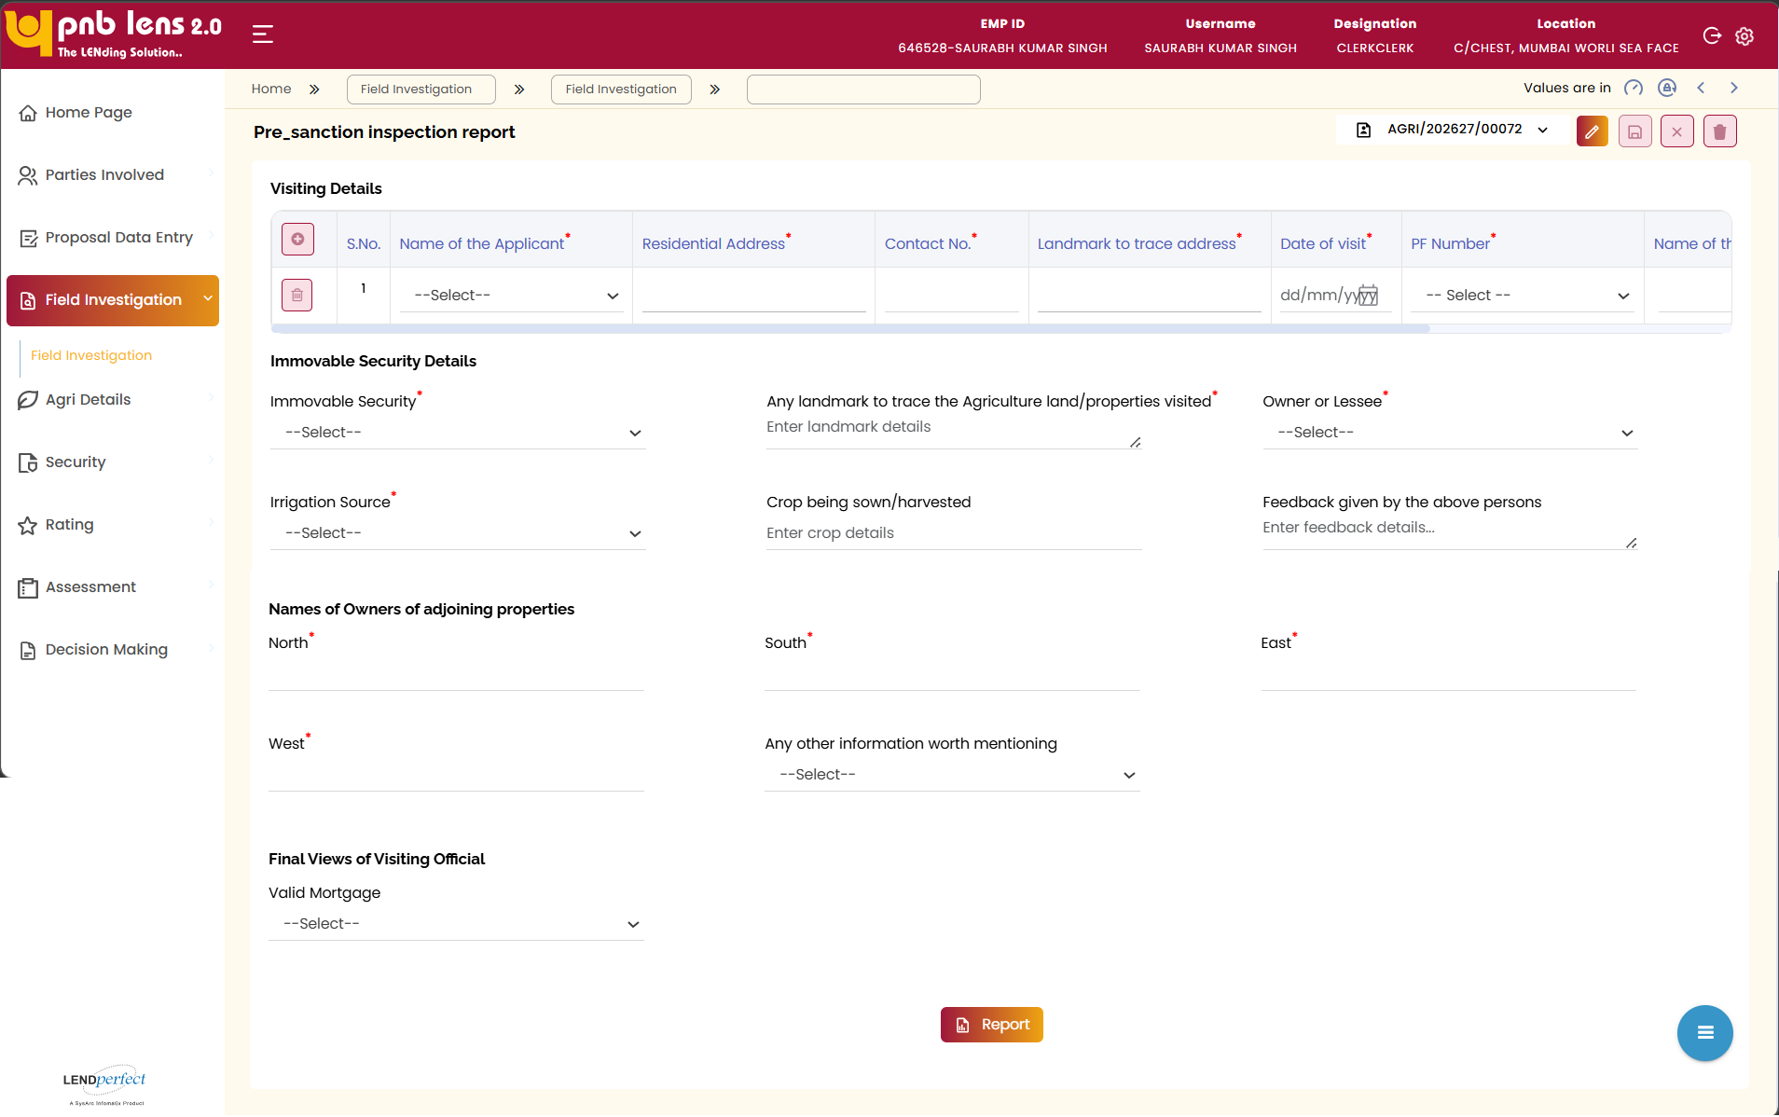
Note:
- Visit report of residence is not applicable for KCC. However, the user can fill the residence visit details if required.
- Agriculture land visit report is mandatory for processing KCC loan. This report is required for running BRE rules.
- The user can recommend the proposal only if the agriculture land visit report is filled.
- Post sanction, this screen is not editable.
Once the visit report details are captured, the user can click the Report button to generate the hard copy of the report for operational purposes.
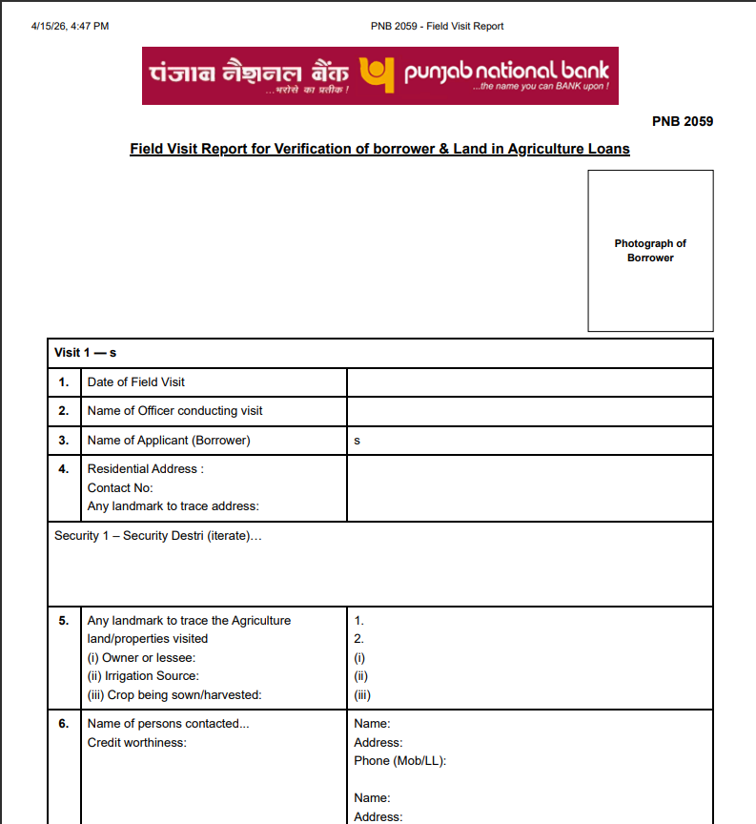
Interface Touch Points
No interface touch points for the screen.

Field Level Validation
S. No | Field Name | Field Type | Source | Validations/ Formulas | Mandatory Flag | DB Type
1 | S.No | Auto Number | Auto | Displays the serial number | Non- mandatory | NUMBER
2 | Name of Applicant | Dropdown | Manual | Fetch from Lead | Mandatory | VARCHAR
3 | Residential Address | Text Box | Manual | Alphanumeric | Mandatory | VARCHAR
4 | Contact No | Text Box | Manual | Numeric | Mandatory | NUMBER
5 | Landmark to trace address | Text Box | Manual | Alphanumeric | Non- mandatory | VARCHAR
6 | Date of Visit | Date Picker | Manual | DD/MM/YYYY | Mandatory | DATE
7 | PF Number | Dropdown | Manual | NA | Mandatory | VARCHAR
 | Name of Inspecting official | Text Area | Manual | Alphabetic | Mandatory | VARCHAR
 | Designation | Text Area | Manual | Alphanumeric | Mandatory | VARCHAR
9 | Immovable Security | Dropdown | Manual | NA | Mandatory | VARCHAR
10 | Landmark for Agriculture Property | Text Area | Manual | Alphanumeric | Mandatory | VARCHAR
11 | Owner or Lessee | Dropdown | Manual | - Owner  - Lessee | Mandatory | VARCHAR
12 | Irrigation Source | Dropdown | Manual | - Pump  - Rainfed  - River  - Canal  - Surface Water  - Municipal Water  - Tanks  - Tube Wells  - Irrigated  - Unirrigated | Mandatory | VARCHAR
13 | Crop being sown/harvested | Text Box | Manual | Alphabetic | Non- mandatory | VARCHAR
14 | Feedback from persons | Text Area | Manual | Alphanumeric | Non- mandatory | VARCHAR
15 | North Owner | Text Box | Manual | Alphanumeric | Mandatory | VARCHAR
16 | South Owner | Text Box | Manual | Alphanumeric | Mandatory | VARCHAR
17 | East Owner | Text Box | Manual | Alphanumeric | Mandatory | VARCHAR
18 | West Owner | Text Box | Manual | Alphanumeric | Mandatory | VARCHAR
19 | Any other information worth mentioning | Dropdown | Manual | Alphanumeric | Non- mandatory | VARCHAR
20 | Valid Mortgage | Dropdown | Manual | - Yes  - No | Mandatory | VARCHAR
21 | Report | Button | Manual | NA | Non- mandatory | VARCHAR

Security

Assets & Security Details
Screen Functionality
Assets & Security Details tab, allows the user to:
- Add a new security detail
- Attach security to a facility and map the security ownership to an applicant
- Add the security to a facility as the primary, secondary or collateral security
- Upload and attach the security-related documents
Note:
- Proposed crop should be added as security in case of KCC loan. However, it is not mandatory. Even without adding the security details, the proposal can be recommended.
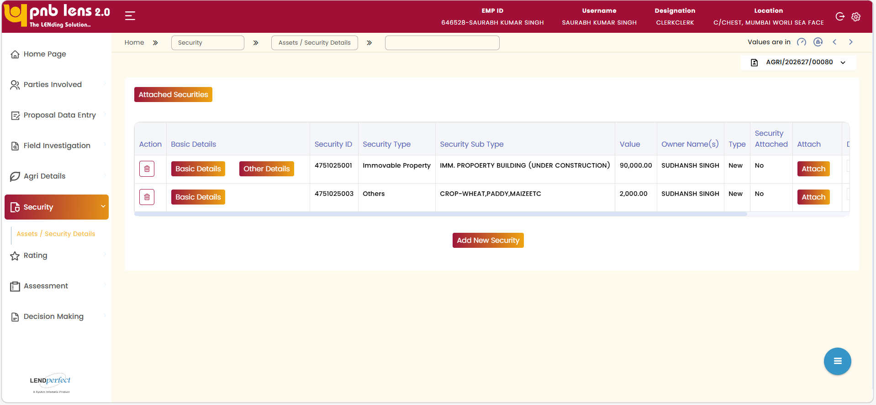
Add New Security: Upon clicking Add New Security, a pop-up display as shown below.
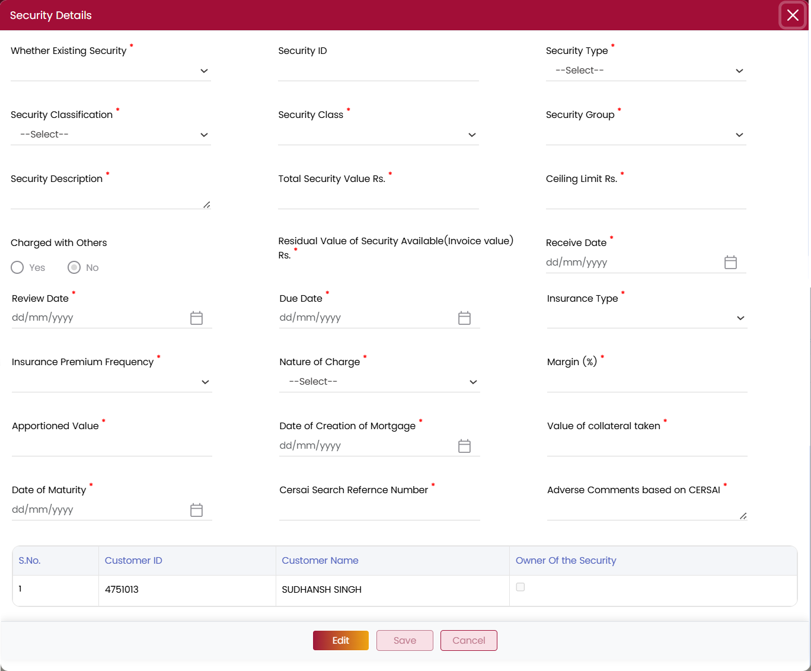
On the Security Details pop-up, the user needs to select the security type, specify any existing charge, nature of the charge, insurance details, classification, security type, security value, net security, etc. The user can map the security to an applicant. Based on the security type selected, the field structure changes.
Click Save, the new security details are saved in the LENDperfect database. The new security details display on the main screen.
BD (Basic Details): The user needs to click BD to enter the Basic details of the security. It is mandatory to enter the basic details for security.
OD (Other Details): The user needs to click OD to enter additional details of the security. It is optional to enter these details.
Attach: Allows the user to map the security to the applicant and facility in the proposed proposal and create a type of lien on the security as primary or secondary. Upon attaching the security to a facility, the security attached status will display as Yes.
Attach Documents: Allows the user to attach the technical and legal opinions against the security.
Attached Securities: Allows the user to view the facilities attached to the proposal.
Interface Touch Points
No interface touch points for the screen.

Field Level Validation
Summary Table
Front End fields (UI Interface)
S. No | Field Name | Field Type | Source | Validations / Formulas | Mandatory Flag | DB Type
1 | Action | Delete Icon | NA | NA | NA | NA
2 | Basic Details | Button | NA | NA | NA | NA
3 | Security ID | Display | Auto populate | Numeric | NA | NA
4 | Security Type | Display | Auto populate | Alphabetic | NA | NA
5 | Security Sub Type | Display | Auto populate | Alphabetic | NA | NA
6 | Value | Display | Auto populate | Numeric | NA | NA
7 | Owner Name(s) | Display | Auto populate | Alphabetic | NA | NA
8 | Type | Display | Auto populate | Alphabetic | NA | NA
9 | Security Attached | Display | Auto populate | Alphabetic | NA | NA
10 | Attach | Button | Manual | Allows to attach the security as primary or collateral | Mandatory | NA
11 | Document Attached | Display | Auto populate | Displays the attached document | NA | NA
Back End fields
Field Level notes, alerts, and static content for validation
Security Details Table
Front End fields (UI Interface)
S. No | Field Name | Field Type | Source | Validations / Formulas | Mandatory Flag | DB Type
1 | Whether Existing Security | Dropdown | Manual | - Yes  - No | Mandatory | VARCHAR
2 | Security ID | Text Box | Manual | Alphanumeric | Non- mandatory | VARCHAR
3 | Security Type | Dropdown | Manual | - Live Stock  - Govt Securities  - Llfe Insurance  - Others  - Immovable Property  - Deposit | Mandatory | VARCHAR
4 | Security Classification | Dropdown | Manual | LOVs based on the Security type | Mandatory | VARCHAR
5 | Security Class | Dropdown | Manual | LOVs based on the Security type | Mandatory | VARCHAR
6 | Security Group | Dropdown | Manual | LOVs based on the Security type | Mandatory | VARCHAR
7 | Security Description | Comment Box | Manual | Alphanumeric | Mandatory | VARCHAR
8 | Total Security Value Rs | Text Box | Manual | Numeric | Mandatory | NUMBER
9 | Ceiling Limit Rs | Text Box | Manual | Numeric | Mandatory | NUMBER
10 | Charged with Others | Ratio Button | Manual | - Yes  - No |  | VARCHAR
11 | Residual Value of Security Available (Invoice value) Rs | Text Box | Manual | Numeric | Mandatory | NUMBER
12 | Receive Date | Data Picker | Manual | DD/MM/YYYY | Mandatory | DATE
13 | Review Date | Data Picker | Manual | DD/MM/YYYY | Mandatory | DATE
14 | Due Date | Data Picker | Manual | DD/MM/YYYY | Mandatory | DATE
15 | Insurance Type | Dropdown | Manual | - FIRE INSURANCE  - COMPREHENSIVE INSURANCE  - THIRD PARTY INSURANCE  - VEHICLE INSURANCE POLICY  - BURGULARY INSURANCE  - INSURANCE COVER NOT REQUIRED/WAIVED  - OTHER INSURANCE  - FIRE EARTHQUAKE FLOOD INSURANCE | Mandatory | VARCHAR
16 | Insurance Premium Frequency | Dropdown | Manual | - HALF YEARLY  - MONTHLY  - YEARLY | Mandatory | VARCHAR
17 | Nature of Charge | Dropdown | Manual | - HYPOTHECATION  - MORTGAGE  - PLEDGE  - PARI-PASSU CHARGE  - SECOND CHARGE  - PARI PASSU SECOND CHARGE  - REGISTERED MORTGAGE | Mandatory | VARCHAR
18 | Margin (%) | Text Box | Manual | Numeric | Mandatory | NUMBER
19 | Apportioned Value | Text Box | Manual | Numeric | Mandatory | NUMBER
20 | Date of Creation of Mortgage | Date Picker | Manual | DD/MM/YYYY | Mandatory | DATE
21 | Value of collateral taken | Text Box | Manual | Numeric | Mandatory | NUMBER
22 | Date of Maturity | Date Picker | Manual | DD/MM/YYYY | Mandatory | DATE
23 | Cersai Search Reference Number | Text Box | Manual | Alphanumeric | Mandatory | NUMBER
24 | Adverse Comments based on CERSAI | Comment Box | Manual | Alphanumeric | Mandatory | VARCHAR
Other Details Tab
Property Details
Front End fields (UI Interface)
S. No | Field Name | Field Type | Source | Validations / Formulas | Mandatory Flag | DB Type
 | Property Type* | Dropdown | Auto populate from basic details | Apartment/Flat  Bungalow  Residential Plot  Open plot  Villas  Row house  Independent House  Land and Building  Others | Mandatory | NUMBER
 | Occupancy of Property* | Dropdown | Manual | Self-occupied  Vacant  Rented | Mandatory | VARCHAR
 | Total Area of Plot* | Text Box & Dropdown | Manual | Numeric & LOV  Note: Total Area should be entered in text box and the corresponding measurement unit should be selected from the dropdown. | Conditional Mandatory  Validation:  If property is Other than Flat, this field will be enabled. | VARCHAR
 | Built-up Area* | Text Box & Dropdown | Manual | Numeric & LOV  Note: Total Area should be entered in text box and the corresponding measurement unit should be selected from the dropdown. For Residential Property, minimum BuA to be 300 Sqft for flats in Metros and 500 Sqft for flats and independent bungalows for all other cities.  For Commercial Property, minimum BuA it should be 200 Sqft | Conditional Mandatory  Applicable for All purposes | VARCHAR
 | Age of House / Flat | Text Box | Manual | Numeric | Mandatory | NUMBER
 | Residual Age of Property (Years) | Text Box | Manual | Numeric | Mandatory | NUMBER
 | Property Document Number | Text Box | Manual | Numeric | Mandatory | NUMBER
 | Property owner Name/Seller Name | Text Box | Manual | Numeric | Mandatory | NUMBER
 | Date of Title Search | Date Picker | Manual | DD/MM/YYYY | Mandatory | DATE
 | Stage of Construction | Dropdown | Manual | NA | Mandatory | VARCHAR
 | Whether Project approved by bank? | Dropdown | Manual | - Yes  - No | Mandatory | VARCHAR
 | RERA/State Law compliant | Dropdown | Manual | - Yes  - No | Mandatory | VARCHAR
 | Geo tagging | Text box / Location button | Manual | NA | Mandatory | VARCHAR
 | CERSAI Registration completed | Dropdown | Manual | - Yes  - No | Mandatory | VARCHAR
 | CERSAI Registration ID | Text Box | Manual | Numeric | Mandatory | NUMBER
 | Cersai Security Interest ID | Text Box | Manual | Numeric | Mandatory | NUMBER
 | Cersai Security Interest ID Date | Date Picker | Manual | DD/MM/YYYY | Mandatory | DATE
 | CERSAI Remarks | Text Box | Manual | Alphanumeric | Mandatory | NUMBER
 | Branch where title deeds deposited | Comment Box | Manual | Alphanumeric | Mandatory | VARCHAR
 | Observation of Branch Official | Comment Box | Manual | Alphanumeric | Mandatory | VARCHAR
 | Any adverse remark | Comment Box | Manual | Alphanumeric | Mandatory | VARCHAR
 | Purchase Price | Text Box | Manual | Numeric | Mandatory | NUMBER
 | Purchase Date | Date Picker | Manual | DD/MM/YYYY | Mandatory | DATE
 | Last NEC Date | Date Picker | Manual | DD/MM/YYYY | Mandatory | DATE
 | Previous NEC Advocate | Comment Box | Manual | Alphanumeric | Mandatory | VARCHAR
Address and Location Details
 | Address 1 | Text Box | Manual | Alphanumeric | Mandatory | VARCHAR
 | Address 2 | Text Box | Manual | Alphanumeric | Mandatory | VARCHAR
 | Address 3 | Text Box | Manual | Alphanumeric | Mandatory | VARCHAR
 | State | Dropdown | Manual | LOV from master | Mandatory | VARCHAR
 | City | Dropdown | Manual | LOV from master | Mandatory | VARCHAR
 | District | Dropdown | Manual | LOV from master | Non-Mandatory | VARCHAR
 | Pin Code* | Auto populate | Manual | Numeric | Mandatory | VARCHAR
Legal Details
 | Security | Drop down | Manual | NA | Mandatory | VARCHAR
 | Advocate Search | Search Box | Manual | NA | Mandatory | VARCHAR
 | Name of Advocate* | Dropdown | Manual | Alphabetic  (List of empanelled lawyers with contact no will be populated) | Mandatory | VARCHAR
 | Contact No. * | Drop down | Manual | Numeric(List of empanelled lawyers with contact no will be populated) | Mandatory | VARCHAR
 | Email Id | Text Box | Auto populate / Manual | Auto populate from CBS for ETB and manual for NTB (If not available from CBS should be manually enterable | Non – Mandatory | VARCHAR
 | Address | Text Box  Text Area | Manual | Alphanumeric | Mandatory | VARCHAR
 | Receipt No (Issued from Registrar of Assurance/Competent Authority) | Text Box | Manual | Alphanumeric | Mandatory | Number
 | Receipt Date | Date Picker | Manual | DD/MM/YYYY | Mandatory | DATE
 | Legal Opinion Date | Date Picker | Manual | DD/MM/YYYY | Mandatory | DATE
 | Name(s) of the Mortgagor(s) / Title holder(s) | Text Box | Manual | NA | Mandatory | VARCHAR
 | Address(es) of the Mortgagor(s) / Title holder(s) | Text Box | Manual | NA | Mandatory | VARCHAR
 | Whether affidavit has been obtained | Drop down | Manual | - Yes  - No | Mandatory | VARCHAR
 | Remarks / Comments | Text box with text editor | Manual | Alphanumeric | Mandatory | VARCHAR
Valuation Details
1 | Security | Dropdown | Manual | NA | Mandatory | VARCHAR
2 | Valuer Search | Search Lookup | Manual | NA | Mandatory | VARCHAR
3 | Valuer Name | Textbox | Auto | Alphabetic | Mandatory | VARCHAR
4 | Valuer Category | Dropdown | Auto | Alphabetic | Mandatory | VARCHAR
5 | Contact No | Textbox | Auto | 10 digits | Mandatory | NUMBER
6 | Email Id | Textbox | Auto | Email format | Mandatory | VARCHAR
7 | Address | Text area | Manual | Alphanumeric | Mandatory | VARCHAR
8 | Valuation Date | Date Picker | Manual | DD/MM/YYYY | Mandatory | DATE
9 | Area | Textbox | Manual | Numeric | Mandatory | NUMBER
10 | Reference Rate | Textbox | Manual | Numeric | Mandatory | NUMBER
11 | Guidance Rate/Circle Rate | Textbox | Manual | Numeric | Mandatory | NUMBER
12 | Market Value | Textbox | Manual | Numeric  (Land Value+ Building Value + Amenity value)  Validation:  Market Value (FMV)> Realizable Value > Forced Sale Value (FSV) | Mandatory | NUMBER
13 | Realizable Value | Textbox | Manual | Numeric  Validation:  Market Value (FMV)> Realizable Value > Force Sale Value (FSV) | Mandatory | NUMBER
14 | Distress Value | Textbox | Manual | Numeric | Mandatory | NUMBER
15 | Remarks of Valuer | Text area | Manual | Alphanumeric | Mandatory | VARCHAR
Government Securities
1. | S.no | Column heading | Manual | Numeric | Mandatory | Number
2. | Dist. SL No From | Column heading | Manual | Numeric | Mandatory | Number
3. | Dist .SL No To | Column heading | Manual | Numeric | Mandatory | Number
4. | Unit | Column heading | Manual | Numeric | Mandatory | Number
Buttons
1. | Action | Column heading | NA | To delete the row | NA | NA
2. | Add Row | Button name | NA | Add a new row | NA | NA
1 | Edit | Button | NA | Allows modifying the details on the active screen. This button is displayed on the screen only after the lead is submitted. | NA | NA
2 | Save | Button | NA | Allows saving the details on the active screen. This button is displayed on the screen only after the lead is submitted. | NA | NA
3 | Cancel | Button | NA | Allows cancelling the current operation. By default, this button will be displayed on the screen. | NA | NA

Rating

Score Card
Click Initiate to trigger the API. The system fetches the details and displays them on the Scorecard.
Track Score will be enabled based on, if the customer has book of account and the loan amount is more than one crore.
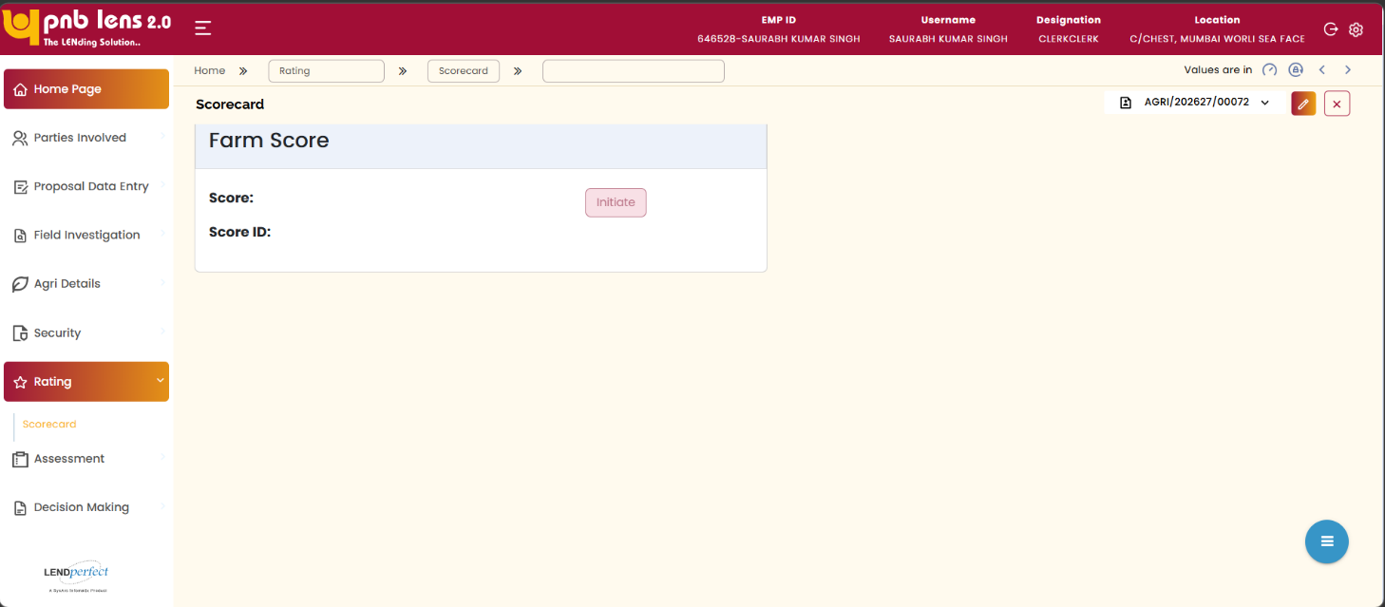
Note:
Farm score not applicable for proposed limit upto three lakhs.

Field Level Validation
S. No | Field Name | Field Type | Source | Validations/ Formulas | Mandatory Flag | DB Type
1 | Score | Display Field | Auto | NA | Non- mandatory | NUMBER
2 | Score ID | Display Field | Auto | NA | Non- mandatory | VARCHAR
3 | Initiate | Button | Manual | NA | Non- mandatory | VARCHAR

Assessment
Assessment tab allows you to evaluate various inputs provided in the proposed proposal, expected income(s), upcoming liabilities (declared) in the proposal, setup parameters for the facilities attached to the proposal to arrive at the eligible loan amount of the applicant.

Assessment Eligibility
Screen Functionality
The Assessment Eligibility screen allows the user to evaluate the applicant’s eligibility based on the selected scheme (KCC or KSY). The system displays the relevant assessment screen based on the chosen scheme.
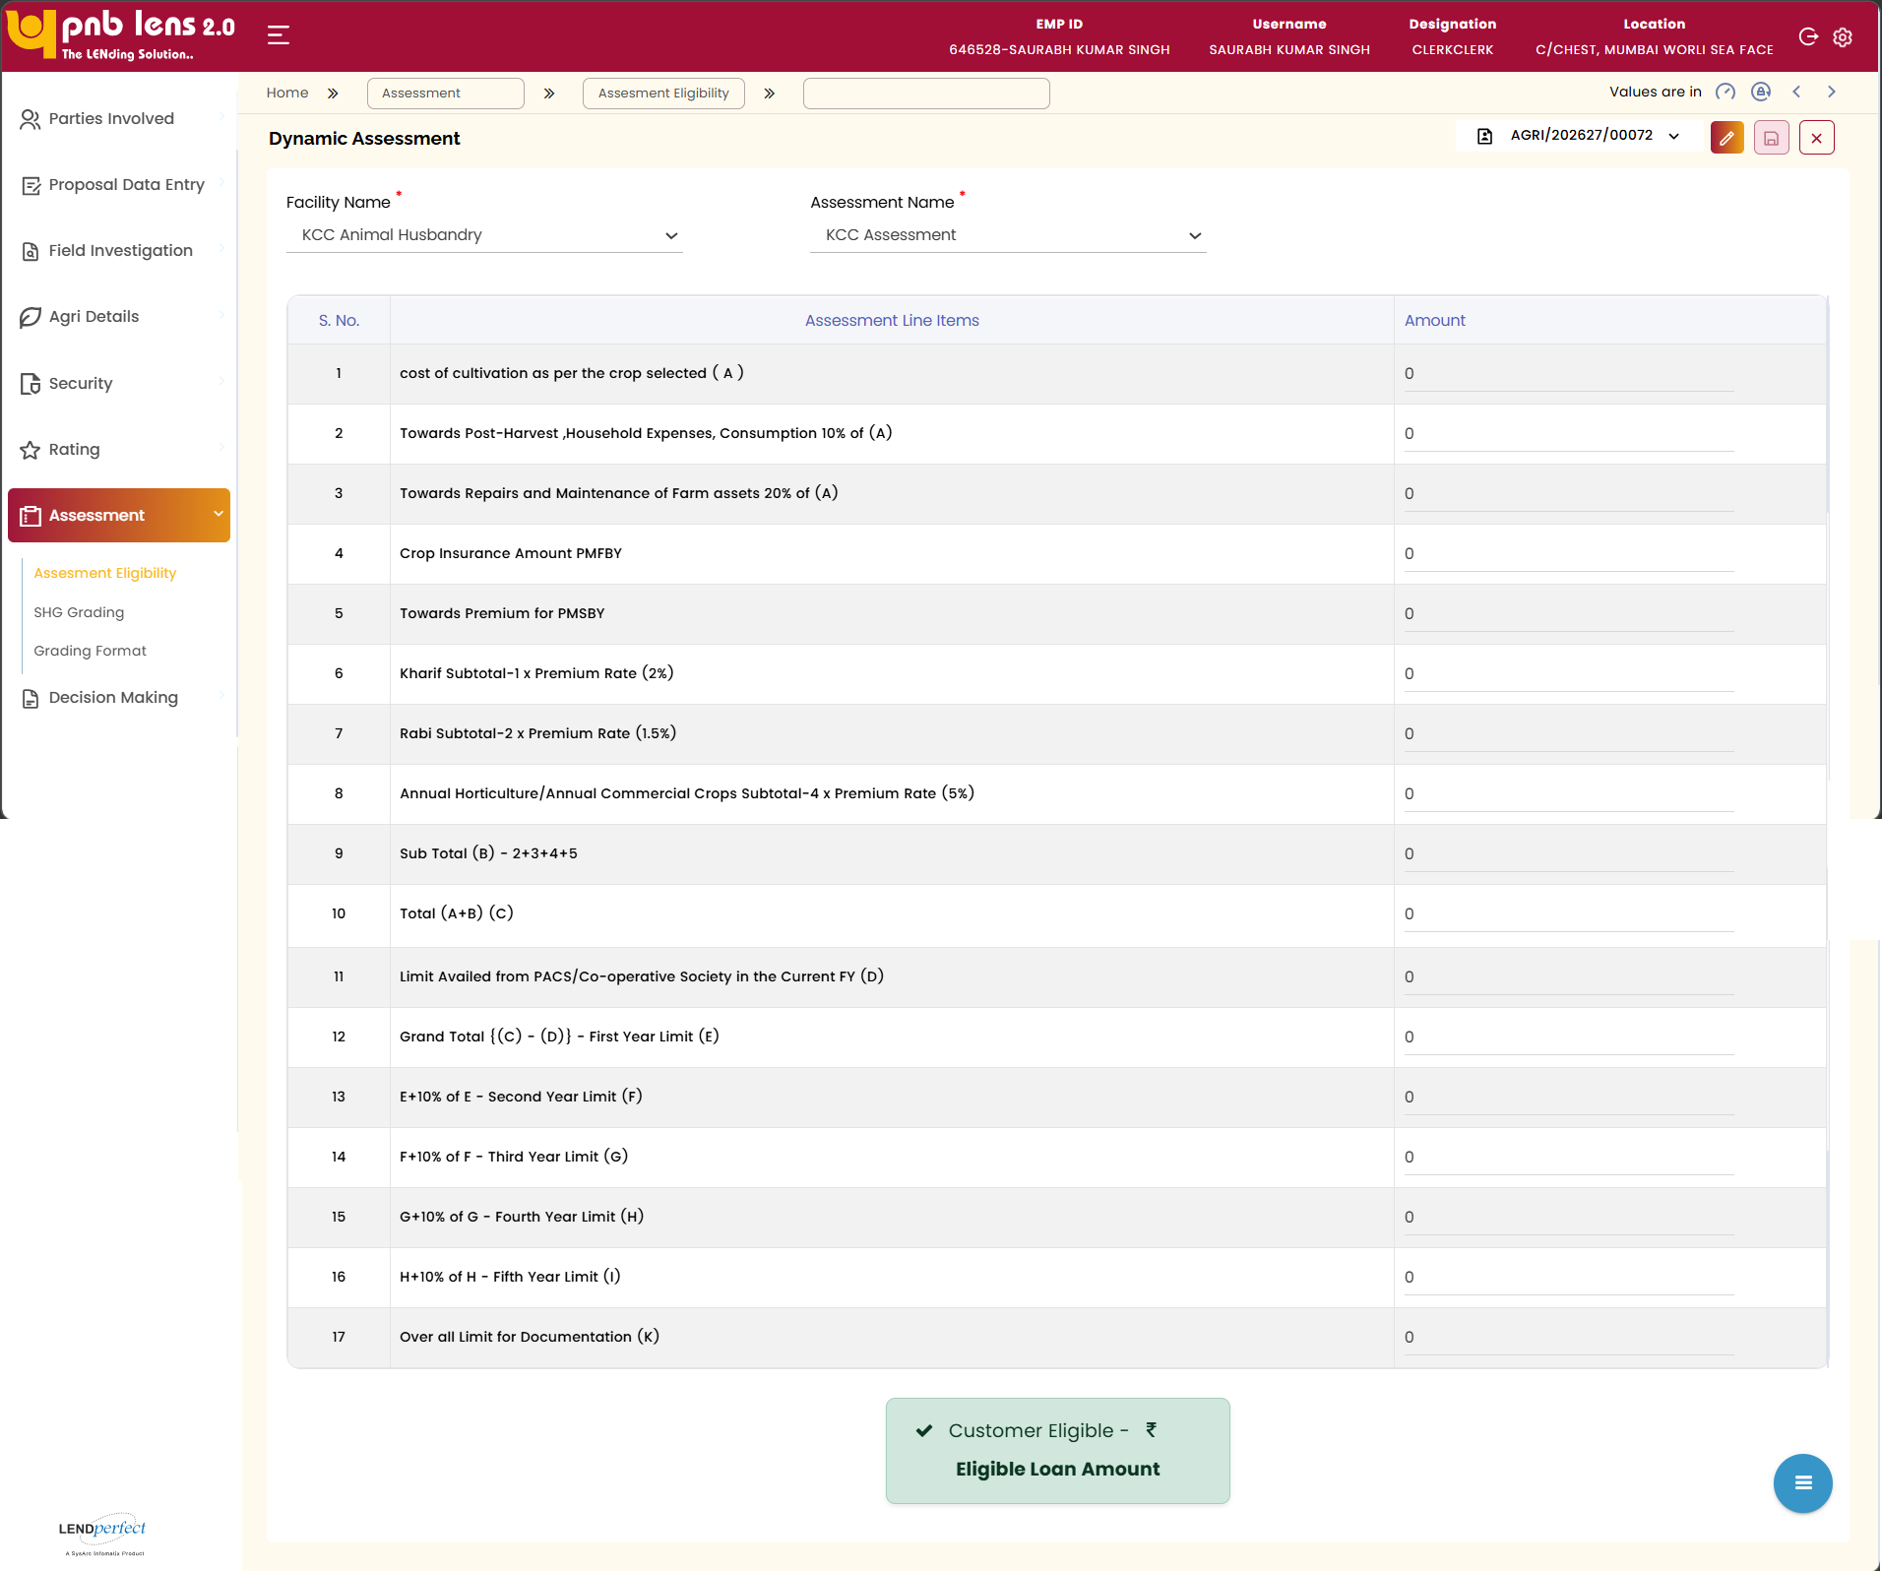
The user can select the Facility Name and Assessment Name, upon which the system automatically calculates and displays the eligible amount.
The calculated eligibility is used for further decision-making in the application process.
Interface Touch Points
No interface touch points for the screen.

Field Level Validation
S. No | Field Name | Field Type | Source | Validations/ Formulas | Mandatory Flag | DB Type
 | Facility Name | Dropdown | Manual | Displays the selected product | Mandatory | VARCHAR
 | Assessment Name | Dropdown | Manual | Assessment for the selected product | Mandatory | VARCHAR
 | S. No | Column Heading | NA | NA | NA | S. No
 | Assessment Line Item | Column Heading | NA | NA | NA | Assessment Line Item
 | Amount | Column Heading | NA | NA | NA | Amount

Decision Making
The decision-making tab allows the user to take the decision regarding the sanctioning of loan against the proposed application based on the information provided in the application, and details fetched from external sources. The following sections are available below the Decision-Making tab:
- Pricing and Concession
- Terms and Conditions
- Proposal Recommendation
- Workflow & Approval
- Workflow History
- Post Sanction Documents
- Handoff Details
- Pre Disbursement Compliance

Pricing and Concession
Screen Functionality
The Pricing and Concession screen allows the user to review and update pricing details for the selected facility. The system displays existing interest rate and facility details for verification.
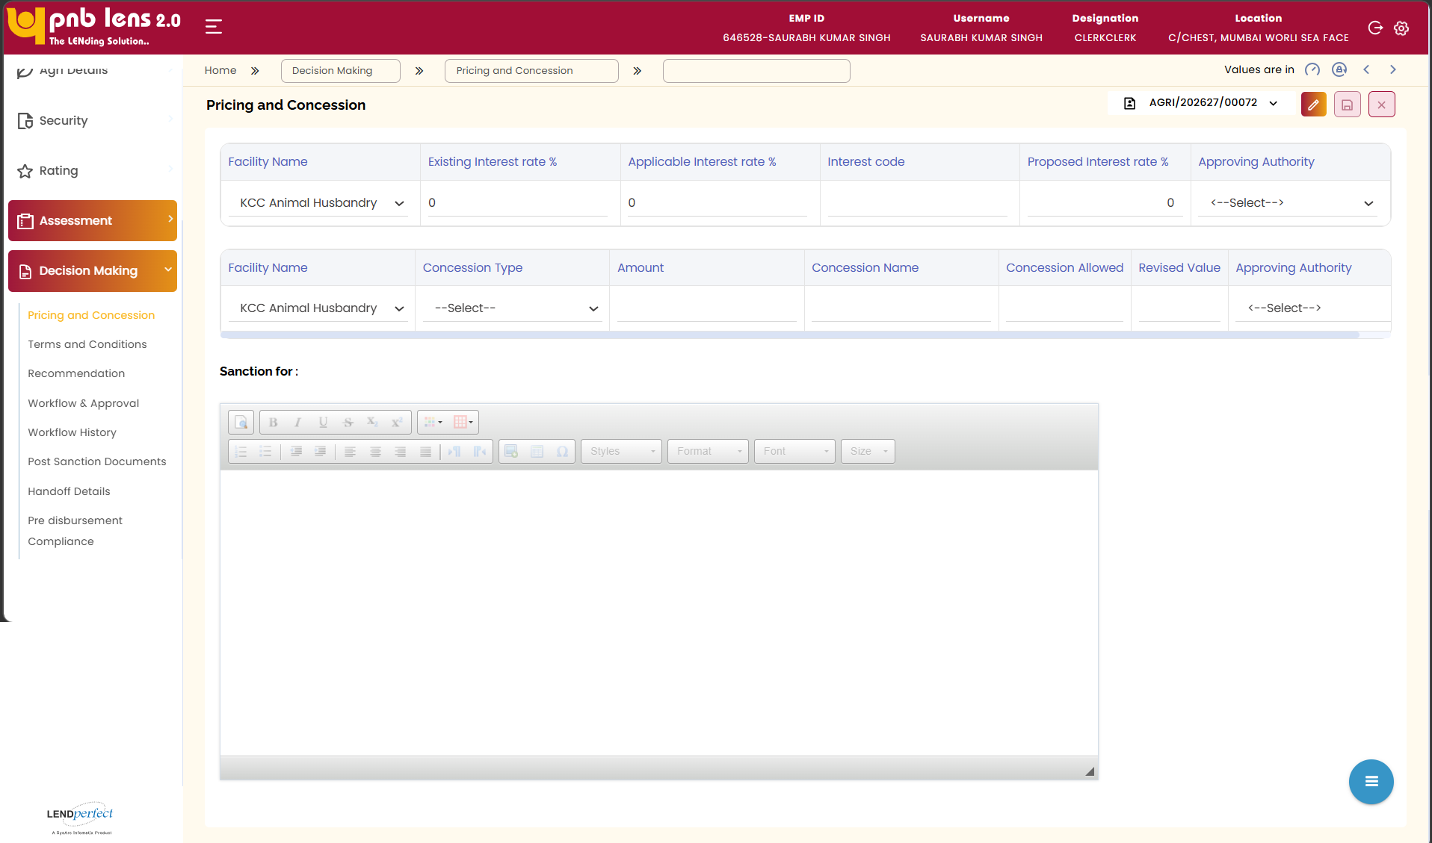
The user can enter or update the proposed interest rate, specify the approving authority, and capture concession details where applicable. The system reflects revised values based on the applied concessions.
The user must ensure all mandatory fields, including remarks and approval details, are completed. Upon clicking Save, the system validates and stores the pricing and concession details for further processing.
Interface Touch Points
No interface touch points for the screen.

Terms and Conditions
Screen Functionality
This screen allows the user to attach product-specific and general terms and conditions to the loan application.
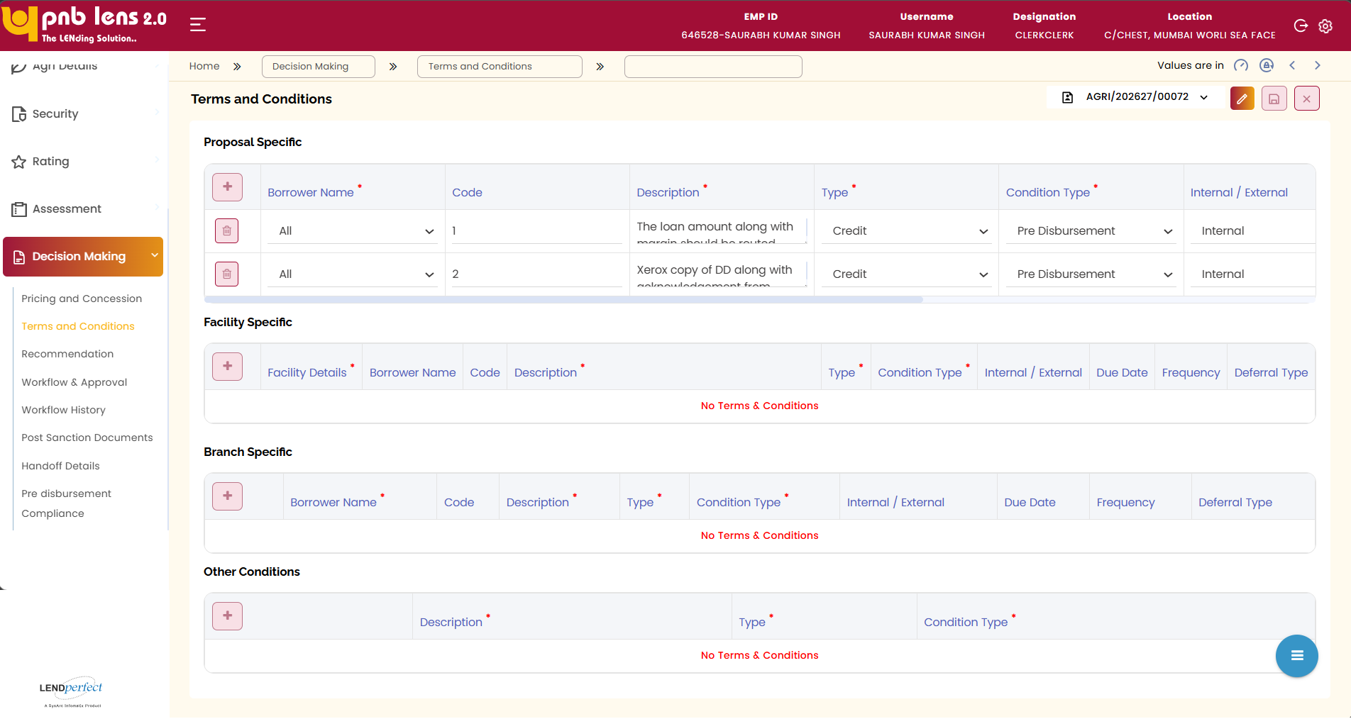
The terms and conditions specific to the product and the general terms and conditions are pre-configured in the setup module. The screen displays the terms and conditions specific to the loan product selected.
Adding new Terms and Condition
The user can add new terms and conditions in addition to the existing terms and conditions. The user must click  at the top left-hand side of the screen to add new terms and conditions. A popup window appears listing the terms and conditions.
The user needs to select the checkbox corresponding to the terms and conditions and click Take it to the Product button. The selected terms and conditions are added to the Terms and conditions screen in the proposed loan application. The terms and conditions created in the application will apply only to the proposed application. Click the Save button to confirm.
Adding User Defined Terms and Conditions
In addition to the pre-configured terms and conditions, the user can also manually attach other terms and conditions at the time of application creation. In this scenario, the user needs to select Draft from the popup window and then click the Take it to the Product button. The terms and conditions get attached as a draft. However, it is editable. The user can rename the terms and conditions.
Interface Touch Points
No interface touch points for the screen.

Field Level Validation
Front End fields (UI Interface)
S. No | Field Name | Field Type | Source | Validations / Formulas | Mandatory Flag | DB Type
A. Proposal Specific
1 | Borrower Name* | Drop-down | Manual | Lists all the participants attached to the proposal | Mandatory | VARCHAR
2 | Code | Text Box | Auto populate | Displays the code of the selected term & condition. It is being configured in setup. | Non-mandatory | NUMBER
3 | Description * | Text Box | Auto populate | Displays the description of the selected term & condition. It is being configured in setup. | Mandatory | VARCHAR
4 | Type | Drop-down | Auto populate | Displays the type of the selected term & condition. It is being configured in setup. | Non-mandatory | VARCHAR
5 | Condition type * | Drop-down | Auto populate | Displays the condition type of the selected term & condition. It is being configured in setup. However, this field is editable.  LOV:  Pre-Disbursement  Post Disbursement | Mandatory | VARCHAR
6 | Internal / External | Drop-down | Auto populate | Displays the condition as internal/external based on the selected terms & conditions. However, this field is editable.  LOV:  Internal  External | mandatory | VARCHAR
7 | Due Date | Date Picker | Manual | dd/mm/yyyy format | Non-mandatory | DATE
8 | Frequency | Drop-down | Manual | Monthly  Quarterly  Half-Yearly  Yearly  Not Applicable | Non-mandatory | VARCHAR
B. Facility Specific
1 | Facility Details * | Drop-down | Manual | Displays the loan product attached to the proposal. | Mandatory | VARCHAR
2 | Borrower Name | Drop-down | Manual | Lists all the participants attached to the proposal | Mandatory | VARCHAR
3 | Code | Text Box | Auto populate | Displays the code of the selected term & condition. It is being configured in setup. | Non-mandatory | NUMBER
4 | Description * | Text Box | Auto populate | Displays the description of the selected term & condition. It is being configured in setup. | Mandatory | VARCHAR
5 | Type | Drop-down | Auto populate | Displays the type of the selected term & condition. It is being configured in setup. | Non-mandatory | VARCHAR
6 | Condition type * | Drop-down | Auto populate | Displays the condition type of the selected term & condition. It is being configured in setup. However, this field is editable.  LOV:  Pre-Disbursement  Post Disbursement | Mandatory | VARCHAR
7 | Internal / External | Drop-down | Auto populate | Displays the condition as internal/external based on the selected terms & conditions. However, this field is editable.  LOV:  Internal  External | Non-mandatory | VARCHAR
8 | Due Date | Date Picker | Manual | dd/mm/yyyy format | Non-mandatory | DATE
9 | Frequency | Drop-down | Manual | Monthly  Quarterly  Half-Yearly  Yearly  Not Applicable | Non-mandatory | VARCHAR
D. Terms - popup window
1 | Terms Code | Column | Setup | Displays the code of the terms & conditions configured in the setup. | NA | NA
2 | Terms Description | Column | Setup | Displays the descriptions of the terms & conditions configured in the setup. | NA | NA
3 | Terms Type | Column | Setup | Displays the type of the terms & conditions configured in the setup. | NA | NA
4 | Disbursement Type | Column | Setup | Displays the disbursement type of the terms & conditions configured in the setup. | NA | NA
5 | Internal / External Condition | Column | Setup | Displays the internal/external condition of the terms & conditions configured in the setup. | NA | NA
6 | Mandatory | Column | Setup | Displays whether the terms & conditions are mandatory or not as configured in the setup. | NA | NA
7 | Deferrable | Column | Setup | Displays whether the terms & conditions are deferrable or not as configured in the setup. | NA | NA
8 | Take it to the product | Button | NA | Allows attaching the selected terms and conditions to the proposal. | NA | NA
E. Buttons
1 | Edit | Button | NA | Allows modifying the details on the active screen. This button is displayed on the screen only after the lead is submitted. | NA | NA
2 | Save | Button | NA | Allows saving the details on the active screen. This button is displayed on the screen only after the lead is submitted. | NA | NA
3 | Cancel | Button | NA | Allows cancelling the current operation. By default, this button will be displayed on the screen. | NA | NA
Back End fields
Field Level notes, alerts, and static content for validation

Proposal Recommendation
Screen Functionality
The Recommendation screen allows the authorized user to recommend the proposal for sanction / rejection.
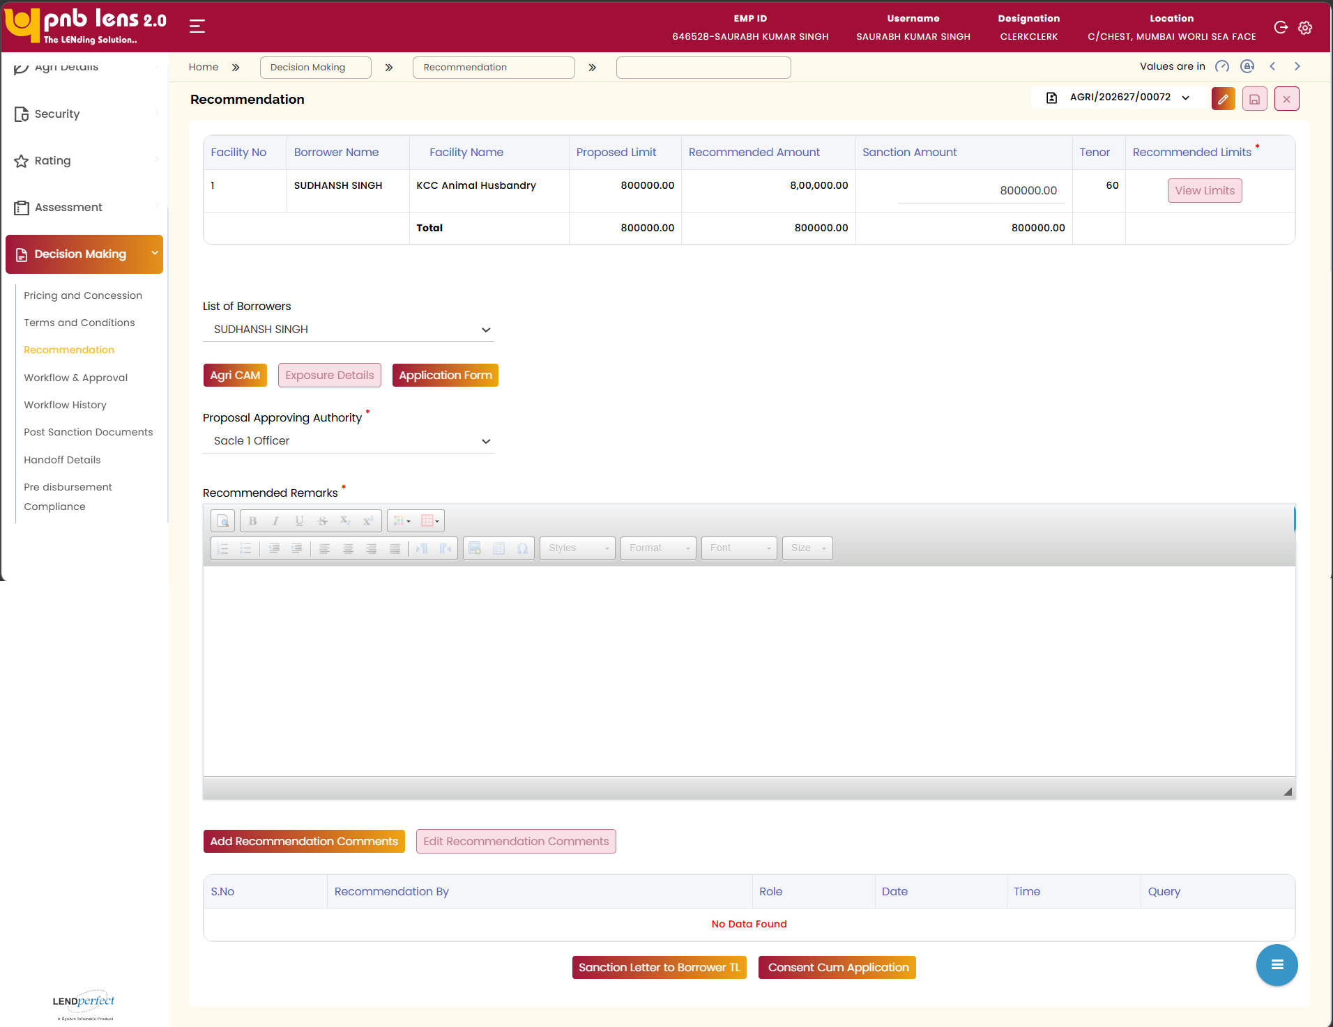
On this screen, the system displays the final eligible amount in the Recommended Value and Sanction Value text boxes. In case of multiple facilities being attached to a single proposal, the screen displays all the facilities in separate rows in the Recommendation table.
Upon clicking the Edit Recommendation Values button, certain fields whichever applicable becomes editable in the Recommendation table. The recommending authority can modify the recommended value. The sanction value also gets updated along with the recommended value.
Validation
- The recommend value should not breach than loan amount requested.
- If the recommended value is changed, there may be a change of deviation being raised in reverse way as follows.
  - Product defined deviation
  - Income based deviation
- In both the above cases, the loan cannot be sanctioned until the deviation is approved by the concerned approving authority.
- Sanction value should be same as the recommended value or can be lesser than the recommended value. But not higher than recommended value.
Based on the recommended value, the system automatically displays the approving authority names in the Approving Authority dropdown. The recommending authority needs to select the appropriate approving authority from the dropdown and enter the recommended remarks in the Recommended Remarks text area by clicking the Add Recommendation Comments button.
The Edit Recommendation Remarks button allows the user to edit the recommendation comments. The user can edit only his remarks until the proposal is within his inbox. Once the proposal is forwarded to the approving authority, the system will restrict the user from editing the recommendation remarks.
If the user clicks View Limit the below Recommended Limits needs to pop up.
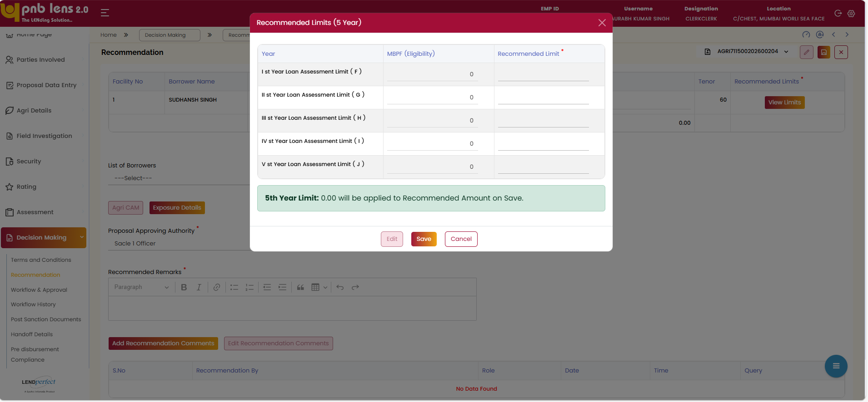
Note:
The above Recommended Limits (5 Years) functionality is only available for KCC.

Process Note Generation
The Process Note for the proposed application is auto generated based on the format shared by the bank. Upon recommendation and initiation for approval, the approving authority will verify the application and the process note.

Sanction letter Generation
The system allows the user to view the softcopy of the KCC loan sanction letter. The Sanction letter is precomposed and configurable based on the KCC loan product selected. The Sanction Letter is automatically customized to capture the borrower’s details. The Sanction Letter to Borrower is generated for the borrower to get acceptance acknowledgment.
The generation of sanction will be enabled to the user only when the proposal gets sanctioned.
Generate Sanction Letter
The user needs to click the Sanction Letter to Borrower to view the borrower copy of Sanction Letter in a popup window.

Application Form Generation
The user needs to click the Consent Cum Application button to generate the soft copy of the application form.
Interface Touch Points
No interface touch points for the screen.

Field Level Validation
Front End fields (UI Interface)
S. No | Field Name | Field Type | Source | Validations / Formulas | Mandatory Flag | DB Type
A. Facility Table
1 | Facility No | Column | Auto updated | Displays the sequence | NA | NA
2 | Borrower Name | Column | Auto populate | Displays the borrower’s name | NA | NA
3 | Facility Name | Column | Auto populate | Displays the selected product | NA | NA
4 | Existing Limit (Incl. of Takeover) | Column | Auto populate | Displays the existing limit of the borrower | NA | NA
4 | Requested Loan Amount | Column | Auto populate | Displays the amount requested | NA | NA
5 | Recommended Amount | Column - Text Box | Auto populate / Manual | Numeric.  Displays the final eligible amount. This field is editable at the maker level upon clicking the Edit Recommendation Values button.  Validation:  Recommended value should not breach the loan amount requested. | Mandatory | DECIMAL (22,2)
6 | Sanction Amount | Column - Text Box | Auto populate / Manual | Numeric.  Displays the recommended amount as it is. This field is editable at the maker level upon clicking the Edit Recommendation Values button.  Validation:  Sanction value should be same as or lesser than the recommended value. But not higher than recommended value | Mandatory | DECIMAL (22,2)
7 | Margin | Column | Auto populate | Numeric | NA | NA
8 | ROI / Commission (%) | Column | Auto populate | Numeric | NA | NA
9 | Tenor | Column | Auto populate | Numeric | NA | NA
10 | FOIR Deviated | Column - Dropdown | Auto populate | Yes  No | Mandatory | NA
11 | Instalment Start Date | Column - Date picker | Manual | dd-mm-yyyy format. | Non-Mandatory | DATE
12 | Recommended | Column - Radio Button | Auto populate / Manual | Yes  No | Non-Mandatory | NA
13 | Repayment Schedule | Display Field | Auto populate | Display | Non- mandatory | Display  Field
B. Other Fields
14 | Edit Recommendation Values | Button | NA | Allows to modify the recommendation values | NA | NA
15 | List of Borrowers | Drop-down | Manual | Lists the applicants attached to the proposal | Mandatory | VARCHAR
16 | Approving Authority | Drop-down | Manual | List of approving authority group from setup | Mandatory | VARCHAR
17 | Recommended Remarks* | Rich Text Editor | Manual | String.  This field is enabled only upon clicking the Add Recommendation Comments button. | Mandatory | VARCHAR
Recommended Limits (5 Years)
 | Year | Table heading | NA | NA | NA | NA
 | MBPF (Eligibility) | Table heading | Auto populate | Details fetch from assessment | NA | NA
 | Recommended Limit | Table heading | NA | NA | Mandatory | NA
1.1 | I st Year Loan Assessment Limit (F) | Text Box | Manual Entry | Numeric | Mandatory | Number
1.2 | II st Loan Assessment Limit (G) | Text Box | Manual Entry | Numeric | Mandatory | Number
1.3 | III st Year Loan Assessment Limit (H) | Text Box | Manual Entry | Numeric | Mandatory | Number
1.4 | IV st Year Loan Assessment Limit (I) | Text Box | Manual Entry | Numeric | Mandatory | Number
1.5 | V st Year Loan Assessment Limit (J) | Text Box | Manual Entry | Numeric | Mandatory | Number
C. Record Table
18 | Facility Details | Button | NA | NA | NA | NA
19 | Sanction Letter to Bank | Button | NA | NA | NA | NA
20 | Sanction Letter to Borrower | Button | NA | NA | NA | NA
D. Buttons
21 | Process Note | Button | NA | Allows generating the Process Note.  This button is enabled only when the user selects an applicant from the List of Borrowers drop down. | NA | NA
22 | Add Recommendation Comments | Button | NA | Allows to capture the recommendation comments. Upon clicking this button, the Recommended Remarks text editor is enabled to capture the remarks. | NA | NA
23 | Edit Recommendation Comments | Button | NA | The same user can edit their comments before forwarding the proposal. | NA | NA
Back End fields
Field Level notes, alerts, and static content for validation

Workflow & Approval
Screen Functionality
The Workflow & Approval screen allows the user to track the workflow for recommendation/approval.
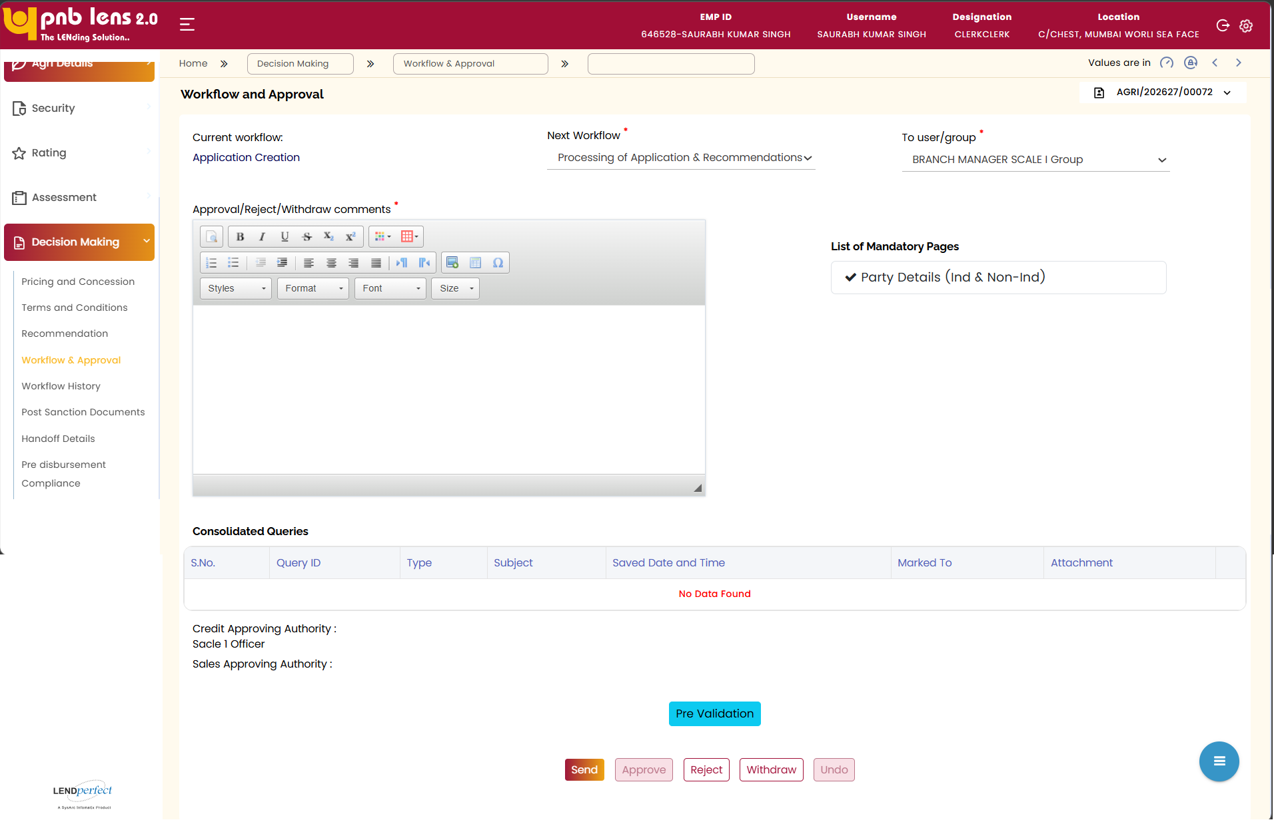
List of mandatory pages – displays the list of mandatory pages preconfigured against workflow. If mandatory screen is completed, a green tick mark will be shown beside the page name. Else a red cross mark will be shown.
Note: In case if any of the mandatory screen is incomplete, the system will restrict the user from forwarding the application to the next stage.
The screen allows the user to forward the proposal to the approving authority post completion of the underwriting process.
To forward the proposal to the approving authority, the user needs to select the workflow of the approving authority and the approving authority/group from the respective dropdowns, and then click Send. The proposal is forwarded to the Group Inbox or the approving authority inbox based on the selection in the To user/group dropdown.
Once the approving authority receives the proposal from the underwriter, the approving authority can either approve, reject, withdraw, or undo the proposal by clicking the respective buttons on this screen.
While approving, the approver can give comments. The comments section is editable only for approver.
Note: The Approve, Reject, and Undo buttons are enabled only for the approving authority.
Undo – The approving authority needs to click this button to send back the proposal to the previous workflow. Once the proposal is sent back, the user can revisit the sanction condition and sanction amount. Once the proposal is sent back, the entire proposal becomes editable.
In this scenario, if any of the assessment and score related parameters gets changed, the eligibility should be revisited and re-sanctioned with revised parameters and data.
Withdraw – The button available at all levels. Upon clicked, the proposal will be removed from the processing inbox. However, it can be searched in the existing proposal search. In this scenario, the proposal will be in read only mode.
Interface Touch Points
No interface touch points for the screen.

Field Level Validation
Front End fields (UI Interface)
S. No | Field Name | Field Type | Source | Validations / Formulas | Mandatory Flag | DB Type
1 | Current Workflow | Text Box | Auto populate | Displays the current workflow | NA | VARCHAR
2 | Next Workflow * | Drop-down | Manual | Lists the workflows configured in the setup | Mandatory | VARCHAR
3 | To user/group * | Drop-down | Manual | Lists the user/user groups configured in the setup. | Mandatory | VARCHAR
4 | Approval / Reject / Withdraw comments * | Text Box | Manual | Alphanumeric | Mandatory | VARCHAR
5 | List of Mandatory Pages | Label | Auto populate | Displays the mandatory pages to be filled in the current workflow i.e., the workflow of the logged in user.  A green tick mark will be shown against the completed pages, and a red cross mark will be shown against the incomplete / pending pages. | NA | NA
Buttons
6 | Send | Button | Manual | Allows the user to forward the proposal to the selected workflow for approval.  This button is enabled only for the user at the maker level. | NA | NA
7 | Approve | Button | Manual | This button is enabled only for the user at the checker level.  Allows the approving authority to approve the proposal | NA | NA
8 | Withdraw | Button | Manual | This button is enabled for users of all levels.  Upon clicking this button, the proposal will be removed from the processing inbox. However, it can be searched in the existing proposal search. In this scenario, the proposal will be in read only mode. | NA | NA
9 | Reject | Button | Manual | Allows to reject the proposal. | NA | NA
10 | Undo | Button | Manual | This button is enabled only for the approving authority.  Allows to recall the sanction only by the approver. | NA | NA
Back End fields
Field Level notes, alerts, and static content for validation

Workflow History
Screen Functionality
Workflow History screen allows the user to view the completed workflow points with the comments entered by various users along with the time stamp.
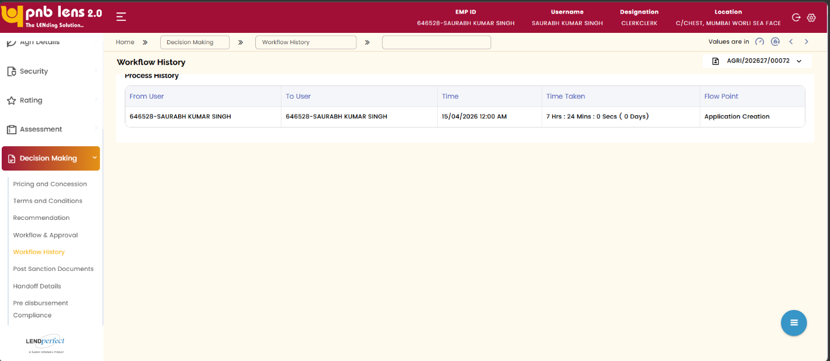
Interface Touch Points
No interface touch points for the screen.

Field Level Validation
Front End fields (UI Interface)
S. No | Field Name | Field Type | Source | Validations / Formulas | Mandatory Flag
1 | From User | Column | Auto populate | Displays the user ID and Name of the user from whom the application has been forwarded. | NA
2 | To User | Column | Auto populate | Displays the user ID and name of the user by whom the application has been received. | NA
3 | Time | Column | Auto populate | Displays the time stamp when the proposal is moved to next workflow | NA
4 | Time Taken | Column | Auto populate | Displays the time period. | NA
5 | Flow Point | Column | Auto populate | Displays the workflow point | NA
Back End fields
Field Level notes, alerts, and static content for validation

Post Sanction Documents
In this screen, the user can upload all the post sanction and legal documents necessary for processing the loan application.
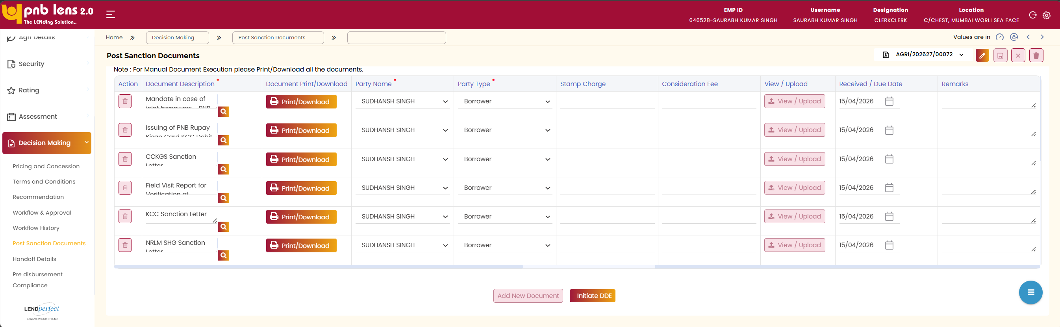
The user needs to capture the details of the document and then click the Upload/View button to upload the documents. Once the document is uploaded, the user can view the uploaded documents by clicking the Upload/View button.
The Add New Document button allows the user to attach multiple documents to the proposal.
Once all the necessary documents are uploaded, the user can execute the documents offline or digitally execute the document through Legal desk. The functionalities for both the scenarios are explained in the consequent section.

Manual Document Execution
A hard copy of the document gets generated to get the customer signature. The signed copy can be uploaded for future references. The list of documents that are to be generated and their locations are given in the table below.
Documents to be generated | Location on LENDperfect
Application Form | Decision Making Proposal Recommendation screen
Sanction Letter | Decision Making Proposal Recommendation screen.
Process Note | Decision Making Proposal Recommendation screen.
Legal Documents | Decision Making Post Sanction Documents screen.

Field Level Validation
Front End fields (UI Interface)
S. No | Field Name | Field Type | Source | Validations / Formulas | Mandatory Flag
1 | Action | Icon/Button | Manual | Allows to delete the row of document details | Non- mandatory
2 | Document Description * | Lookup/Search | Manual | Displays document list | Mandatory
3 | Document Print/Download | Button | Auto | Displays the type of document | Non- mandatory
4 | Party Name * | Dropdown | Manual | Allows the user to view the uploaded document | Mandatory
5 | Party Type * | Dropdown | Manual | List of participants attached to the proposal | Mandatory
6 | Stamp Charge | Text Box | Manual | Numeric | Non- mandatory
7 | Consideration Fee | Text Box | Manual | Numeric | Non- mandatory
8 | View / Upload | Button | Manual | Allows to view/upload the document | Non- mandatory
9 | Received / Due Date * | Date Picker | Manual | DD/MM/YYY | Mandatory
10 | Remarks | Text Box | Manual | Alphanumeric | Non- mandatory
11 | Add New Document | Button | Manual | Allows to add new row to enter document details | Non- mandatory
12 | Initiate DOC | Button | Manual | NA | Non- mandatory

Handoff Details
Click Decision Making and then click Handoff Details on the left navigation bar. The Handoff Details screen appears as below. Wherein you can initiate loan account creation and account handoff.
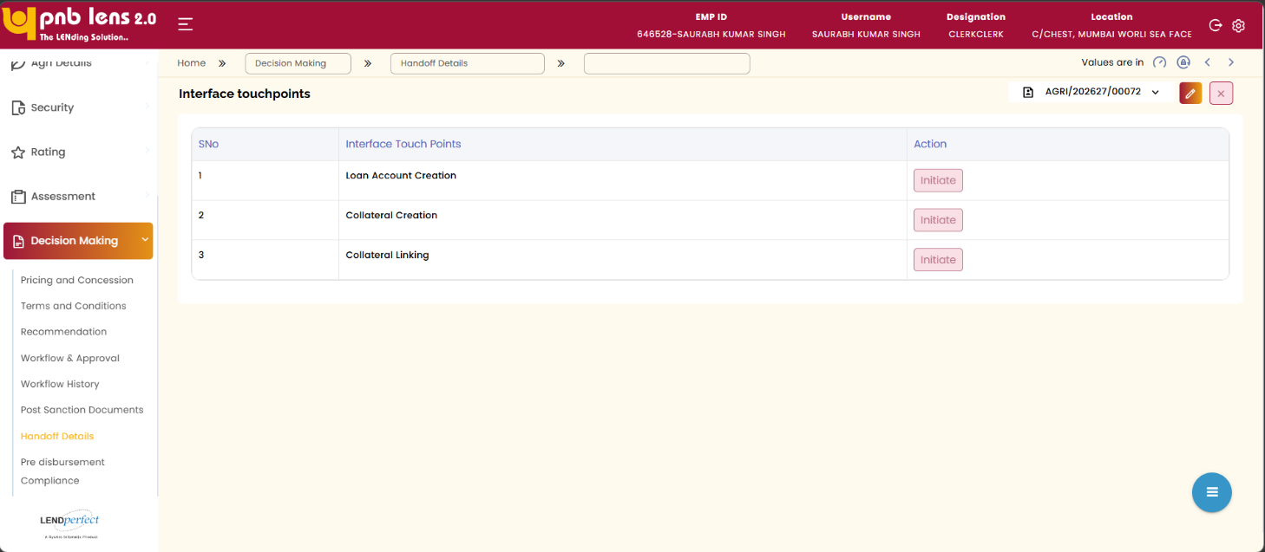
Click Edit and then click Initiate corresponding to Loan Account Creation. The Loan Account Creation pop up appears.
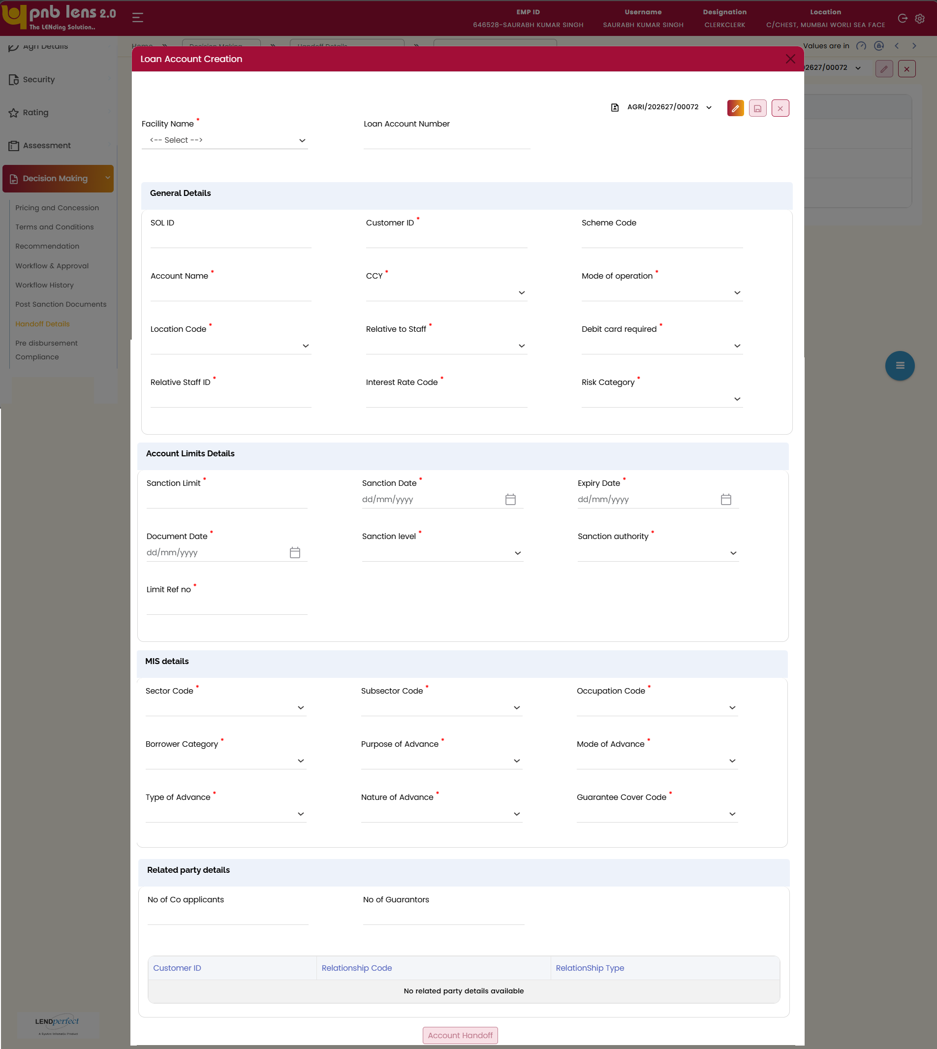
Verify the facility name. Enter all the mandatory details in General Details section. Verify interest, risk, and category details aligned with the sanctioned proposal. Review sanction details, dates, and sanctioning authority. Enter or verify required document and sanction-related dates. Enter the relevant details in all the mandatory fields in MIS details section.
Note:
It is mandatory to fill the MIS Details screen, for loan account creation.
Review related party details, including co-applicants or guarantors. Ensure all mandatory account and limit information is completed. Click Account Handoff. The details are pushed to CBS for loan account creation in CBS.
Once the loan account is successfully created in CBS, the below popup window appears. Also, the loan account number is updated.
KCC or KSY Loan Account Number is successfully created based on the selected scheme.
Once the loan account number is generated, click Initiate corresponding to the Collateral Creation, the Collateral ID will be created.

Field Level Validation
Front End fields (UI Interface)
S. No | Field Name | Field Type | Source | Validations / Formulas | Mandatory Flag | DB Type
A. Proposal Specific
1 | Facility Name | Dropdown | Manual | Displays the selected product | Mandatory | VARCHAR
2 | Loan Account Number | Text Box | Auto | Alphanumeric | Non- mandatory | VARCHAR
3 | SOL ID | Text Box | Auto | Alphanumeric | Non- mandatory | VARCHAR
4 | Customer ID | Text Box | Auto | Alphanumeric | Mandatory | VARCHAR
5 | Scheme Code | Text Box | Auto | Displays the code as per the selected scheme | Non- mandatory | VARCHAR
6 | Account Name | Text Box | Manual | Alphanumeric | Mandatory | VARCHAR
7 | CCY | Dropdown | Manual | INR | Mandatory | VARCHAR
8 | Mode of Operation | Dropdown | Manual | - JOINT - JOINTLY  - AUTH - AUTHORISED SIGNATORY | Mandatory | VARCHAR
9 | Location Code | Dropdown | Manual | - SEMIU - SEMI-URBAN AREA  - METRO - METROPOLITAN CITY  - RURAL - RURAL AREA  - URBAN - URBAN AREA | Mandatory | VARCHAR
10 | Relative to Staff | Dropdown | Manual | - Y - Yes  - N - No | Mandatory | VARCHAR
11 | Debit Card Required | Dropdown | Manual | - Y – Yes  - N - No | Mandatory | VARCHAR
12 | Relative Staff ID | Text Box | Manual | Alphanumeric | Non- mandatory | VARCHAR
13 | Interest Rate Code | Dropdown | Manual | Alphanumeric | Mandatory | VARCHAR
14 | Risk Category | Dropdown | Manual | - L — Low Risk  - M — Medium Risk  - H - High Risk | Mandatory | VARCHAR
Account Limit Details Tab starts
15 | Sanction Limit | Text Box | Manual | Numeric | Mandatory | NUMBER
16 | Sanction Date | Date Picker | Manual | DD/MM/YYYY | Mandatory | DATE
17 | Expiry Date | Date Picker | Manual | DD/MM/YYYY | Mandatory | DATE
18 | Document Date | Date Picker | Manual | DD/MM/YYYY | Mandatory | DATE
19 | Sanction Level | Dropdown | Manual | - 5 - CIRCLE OFFICE  - 9 - RAM/iRAM  - 2 - ZONAL OFFICE  - 1 - HEAD OFFICE  - 4 - BRANCH  - 10 - MCC | Mandatory | VARCHAR
20 | Sanction Authority | Dropdown | Manual | LOVs of Sanction authority based on product | Mandatory | VARCHAR
21 | Limit Ref No | Text Box | Manual | Alphanumeric | Mandatory | VARCHAR
MIS Details
22 | Sector Code | Dropdown | Manual | Based on the Product | Mandatory | VARCHAR
23 | Subsector Code | Dropdown | Manual | Based on the Sector code | Mandatory | VARCHAR
24 | Occupation Code | Dropdown | Manual | LOVs of Occupation Code
25 | Borrower Category | Dropdown | Manual | - 14 - Tenant Farmer Group  - 17 — Tenant Farmer - Single borrower  - 18 - Oral Tenant — Single borrower  - 19 - Land less Labour - Single borrower  - Lessee allottee-farmers with record occupancy rights or farmers with ancestral/perpetual rights of cultivation  - 392  - 393  - Single borrower - land held jointly with others  - 394 - Joint borrowers with separate lands ownership  - 395 - Joint borrowers who jointly held land  - 396  - - Single borrower - individual owner and cultivator | Mandatory | VARCHAR
26 | Purpose of Advance | Dropdown | Manual |  | Mandatory | VARCHAR
27 | Mode of Advance | Dropdown | Manual |  | Mandatory | VARCHAR
28 | Type of Advance | Dropdown | Manual | 002 - Term Loan  001 — Cash Credit | Mandatory | VARCHAR
29 | Nature of Advance | Dropdown | Manual | 1 - FULLY SECURED ADVANCE  2 - PARTLY SECURED ADVANCE  3 - UNSECURED ADVANCE  999 - OTHERS  DWCUA - DWCUA COMPONENT OF SJSRY  USEP - USEP COMPONENT OF SJSRY | Mandatory | VARCHAR
30 | Guarantee Cover Code | Dropdown | Manual | - CGCAS - CGCAS  - CGFEL - CGFEL  - CGFSD - CGFSD  - CGPMV - CGPMV  - CGSSU - CGSSU  - CRGFS - CRGFS  - NOCGF - NOCGF  - CGTHB  - CGTMSE HYBRID[CGTHB]  - CGTSI - CGTSI | Mandatory | VARCHAR
Related Party Details
31 | No of Co-applicants | Text Box | Manual | Numeric | Non- mandatory | NUMBER
32 | No of Guarantors | Text Box | Manual | Numeric | Non- mandatory | NUMBER
33 | Customer ID (Grid) | Table Column | Auto | NA | Non- mandatory | VARCHAR
34 | Relationship Code | Table Column | Auto | NA | Non- mandatory | VARCHAR
35 | Relationship Type | Table Column | Auto | NA | Non- mandatory | VARCHAR
36 | Account Handoff | Button | Manual | NA | Non- mandatory | VARCHAR

Pre Disbursement Compliance
Screen Functionality
CBS Parameters screen allows the user to initiate the loan account creation and account handoff for KCC Loan. The screen displays the account details to be pushed to CBS database. The Field values to be updated to the CBS database are pre-configured in the Setup module. The list of field updates to CBS database displays on the screen. The user must manually select the values to be passed to CBS database.
Once the proposal is approved by the sanctioning authority, the user can click the Account Handoff button to create a unique loan account number for the proposal in the CBS. Once the loan account is created in CBS, it will be updated in the LENDperfect system automatically. The loan account number is auto populated on the relevant field on the CBS Parameter screen as well as the Disbursement Schedule screen.
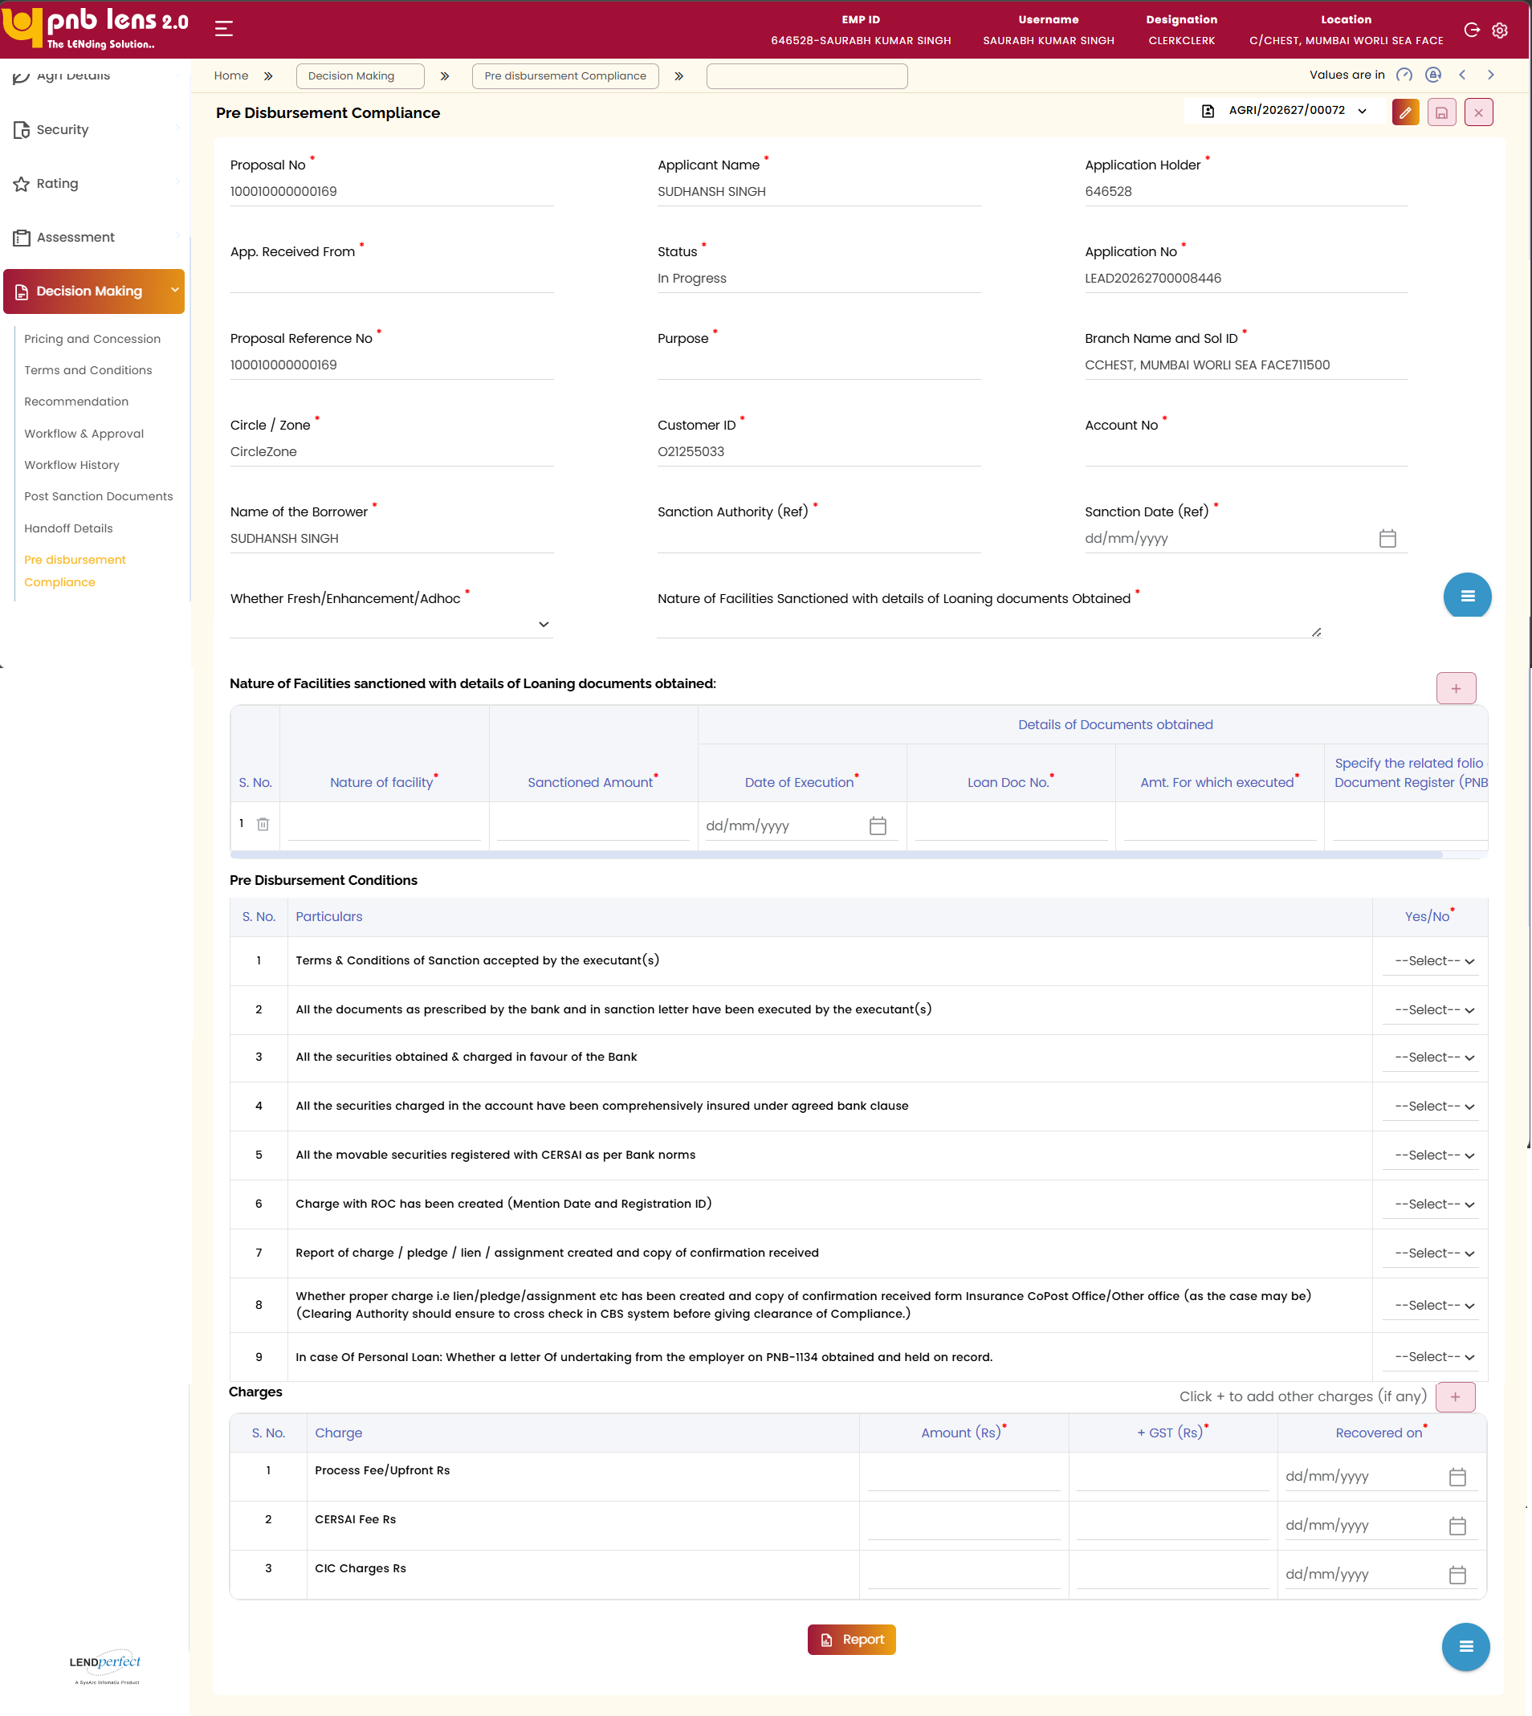
The following are the list of CBS services invoked.
CBS Service | Stage/Screen
Get Token Service | CBS Parameters screen
Create CIF Service | CBS Parameters screen – invoked only for NTB Customer
Create Loan Account service (including disbursement schedule generation) | CBS Parameters screen
Fetch Deposit | Customer Details screen
Fetch Liabilities | Customer Details screen
Enquiry CIF | Lead/Customer Details screen
Dedupe | Lead/Customer Details screen
Note:
The screen to be designed based on the production grade API document which has to be shared by the bank.
Click Report to view the compliance details.
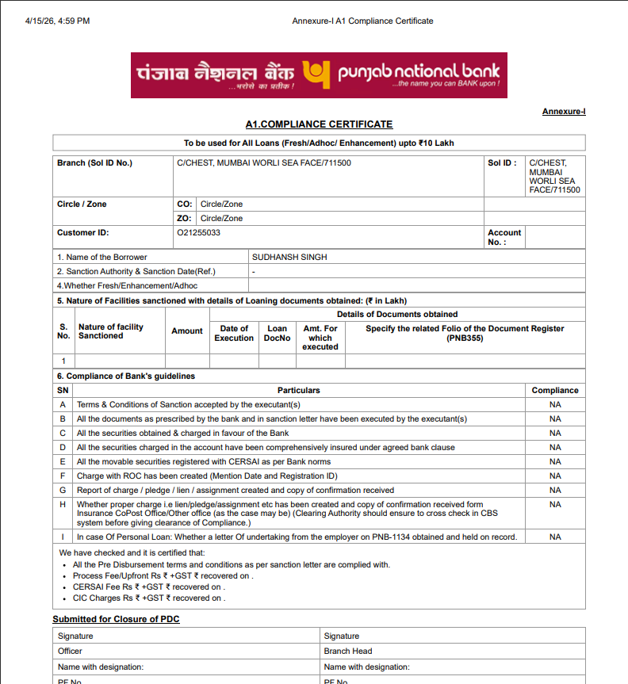
Interface Touch Points
Above services will be invoked.

Field Level Validation
Front End fields (UI Interface)
S. No | Field Name | Field Type | Source | Validations / Formulas | Mandatory Flag | DB Type
A. Proposal Specific
1 | Proposal No | Text Box | Auto | Numeric | Mandatory | VARCHAR
2 | Applicant Name | Text Box | Auto | Alphanumeric | Mandatory | VARCHAR
3 | Application Holder | Text Box | Auto | Alphanumeric | Mandatory | VARCHAR
4 | Application Received From | Text Box | Manual | Alphanumeric | Mandatory | VARCHAR
5 | Status | Text Box | Auto | Alphanumeric | Non- mandatory | VARCHAR
6 | Application No | Text Box | Auto | Numeric | Mandatory | VARCHAR
7 | Proposal Reference No | Text Box | Auto | Numeric | Mandatory | VARCHAR
8 | Purpose | Text Box | Manual | Alphanumeric | Mandatory | VARCHAR
9 | Branch Name & SOL ID | Text Box | Auto | Alphanumeric | Mandatory | VARCHAR
10 | Circle / Zone | Text Box | Auto | Alphanumeric | Mandatory | VARCHAR
11 | Customer ID | Text Box | Auto | Numeric | Mandatory | VARCHAR
12 | Account No | Text Box | Auto | Alphanumeric | Mandatory | VARCHAR
13 | Name of Borrower | Text Box | Auto | Alphabetic | Mandatory | VARCHAR
14 | Sanction Authority (Ref) | Text Box | Manual | Alphabetic | Mandatory | VARCHAR
15 | Sanction Date (Ref) | Date Picker | Manual | DD/MM/YYYY | Mandatory | DATE
16 | Facility Type (Fresh/Enhancement/Adhoc) | Dropdown | Manual | Fresh  Enhancement  Adhoc | Mandatory | VARCHAR
17 | Nature of Facilities Description | Text Area | Manual | Alphanumeric | Mandatory | VARCHAR
18 | S.No (Facility Grid) | Auto Number | Auto | Displays the serial number | Non- mandatory | NUMBER
19 | Nature of Facility | Text Box | Manual | Alphanumeric | Mandatory | VARCHAR
20 | Sanctioned Amount | Text Box | Manual | Numeric | Mandatory | NUMBER
21 | Date of Execution | Date Picker | Manual | DD/MM/YYYY | Mandatory | DATE
22 | Loan Doc No | Text Box | Manual | Numeric | Mandatory | VARCHAR
23 | Amt. For which executed | Text Box | Manual | Numeric | Mandatory | NUMBER
24 | Specify the related folio of the Document Register | Text Box | Manual | Numeric | Non- mandatory | VARCHAR
25 | Checklist Particular | Label | Auto | NA | Mandatory | VARCHAR
27 | S.No (Charges) | Auto Number | Auto | Displays the serial number | Non- mandatory | NUMBER
28 | Charge Type | Label | Auto | NA | Non- mandatory | VARCHAR
29 | Amount | Text Box | Manual | Numeric | Mandatory | NUMBER
30 | GST Amount | Text Box | Manual | NA | Mandatory | NUMBER
31 | Recovered Date | Date Picker | Manual | DD/MM/YYYY | Mandatory | DATE
32 | Report | Button | Manual | NA | Non- mandatory | VARCHAR

Dependencies

